Matching Set 2
(Especially of clothes or furnishings) providing physical ease and relaxation. | 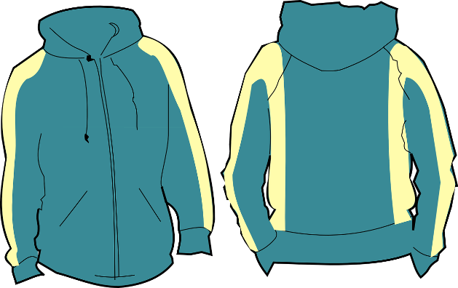
(Of food) belonging to the category that is salty or spicy rather than sweet. | 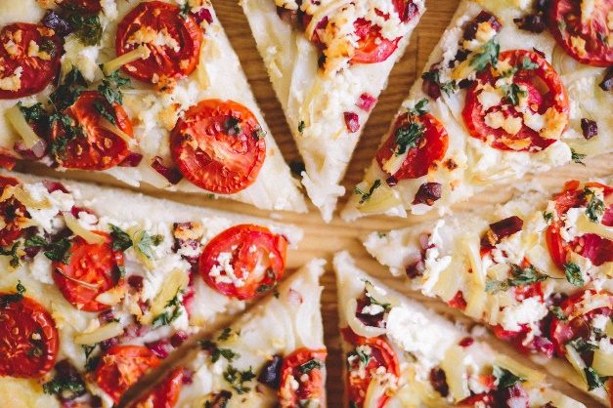
Able to be used for practical purpose or in several ways.
Stimulated by, or as if by, caffeine. | 