________________________________________________________________________________________

________________________________________________________________________________________

________________________________________________________________________________________

________________________________________________________________________________________

________________________________________________________________________________________

________________________________________________________________________________________

________________________________________________________________________________________

________________________________________________________________________________________

________________________________________________________________________________________

________________________________________________________________________________________

________________________________________________________________________________________

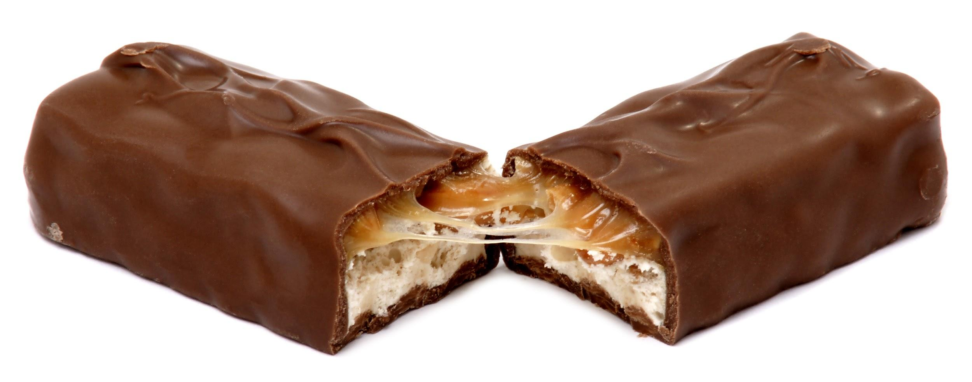
Fuente de la imagen: Evan-Amos. (2010, 28 de agosto). Una barra de Snickers partida a la mitad [Imagen]. Wikimedia Commons. https://commons.wikimedia.org/wiki/File:Snickers-broken.JPG

________________________________________________________________________________________

________________________________________________________________________________________

________________________________________________________________________________________

________________________________________________________________________________________

________________________________________________________________________________________

________________________________________________________________________________________

________________________________________________________________________________________

________________________________________________________________________________________

________________________________________________________________________________________

________________________________________________________________________________________

________________________________________________________________________________________

________________________________________________________________________________________________________________________________________________________________________________________________________________________________________________________________________________________________________________________________________________________________

________________________________________________________________________________________

________________________________________________________________________________________

________________________________________________________________________________________

________________________________________________________________________________________

________________________________________________________________________________________

________________________________________________________________________________________

________________________________________________________________________________________

________________________________________________________________________________________

________________________________________________________________________________________

________________________________________________________________________________________

________________________________________________________________________________________

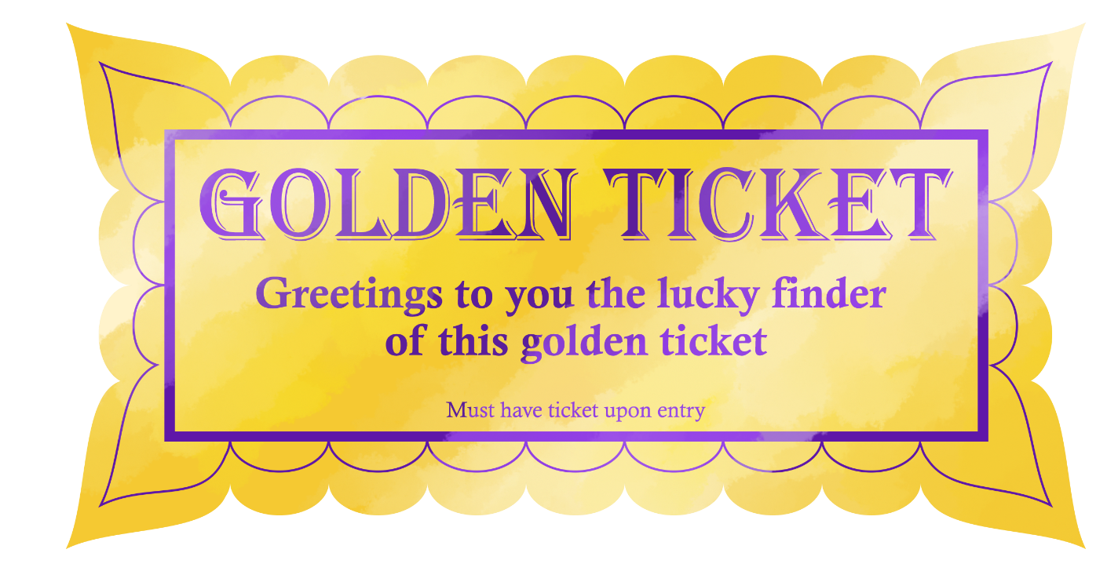

________________________________________________________________________________________

________________________________________________________________________________________

________________________________________________________________________________________

________________________________________________________________________________________

________________________________________________________________________________________

________________________________________________________________________________________

________________________________________________________________________________________

________________________________________________________________________________________

________________________________________________________________________________________

________________________________________________________________________________________

________________________________________________________________________________________

________________________________________________________________________________________
________________________________________________________________________________________________________________________________________________________________________________
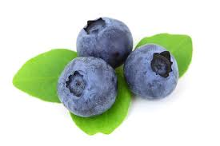
Fuente de la imagen: Kratochvil, P. (n.d.). Arándano fresco aislado sobre fondo blanco [Imagen]. PublicDomainPictures.net. https://www.publicdomainpictures.net/en/view-image.php?image=3419&picture=blueberry

________________________________________________________________________________________

________________________________________________________________________________________

________________________________________________________________________________________

________________________________________________________________________________________

________________________________________________________________________________________

________________________________________________________________________________________

________________________________________________________________________________________

________________________________________________________________________________________

________________________________________________________________________________________

________________________________________________________________________________________

________________________________________________________________________________________

