________________________________________________________________________________________

________________________________________________________________________________________

________________________________________________________________________________________

________________________________________________________________________________________

________________________________________________________________________________________

________________________________________________________________________________________

________________________________________________________________________________________

________________________________________________________________________________________

________________________________________________________________________________________

________________________________________________________________________________________

________________________________________________________________________________________

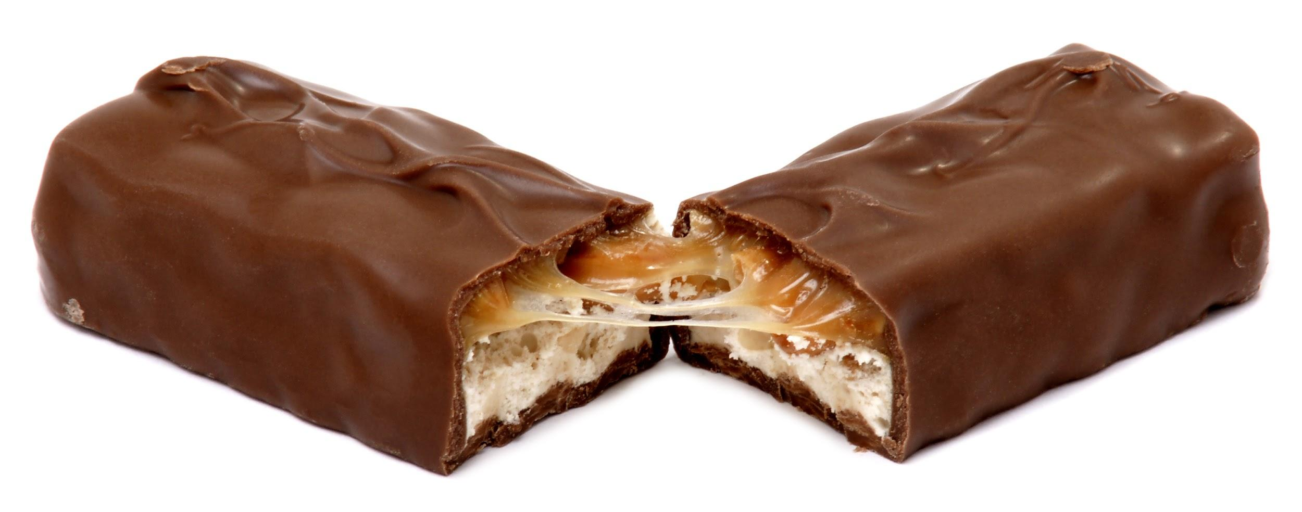
Image Source: Evan-Amos. (2010, August 28). A Snickers candy bar, broken in half [Image]. Wikimedia Commons. https://commons.wikimedia.org/wiki/File:Snickers-broken.JPG

________________________________________________________________________________________

________________________________________________________________________________________

________________________________________________________________________________________

________________________________________________________________________________________

________________________________________________________________________________________

________________________________________________________________________________________

________________________________________________________________________________________

________________________________________________________________________________________

________________________________________________________________________________________

________________________________________________________________________________________

________________________________________________________________________________________

________________________________________________________________________________________________________________________________________________________________________________________________________________________________________________________________________________________________________________________________________________________________

________________________________________________________________________________________

________________________________________________________________________________________

________________________________________________________________________________________

________________________________________________________________________________________

________________________________________________________________________________________

________________________________________________________________________________________

________________________________________________________________________________________

________________________________________________________________________________________

________________________________________________________________________________________

________________________________________________________________________________________

________________________________________________________________________________________

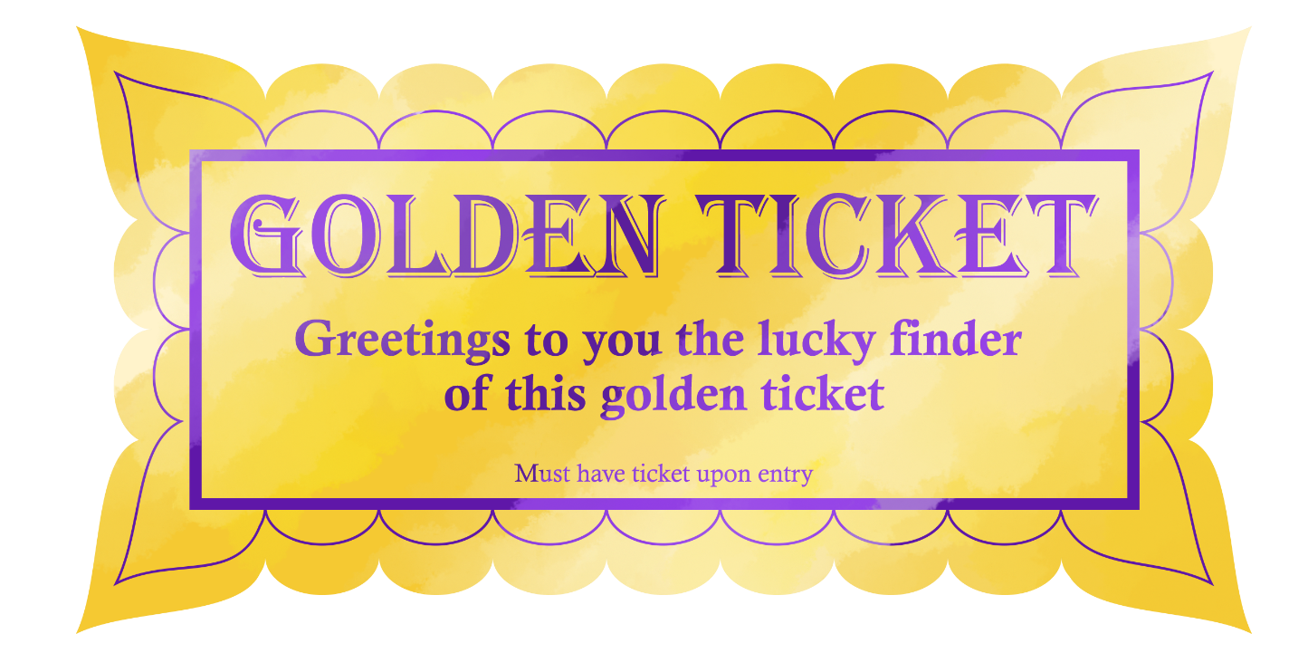

________________________________________________________________________________________

________________________________________________________________________________________

________________________________________________________________________________________

________________________________________________________________________________________

________________________________________________________________________________________

________________________________________________________________________________________

________________________________________________________________________________________

________________________________________________________________________________________

________________________________________________________________________________________

________________________________________________________________________________________

________________________________________________________________________________________

________________________________________________________________________________________
________________________________________________________________________________________________________________________________________________________________________________
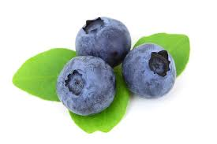
Image Source: Kratochvil, P. (n.d.). Fresh blueberry isolated on white background [Image]. PublicDomainPictures.net. https://www.publicdomainpictures.net/en/view-image.php?image=3419&picture=blueberry

________________________________________________________________________________________

________________________________________________________________________________________

________________________________________________________________________________________

________________________________________________________________________________________

________________________________________________________________________________________

________________________________________________________________________________________

________________________________________________________________________________________

________________________________________________________________________________________

________________________________________________________________________________________

________________________________________________________________________________________

________________________________________________________________________________________

