Yellowstone Species Cards
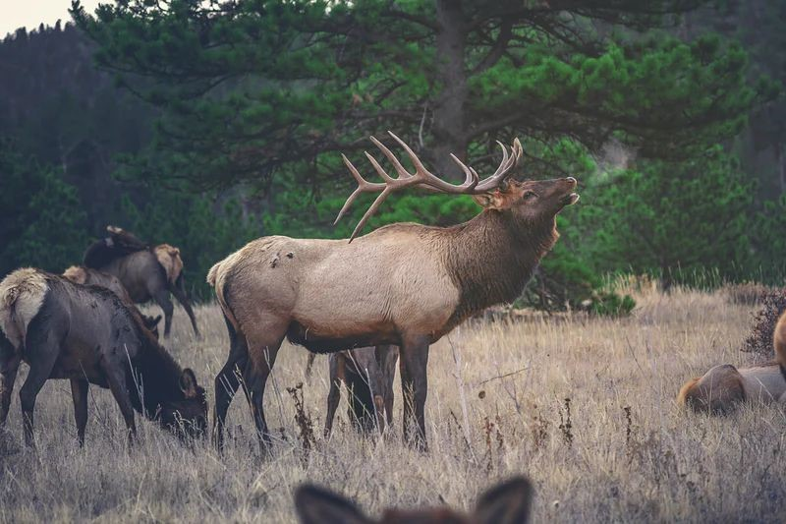 |  | Elk are the most abundant large mammal found in Yellowstone. After wolves were removed from the Park, the elk populations exploded, resulting in severe overgrazing of willows and aspen needed by beavers for food, shelter, and dam building. Currently (2020), the Yellowstone Ecosystem is home to approximately 6,000-8,000 elk. The Park is “arguably the most carnivore-rich area in North America. Early management of predators caused dynamic changes to the ecosystem. The reappearance of carnivores on the landscape has had significant and sometimes unexpected impacts on the resident grazers and their habitat” (NPS).
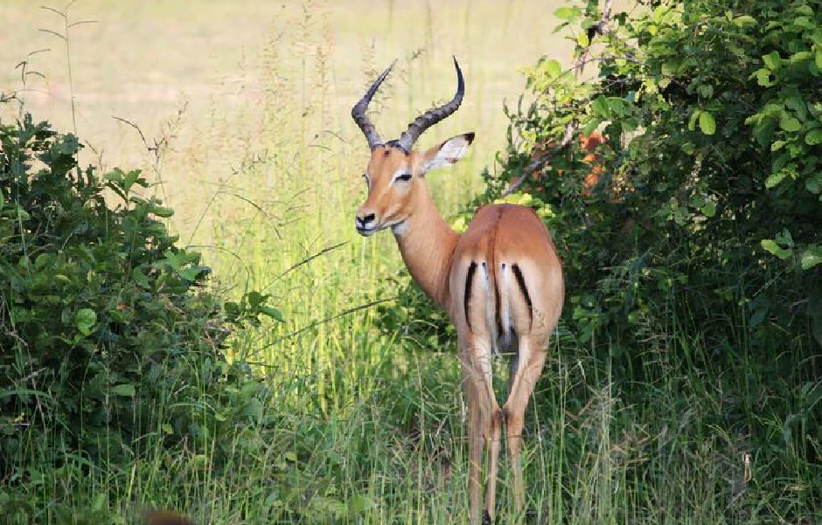 |  | Pronghorn antelopes form groups to protect themselves from predators. The pronghorn can sustain speeds of 45-50 miles per hour, enabling them to outrun predators. Older pronghorns and fawns, however, are easy prey. Predators and competition with elk for grazing affected the size of the herd. Herd sizes in the 1990’s were very low due to coyote predation and land development by private owners. Since the early 2000’s, herds have increased, but the small population is susceptible to extirpation.
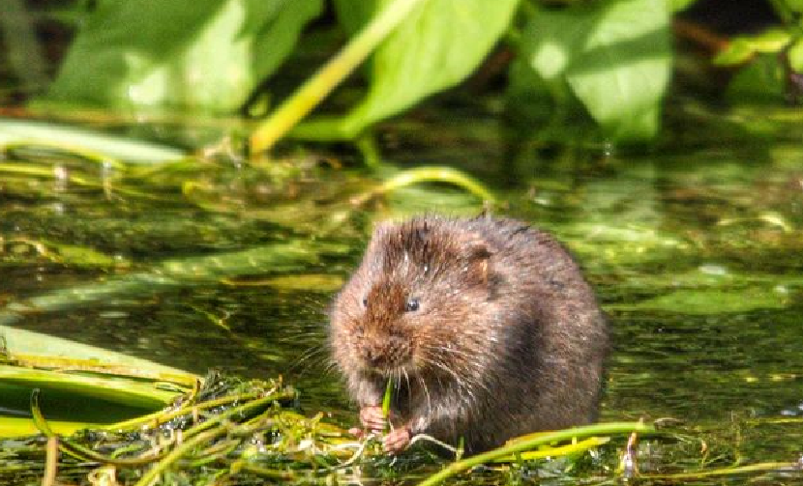 |  | Rodents such as voles, gophers, and ground squirrels are a vital part of the ecosystem in Yellowstone. They are both major food sources for predators, and valuable park engineers that aerate the soil by foraging beneath the surface for underground stems, roots, and bulbs, by tunneling and maintaining vegetation growth and enriching plant nutrient content. Red squirrels are efficient seed-spreaders, assisting in the diaspora of conifer seeds. They also eat insects and grubs.
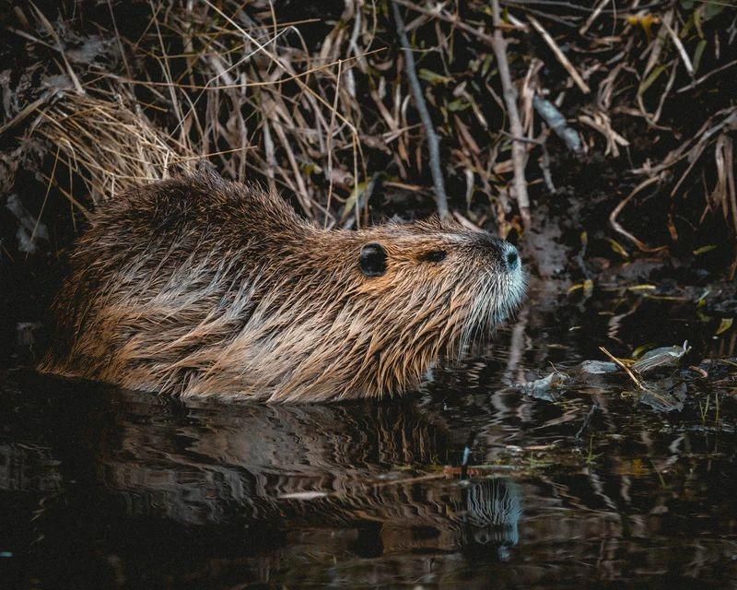 |  | Beavers virtually disappeared after the wolves were removed from Yellowstone. Dams disintegrated, turning marshy ponds into streams. There was heavy stream erosion and a massive loss of mature willows and aspens. Many plant and animal species were affected. When wolves were reintroduced, beavers returned and began to reinforce and reconnect streams by irrigating riverbanks, resulting in the return of many wildlife species.
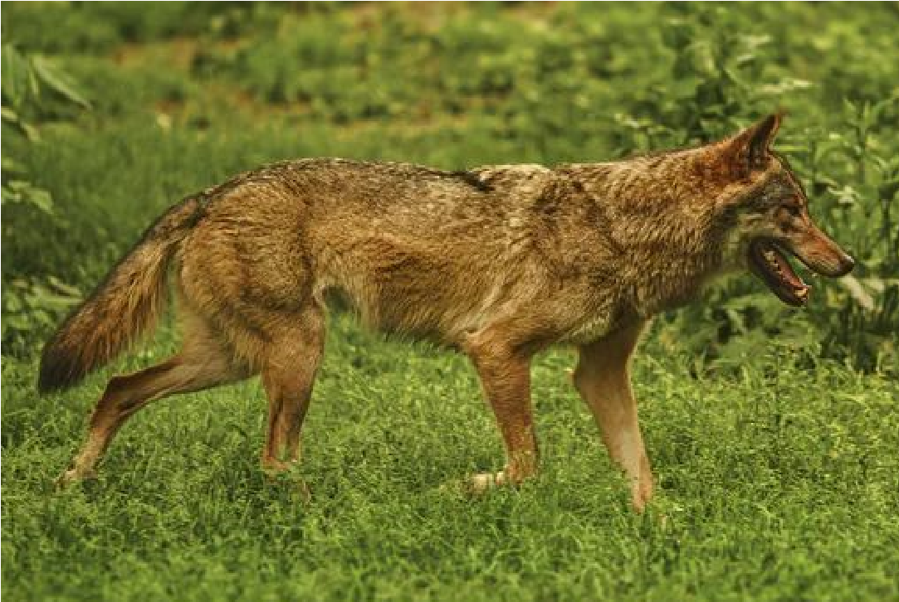 |  | Once the wolves were removed from Yellowstone, the coyote became the apex predator, driving down populations of pronghorn antelope, red fox, and rodents, and birds that prey on small animals. They had little influence on the elk because of size although old cows and bulls and newborn calves were subject to predation by coyotes. A keystone species, the coyote can regulate small prey, eggs and ground-nesting birds. When their numbers increase, they limit the presence of predator birds like hawks and eagles that prey on small rodents and birds. When coyote populations are reduced, small rodents and rabbits increase, adversely affecting vegetation and soil. When the wolves were reintroduced, the coyote population decreased as much as 50% because of competition with wolves for food, attacks by wolves, and general loss of territory.
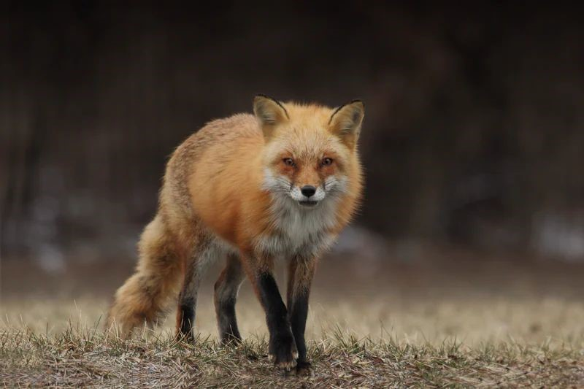 |  | The red fox, native to Yellowstone, is the smallest canid in the Park. The red fox increased in numbers when the coyote population decreased. A smaller predator, the fox had less competition for small prey as the coyote numbers diminished. Nocturnal, foxes prefer to live in forested habitats, while coyotes and wolves prefer open meadows. In addition to preying on small mammals, lizards, and frogs, foxes are scavengers, visiting carcasses from wolf or coyote kills.
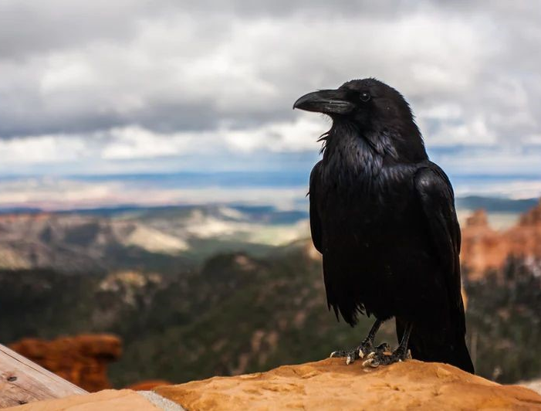 |  | The common raven, a year-round inhabitant of the Park, is an opportunistic feeder. Ravens are attracted to wolf kills and have been known to follow wolves while they hunt elk. They eat a variety of foods, including small mammals, baby birds, amphibians, seeds, and berries. A primary source of food is carrion—animals killed by the larger canids. The ravens appear in flocks immediately after a kill. It is not unusual for a flock of ravens to keep a larger predator bird like a bald or golden eagle away from a carcass. Before the reintroduction of wolves in the park, nearly 75% of the ravens used human areas for scavenging.
 |  | Golden eagles and bald eagles are raptors that live year-round in the Park. The raptors feed primarily on fish, waterfowl, and carrion. When the wolves were removed, the availability of carrion from elk, a major food source, significantly declined. Forced to survive on smaller mammals, birds, and amphibians, the eagles reduced those populations exponentially. In 1967, the US Fish and Wildlife Service listed the Bald Eagle as an endangered species. Numbers of the Bald Eagle seriously declined during the 1990’s because of habitat loss, shooting, and pesticides. The return of the wolves made elk carrion more available, creating a small, but gradual increase in eagle populations. In 2019, the Park Service monitored 20 active nests, and nine eaglets were produced that year.
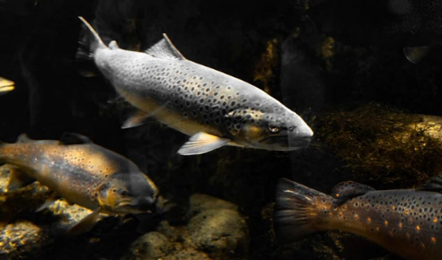  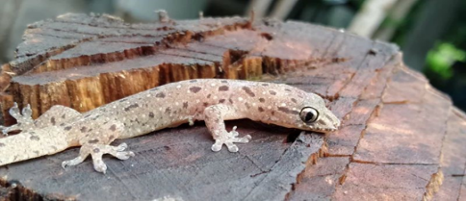 |  | Amphibians and fish in Yellowstone depend on habitat with shallow, quite waters suitable for egg laying and hatching. The removal of the Gray Wolf led to significant restructuring of rivers due to excessive grazing by exploding populations of elk and subsequent erosion of riverbanks and areas suitable to amphibians and fish. The re-introduction of wolves to the Park reduced elk population, resulting in increased beaver activity, leading to fish, amphibians, and insects increases as well.
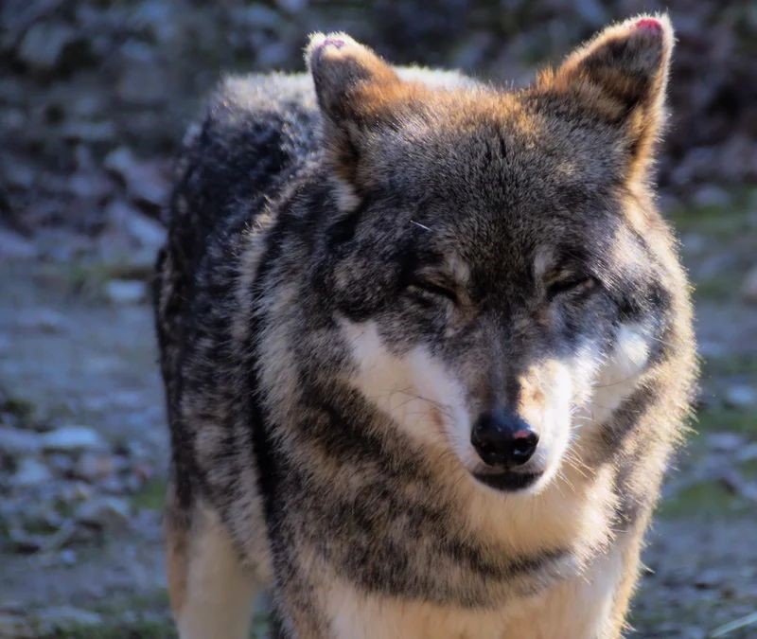 |  | The gray wolf (Canis lupus) was intentionally exterminated in Yellowstone Park in the 1920s. Sanctioned by government policy the removal of the Gray Wolf—the apex predator—triggered an ecosystem collapse known as trophic cascade. Once the wolves were gone, elk populations rose dramatically, setting into motion catastrophic effects on the landscape, other mammals, birds, and fish throughout the entire Park. In 1995—through use of the Endangered Species Act—the conservation community reintroduced the gray wolf to restore balance. The impact was dramatic.

Sources:
Bachman, Mairi & Chelsea Crawford. (n.d.). Grey wolves effect on Yellowstone. Virginia Commonwealth University Earth Systems. https://rampages.us/earth-systems/2020/12/06/grey-wolves-effect-on-yellowstone/
Konstantinovsky, Michelle. (2018, November 14.). Wolves’ return to Yellowstone a boon for streams. HowStuffWorks. https://animals.howstuffworks.com/mammals/wolves-return-to-yellowstone-boon-for-streams.htm
National Park Service. (2020, October 22). Coyote. https://www.nps.gov/yell/learn/nature/coyote.htm
National Park Service. (2020, December 7). Mammals. https://www.nps.gov/yell/learn/nature/mammals.htm
National Park Service. (2020, May 28). Eagles. https://www.nps.gov/yell/learn/nature/bald-eagle.htm
National Park Service. (2020, December 2). Elk. https://www.nps.gov/yell/learn/nature/elk.htm
National Park Service. (2020, October 22). Pronghorn. https://www.nps.gov/yell/learn/nature/pronghorn.htm
National Park Service. (2020, October 21). Red Fox. https://www.nps.gov/yell/learn/nature/red-fox.htm
US Parks. (n.d.). Yellowstone National Park Common Raven. https://www.us-parks.com/yellowstone-national-park/common-raven.html
Wikipedia. (2021, March 4). History of wolves in Yellowstone. https://en.wikipedia.org/wiki/History_of_wolves_in_Yellowstone

