GARBAGE DETECTIVE: CLUES HANDOUT
Below are the scenarios and clues you will need to help solve the case of the mysterious neighbor!

Scenario
You are in charge of your neighborhood watch, which means that you are responsible for making sure that your neighbors are safe and nothing suspicious is going on. A new neighbor has moved in down the street and is very mysterious. The neighborhood group has decided that you should dig through the garbage to see what you can learn. You will need to look for clues, and the way to do this is to make observations and inferences.

Clues
- This person has never been seen during the day.
- An eyewitness next door has seen a tall figure with dark blonde or red hair leave at around 8:00 pm most nights.
- This person drives a dark SUV with an out-of-state license plate.
- The shutters on the windows are always closed during the day.

The Neighbor’s Garbage
You have a case to solve! In this lesson, it is your task to make observations and inferences about the individual items and whole picture of the neighbor’s garbage. Of course, in real life this is a violation of privacy—so in your own neighborhood, leave your neighbors be!
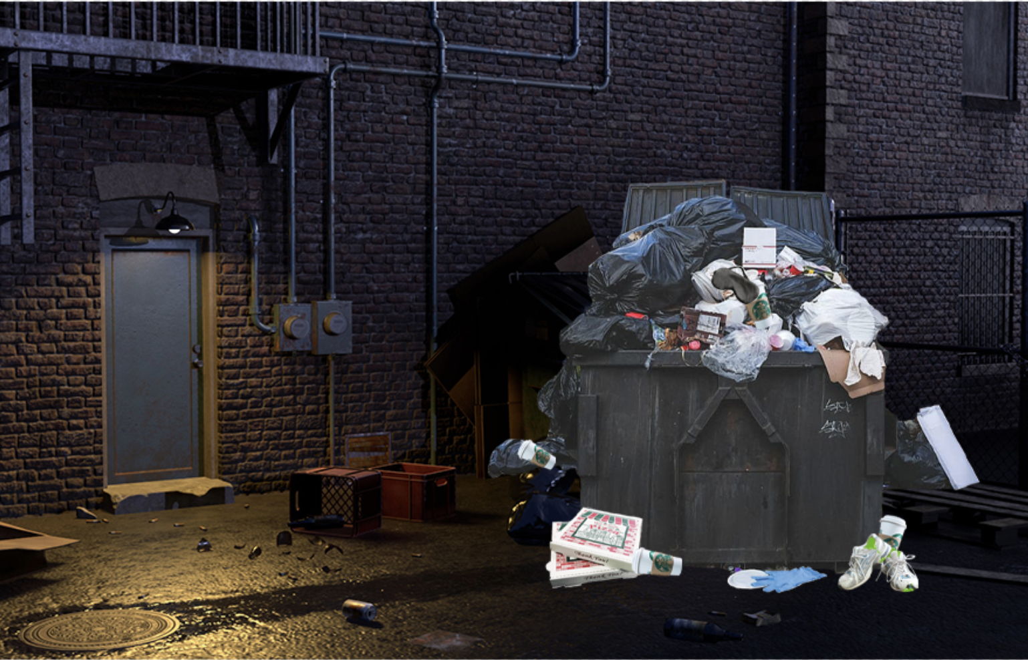

THE NEIGHBOR’S GARBAGE: INDIVIDUAL ITEMS

