Attractions and subatomic particles

Part 1: Black Box
Draw what you think is in your black box.

Part 2: Magnet Attractions
You can use your bar magnets to test the relationship between the positive and negative poles of two magnets. Before you begin, answer the questions below.
- How will you know if the poles are attracted to each other?

- How will you know if the poles are repelled from each other?
Document in the chart below whether the poles are attracted to or repelled from each other.

 |  | 1st Magnet
 |  | Positive | Negative
2nd Magnet | Positive
 | Negative

What do the patterns and relationships you observed tell you? Does the data you recorded above align with your prior knowledge?

Part 3: Subatomic Particles
Sub is a prefix that means “smaller than.” Knowing this, what does “subatomic” mean?

- Proton: positively charged particle (shorthand: p⁺)
- Neutron: neutrally charged particle, about the same size and mass as a proton (shorthand: n⁰)
- Electron: negatively charged particle, much smaller than protons or neutrons (shorthand: e⁻)

- In what way do these definitions relate to the magnets you experimented with in part 2?

- In what ways are they different?

Part 4: Subatomic Particle Attractions
The table below should look familiar—it has been changed to reflect the names of the particles in the atom. Unlike with magnets, protons and electrons are too small to experiment with directly. Just as you observed the layout of the black boxes without seeing the insides directly, it is not yet possible to view atoms or particles directly. Instead, scientists must use indirect variation–using other data sources to predict and verify relationships. Try to predict whether particles will be attracted to or repelled by each other in the chart below.

 |  | 1st Particle
 |  | Proton | Electron
2nd Particle | Proton
 | Electron

- Why do you think your prediction is correct? What data did you rely on and adapt for your prediction?

- Why were neutrons not included in the table?

Part 5: The Atom
Read the following paragraph:
The three sub-atomic particles–protons, neutrons, and electrons–together make the atom. Protons are in the center. Neutrons are also in the center. Scientists speculate that this is to provide stability against the close positive charges repelling each other. Together, protons and neutrons make the nucleus. Electrons swirl around the nucleus, forming electron clouds. Electrons are constantly attracted to the nucleus but repelled by the other electrons.
Do your data and predictions align with the information you just read?

Using the information you have learned, label the diagram below:

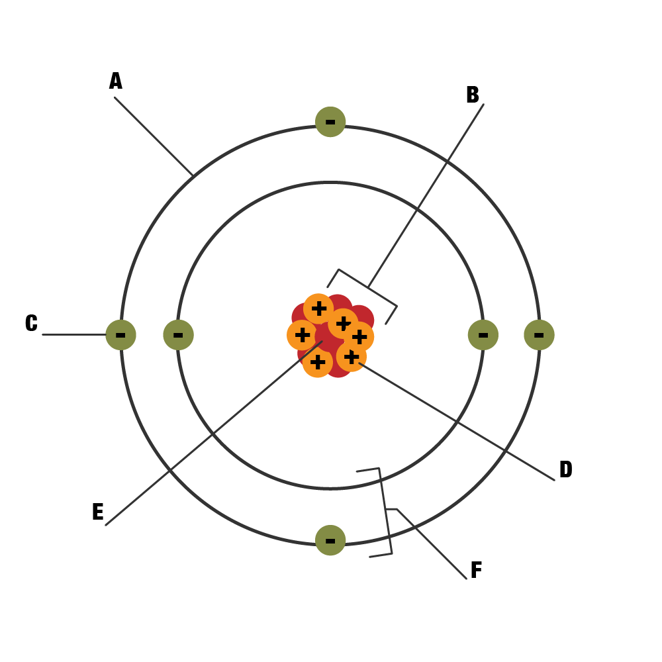

Part 6: Atoms of Different Elements
Go to the PhET Atom Builder at https://tinyurl.com/preucs2.
- Select “Atom.”
- At the bottom, make sure the “Stable/Unstable” box is checked.
- Also make sure the “Mass Number” and “Net Charge” drop-downs are expanded.
Now that all options are selected, drag protons, neutrons, and electrons to the atom. Keep an eye out for patterns and answer the following questions:
- Which subatomic particle defines what element the atom is?

- Which subatomic particle provides stability to the nucleus?

- What proton-to-neutron ratio generally (but not always) provides the best stability?

Any atom with a net charge of zero is called neutral.

Any atom with a net charge other than zero is called an ion.

- How is net charge calculated?

- Which subatomic particles controls the net charge?

- Which subatomic particle changes the charge but doesn’t change the element?

Part 7: Synthesis of Knowledge
Based on everything you have learned, write a plan for how you can classify an atom based on its composition of protons, neutrons, and electrons to determine 1) its element, and 2) its charge status.

