What Is the Third Estate?
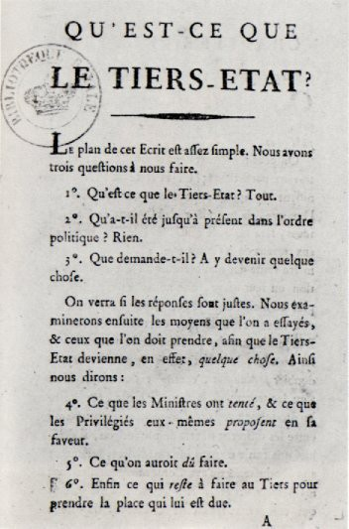
Emmanuel Sieyès was a member of the Second Estate. As a clergy member, he wrote a pamphlet called “What is the Third Estate?” This document was intended to bring attention to the issues facing those within the majority of France’s population. Sieyès based his writing on the idea that the Third Estate deserved political representation because the Third Estate was responsible for the majority of the labor in France. The Third Estate also represented the biggest portion of the population. Sieyès asked three questions in his writing:

“What is the Third Estate? Everything.

What has it been heretofore in the political order? Nothing.

What does it demand? To become something.”

Sieyès’ pamphlet helped the Third Estate form their demands for greater political representation. At the time, when the estates met to decide on issues such as taxation, each estate would get one vote. The First and Second Estates votes together, overruling the Third Estate’s single vote. This upset those within the Third Estate because the Third Estate represented approximately 98% of France’s population. The Third Estate asked to vote based on percentage of the population rather than by each estate only getting one vote each.

How would Emmanuel Sieyès’ writing influence the people of the Third Estate to demand change? How does Sieyès' status as a member of the Second Estate lend importance to this pamphlet?

Sieyès, E. (1789, January). What Is the Third Estate? Encyclopedia Britannica. https://www.britannica.com/topic/What-Is-the-Third-Estate

Influence of the Enlightenment
“Man was born free, but everywhere he is in chains. This man believes that he is the master of others, and still he is more of a slave than they are…”
“If we enquire wherein lies precisely the greatest good of all, which ought to be the good of every system of law, we shall find that it comes down to two main objects, freedom and equality…”
Jean-Jacques Rousseau, The Social Contract (1763)

“The state of nature has a law of nature to govern it... which is that law teaches all mankind... that being all equal and independent, no one ought to harm another in his life, health, liberty, or possessions...”
John Locke, Two Treatises of Government (1690)

The Age of Enlightenment was a movement of ideas in many areas including science and government. The Enlightenment brought new ways of thinking about the rights people had and how government should function. Jean-Jacques Rousseau and John Locke were Enlightenment philosophers that wrote about natural rights. How would these types of new ideas influence the citizens of France to demand changes from their government?

Rousseau, J.-J., & In Frankel, C. (1947). The social contract. New York: Hafner Publishing Co.
Locke, J., & Laslett, P. (1988). Two treatises of government. England: Cambridge University Press.

The Price of bread
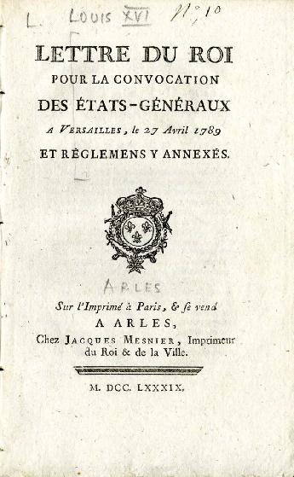
“This excerpt from Women in the French Revolution suggests one reason why women in France might have felt that revolution was necessary: ‘Your Highness, our latest troubles should be attributed to the high cost of bread.’ And this is plain to see: at that time, Paris harbored more than 70,000 people without work, and a 4-pound loaf of bread cost 12 sous [an amount of money] on 8 November 1788, 13 sous on the 13 sous on the 28th, 14 sous on 11 December, and 14.5 sous in February 1789. It remained at this price until the fall of the Bastille. A worker earned between 18 and 20, a woman between 10 and 15 sous a day. The price of bread was the women’s main demand; for, despite token decreases of 1, then 2 sous, a loaf of bread cost between 40 to 80% of a woman’s wages.”

How would the conditions described above contribute to unrest in France?

Bessieres, Y., & Niedzwiecki, P. (1991). Women in the French Revolution (Vol. 33). Commission of the European Communities. http://aei.pitt.edu/34003/1/A480.pdf

Three Estates’ Social Structure
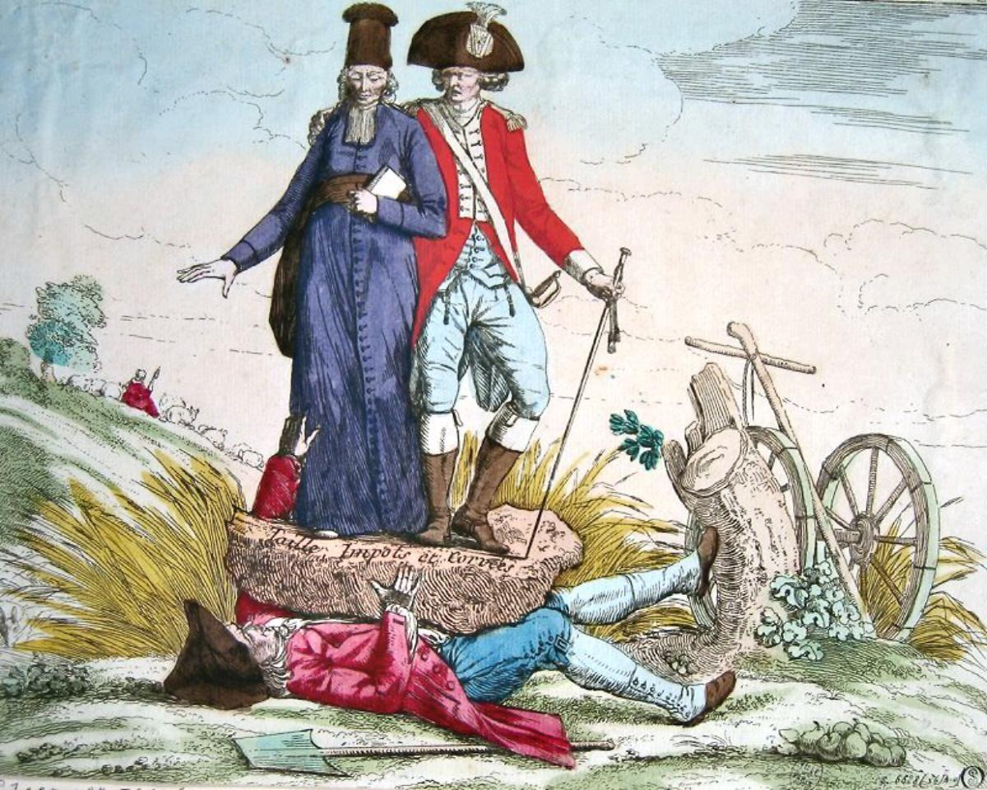
A member of the First and Second Estates stands on a rock that is holding down a member of the Third Estate. The inscription on the rock says “Taille Impôts et Corvées,” which translates to “Cut Taxes and Labor.”

What is happening to the person that represents the Third Estate? What is the message the artist is trying to convey?

AAD Reports. (2018 December). Crushing taxes en France on the third estate. Art Antiques Design. https://www.art-antiques-design.com/european/1716-crushing-taxes-en-france-on-the-third-estate

France’s Three Estates
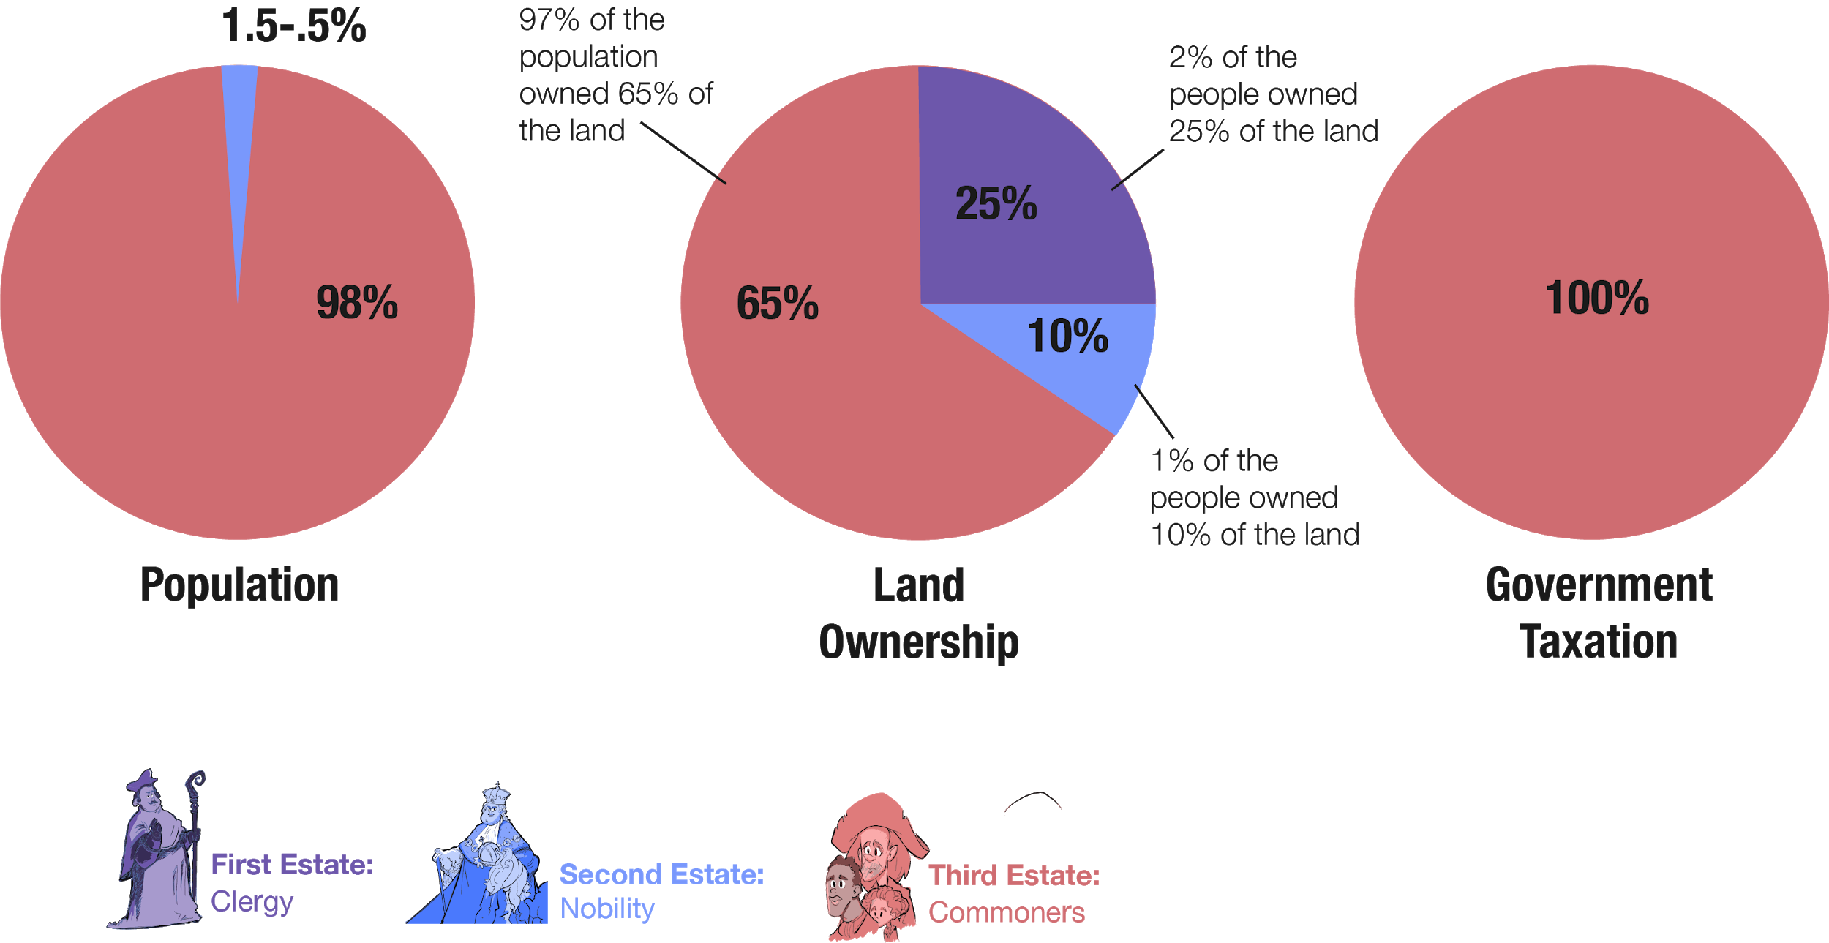

The chart above illustrates the way French society was structured prior to the revolution. How could the way taxes were paid and the way land was owned lead to unrest?

