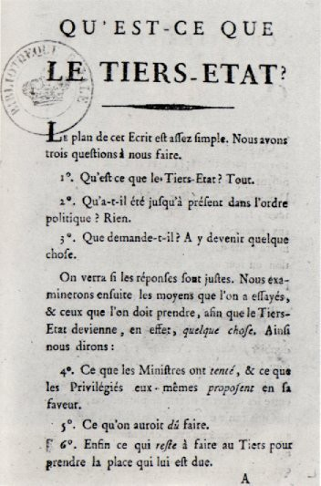
pre-revolution documents

What is the Third Estate?
Emmanuel Sieyès was a member of the Second Estate. He wrote a pamphlet called “What is the Third Estate?” to bring attention to the issues facing those within most of France’s population. He believed that the Third Estate deserved political representation because it was responsible for most of the labor in France and represented the biggest portion of the population. Sieyès asked three questions in his writing:

“What is the Third Estate? Everything.

What has it been heretofore in the political order? Nothing.

What does it demand? To become something.”

Sieyès’ pamphlet helped the Third Estate form their demands for greater political representation. When the estates met to decide on issues such as taxation, each estate would get one vote. The First and Second Estates voted together, overruling the Third Estate’s single vote. The Third Estate represented about 98% of France’s population and wanted to vote based on the percentage of the population instead of each estate receiving one vote.

How would Emmanuel Sieyès’ writing influence the people of the Third Estate to demand change? What is the importance of Sieyès' status as a member of the Second Estate?

The Price of Bread
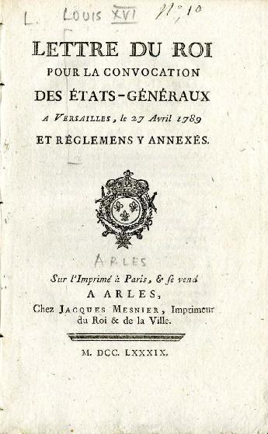
This excerpt from Women in the French Revolution suggests one reason why women in France might have felt that revolution was necessary: “Your Highness, our latest troubles should be attributed to the high cost of bread.” This was an obvious observation. On November 8, 1788, Paris harbored more than 70,000 people without work, and a four-pound loaf of bread cost 12 sous [an amount of money]. The same loaf of bread would cost 13 sous on November 28, 14 sous on December 11, and 14.5 sous in February 1789. The average worker earned between 18 and 20 sous per day, and a woman earned less, typically between 10 and 15 sous a day. The price of bread was the women’s main demand; a loaf of bread cost between 40 to 80% of a woman’s wages.

How would the conditions described above contribute to unrest in France?

Influence of the Enlightenment
“If we enquire wherein lies precisely the greatest good of all, which ought to be the good of every system of law, we shall find that it comes down to two main objects, freedom and equality…” Jean-Jacques Rousseau, The Social Contract (1763)
“The state of nature has a law of nature to govern it... which is that law teaches all mankind... that being all equal and independent, no one ought to harm another in his life, health, liberty, or possessions...” John Locke, Two Treatises of Government (1690)

The Enlightenment challenged traditional views on government and human rights through the work of philosophers like Locke and Rousseau. How did these ideas drive French citizens to demand political change?

Three Estates’ Social Structure

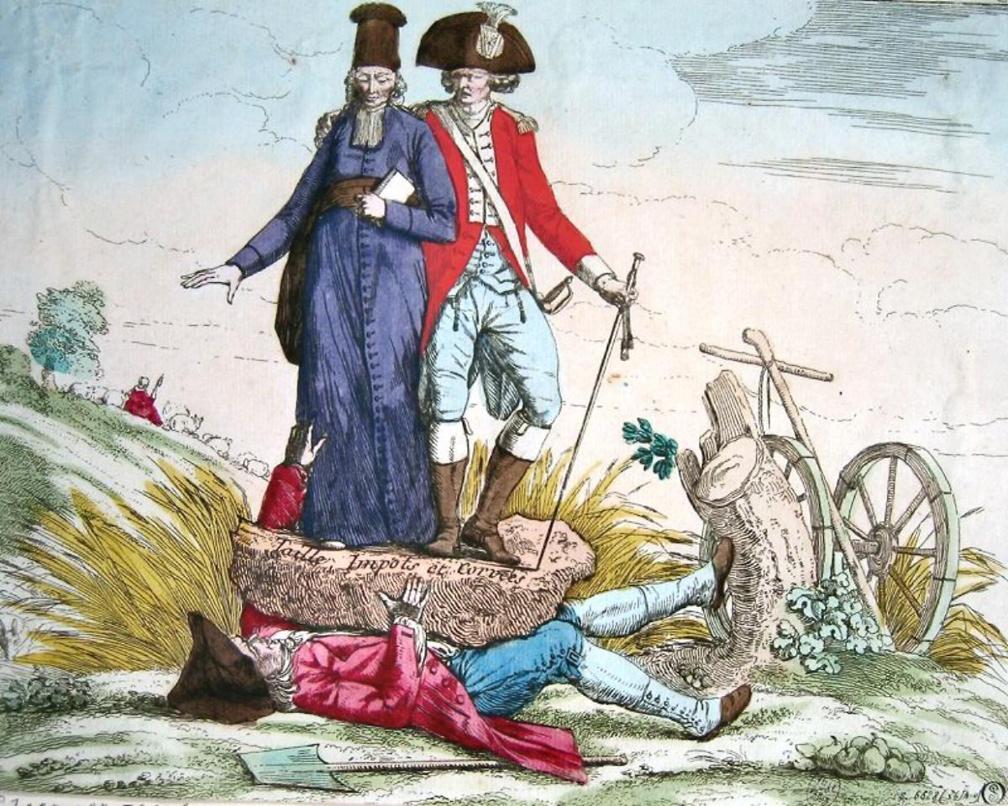
A member of the each of the First and Second Estates are on top of the rock, with a member of the Third estate under it. On the rock it says “Taille Impôts et Corvées,” which translates to “Cut Taxes and Labor.”

What is the message the artist is trying to convey?

Sources

Sieyès, E. (1789). What is the third estate? Encyclopedia Britannica. https://www.britannica.com/topic/What-Is-the-Third-Estate

Rousseau, J.-J., & In Frankel, C. (1947). The social contract. New York: Hafner Publishing Co.

Locke, J., & Laslett, P. (1988). Two treatises of government. England: Cambridge University Press.

Bessieres, Y., & Niedzwiecki, P. (1991). Women in the French Revolution (Vol. 33). Commission of the European Communities. http://aei.pitt.edu/34003/1/A480.pdf

AAD Reports. (2018, December). Crushing taxes en France on the third estate. Art Antiques Design. https://www.art-antiques-design.com/european/1716-crushing-taxes-en-france-on-the-third-estate

