Ada Lois Sipuel Fisher

Secondary Source: “Fisher, Ada Lois, Sipuel (1924-1995)”

By Melvin C. Hall
Oklahoma Civil Rights activist Ada Lois Sipuel was born February 8, 1924, in Chickasha, Oklahoma. An excellent student, she graduated from Lincoln High School in 1941 as valedictorian. Initially, she enrolled in Arkansas A&M College at Pine Bluff. After one year she transferred to Langston University in September 1942, and she majored in English and dreamed of being a lawyer. On March 3, 1944, she married Warren Fisher. On May 21, 1945, Ada Lois Sipuel Fisher graduated from Langston University with honors.
Even in education, Oklahoma was segregated. Langston University did not have a law school, and state statutes prohibited blacks from attending white state universities. Instead, Oklahoma provided funding whereby they could go outside the state of Oklahoma and attend law schools and graduate schools that accepted blacks. At the urging of the National Association for the Advancement of Colored People (NAACP) twenty-one-year-old Fisher agreed to seek admission to the University of Oklahoma's law school in order to challenge Oklahoma's segregation laws and achieve her lifelong ambition of becoming a lawyer.
On January 14, 1946, she applied for admission to the University of Oklahoma College of Law. After reviewing Fisher's credentials, the university's president, Dr. George Lynn Cross, advised her that there was no academic reason to reject her application for admission, but that Oklahoma statutes prohibited whites and blacks from attending classes together. The laws also made it a misdemeanor to instruct or attend classes comprised of mixed races. Cross would have been fined up to fifty dollars a day, and the white students who attended class with her would have been fined up to twenty dollars a day.
On April 6, 1946, with the support of civic leaders from across the state, Ada Lois Sipuel Fisher filed a lawsuit in the Cleveland County District Court, prompting a three-year legal battle. A young attorney, Thurgood Marshall, later a U.S. Supreme Court Justice, represented Fisher. She lost her case in the county district court and appealed to the Oklahoma Supreme Court. It sustained the ruling of the lower court, finding that the state's policy of segregating whites and blacks in education did not violate the United States Constitution.
After an unfavorable ruling from the Oklahoma Supreme Court, Fisher filed an appeal with the U.S. Supreme Court. On January 12, 1948, the nation's highest tribunal ruled in Sipuel v. Board of Regents of the University of Oklahoma that Oklahoma must provide Fisher with the same opportunities for securing a legal education as it provided to other citizens of Oklahoma. The case was remanded to the Cleveland County District Court to carry out the ruling. Following the Court's favorable ruling, the Oklahoma Legislature, rather than admit Fisher to the Oklahoma University law school or close the law school to students both black and white, decided to create a separate law school exclusively for her to attend. The new school, named Langston University School of Law, was thrown together in five days and was set up in the State Capitol's Senate rooms. Ada Lois Sipuel Fisher refused to attend Langston University School of Law, and on March 15, 1948, her lawyers filed a motion in the Cleveland County District Court contending that Langston's law school did not afford the advantages of a legal education to blacks substantially equal to the education whites received at OU's law school. This inequality, they argued, entitled Fisher to be admitted to the University of Oklahoma College of Law. However, the Cleveland court ruled against her, finding that the two state law schools were "equal." The Oklahoma Supreme Court, predictably, upheld the finding.
After this second adverse ruling Fisher's lawyers announced their intention to again appeal to the U.S. Supreme Court. However, Oklahoma Attorney General Mac Q. Williamson declined to return to Washington, D.C., and face the same nine Supreme Court justices in order to argue that Langston's law school was equal to OU's law school. As a result of this concession, on June 18, 1949, more than three years after Ada Lois Sipuel Fisher first applied for admission to the University of Oklahoma College of Law, she was admitted. Langston University's law school closed twelve days later.
Although Fisher was generally welcomed by her white classmates, she was forced to sit in the back of the room behind a row of empty seats and a wooden railing with a sign designated "colored." All black students enrolled at the University of Oklahoma were provided separate eating facilities and restrooms, separate reading sections in the library, and roped-off stadium seats at the football games. These conditions persisted through 1950.
However, the end of segregation in higher education had already begun. In 1948 a group of six black Oklahomans applied to University of Oklahoma's graduate schools in disciplines ranging from zoology to social work. All were denied admission under the same statute that denied admission to Fisher. Thurgood Marshall selected one of the six students, George W. McLaurin, to present yet another challenge to segregation in higher education. In a June 5, 1950, U.S. Supreme Court decision in the case of McLaurin v. Oklahoma State Regents, the Court ruled that the restrictions of segregation imposed on McLaurin at OU impaired and inhibited his ability to study. The decision meant that blacks could no longer be segregated at OU and could now be admitted to graduate schools at all state-supported colleges and universities in the nation. The state soon realized that it could not create separate graduate programs for blacks similar to the sham law school it had quickly invented for Ada Lois Sipuel Fisher.
In August 1952 Fisher graduated from the University of Oklahoma College of Law. She earned a master's degree in history from the University of Oklahoma in 1968. After briefly practicing law
in Chickasha, Fisher joined the faculty of Langston University in 1957 and served as chair of the Department of Social Sciences. She retired in December 1987 as assistant vice president for academic affairs. In 1991 the University of Oklahoma awarded Fisher an honorary doctorate of humane letters.
On April 22, 1992, Gov. David Walters symbolically righted the wrongs of the past by appointing Dr. Ada Lois Sipuel Fisher to the Board of Regents of the University of Oklahoma, the same school that had once refused to admit her to its College of Law. As the governor said during the ceremony, it was a "completed cycle." The lady who was once rejected by the university was now a member of its governing board.
On October 18, 1995, Dr. Ada Lois Sipuel Fisher died. In her honor the University of Oklahoma subsequently dedicated the Ada Lois Sipuel Fisher Garden on the Norman campus. At the bottom of a bronze plaque commemorating Fisher's contribution to the state of Oklahoma, an inscription reads, "In Psalm 118, the psalmist speaks of how the stone that the builders once rejected becomes the cornerstone."
Source: Hall, M.C. (n.d.). Fisher, Ada Lois Sipuel (1924-1995). Oklahoma Historical Society. https://www.okhistory.org/publications/enc/entry.php?entry=FI009. Reprinted with permission.

Primary Source: Excerpts from A Matter of Black and White: The Autobiography of Ada Lois Sipuel Fisher
Mr. Dunjee [a renowned civil rights activist and journalist] was easy to meet. Dr. Bullock [the NAACP regional director] introduced me as the young lady about whom he had called. Dunjee smiled in recognition. He remembered me as one of the Langston students he had met with earlier, the ones that were so upset about the red mud. We sat down and exchanged the usual small talk. Bullock handed Dunjee my transcripts. He examined them carefully and smiled. The doctor told Dunjee that my father was a minister; in fact, he was state bishop of the Churches of God in Christ of Oklahoma. Dunjee asked about my husband, and I told him about Warren, who was overseas in the military, but who stood ready to give his full support. Both men agreed it was good that my father and husband were insulated from economic pressure. They were also aware that being a minister’s daughter would attract support from churches of all denominations.
Dunjee usually assumed a certain posture when he was in deep thought. He would lean his chair back, clasp his hands behind his head, and look toward the ceiling. In that posture he told me that the struggle would be long, expensive, and possibly bitter. Did I have the necessary coverage and patience? Could I remain poised under duress and pressure? Was I available to make speaking appearances to help raise money to carry on the litigation?
Yes. Yes. Oh, yes. […]
About a week after the interview, Bullock called. I was not at home, so he gave the message to Mother. I had been selected. When I walked in the door, Lemuel [Ada's brother] and Mother were all smiles as they gave me the good news. After a happy family celebration, I got on the phone to spread the word around the community. Persons who were active in the local chapter of the NAACP gave me their excited congratulations and encouragement. [...]
African Americans have traditionally been subjected to prejudice and bigotry. We have been stereotyped as Aunt Jemima, Sapphire, Uncle Tom, and Sambo. We have sat at the back of buses and up front in curtained-off cubbyholes on trains. We have climbed stairs to the balcony in theaters. “Whites only” water fountains and restrooms were everywhere. We have cleaned, cooked, and entertained in clubs and restaurants in which we could not be served. We were relegated to lowest-level and lowest paid jobs; last hired, first fired. We fought to defend our country and make the world safe for democracy in a segregated army. We traded in stores that in some places did not permit us to try on the dresses and hats we were purchasing.
I have tried to decide what racist action or situation over the years I have felt most acutely. There have been many, and all of them have hurt. Hate always hurts. I think perhaps walking past my classmates in the law school classroom and climbing the levels up to the “colored” chair was the most humiliating. I was finally there, enrolled as a student along with some one hundred other first-year law students. We all were young American citizens with at least a bachelor’s degree. We all had met qualifications for admission, and we were there solely for the purpose of studying the law. I, however, was considered so different that I must sit apart from my peers. As I climbed the levels and rows of seats, I realized that all eyes were on me. What were they thinking? Was I walking erect and maintaining a calm demeanor? I must show no emotion. I had to be careful not to stumble. As I ascended the levels to my chair, I wondered why that particular experience was worse than others.
Maybe it was the aloneness, knowing the arrangement was directed toward one person: me. Would it have been less traumatic if several blacks were along with me? I doubt it. The basic reason for my despair was the fact that this discriminatory arrangement was not the act of one or a few “rednecks” or a few bigoted people. On the contrary, it represented the laws and public policy of the state. It was designed and implemented by the government of the state of Oklahoma. My state had resorted to this ridiculous scheme. […]
Source: Fisher, A. L. S. (1996). A matter of black and white: The autobiography of Ada Lois Sipuel Fisher. Norman, Okla.: University of Oklahoma Press. Reprinted with permission.

Primary Source: “Additional Instructions with Respect to Facilities Available to Colored Students”

LIBRARY FACILITIES:
A special room, just off the main reading room of the University Library, Reserve Room #201 has been reserved for members of the colored race. Reservation signs have been placed on the library tables.
Please report to Mr. J. L. Rader, Librarian, for instruction with respect to the use of the main library facilities.

EATING FACILITIES:
The Jug, located on the second floor of the Union Building, is reserved daily from 12:00 to 1:00 p.m. for lunch for colored students, both men and women.
During the day, special tables in the north end of the Jug are reserved, and so marked, for colored students. The Jug serves coffee, tea, coca-cola, sandwiches and other snacks between the hours of 7:30 a.m. and 12:00 noon, Monday through Friday (the Jug is not open on Saturday during the summer).

REST ROOM FACILITIES: (Reserved and so marked in the following buildings)
Colored Men Colored Women
Education 1st floor 1st and 3rd floors
University Library 1st floor 1st floor
Kaufman Hall 2nd floor 2nd floor
Liberal Arts 1st floor 2nd floor
Holmberg Hall -- 1st floor
Carl Mason Franklin
Executive Vice President
Source: Franklin, C.M. (C. 1948). Additional instructions with respect to facilities available to colored students. Courtesy of University Archives Vertical File: Desegregation. Western History Collections, University of Oklahoma Libraries.

Photograph: Ada Lois Sipuel Fisher meeting with OU President George Lynn Cross
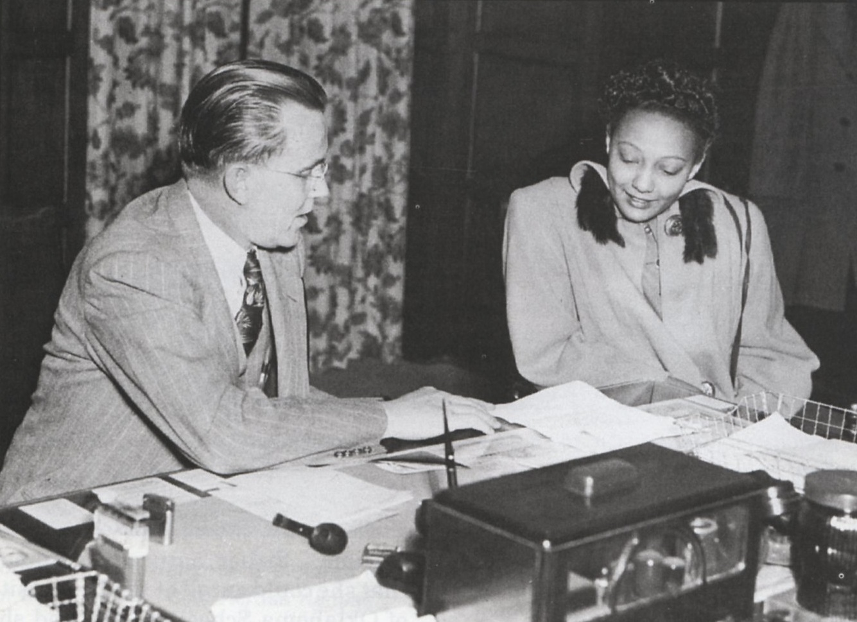
Photo of Ada Lois Sipuel Fisher meeting with OU President George Lynn Cross. (1948). Courtesy of Oklahoma Hall of Fame Archives, Oklahoma Hall of Fame at the Gaylord-Pickens Museum, Oklahoma City, OK.

