Clara Luper

Secondary Source: “Luper, Clara Shepard (1923-2011)”

By Stefanie Lee Decker
Educator and Civil Rights Leader Clara Shepard Luper was born in Okfuskee County, Oklahoma. The daughter of Ezell and Isabell Shepard, she married Charles P. Wilson and had three children, Calvin, Marilyn Luper Hildreth, and Chelle Marie. In 1944 Luper received a bachelor’s degree from Langston University. She later attained a master’s degree from the University of Oklahoma in 1951 and was the first African American admitted to the graduate history program in the University of Oklahoma. Luper taught history and public relations at Dunjee High School in Spencer, Oklahoma, and at John Marshall and Classen High Schools in Oklahoma City. While teaching, Luper wrote, directed, and produced Brother President, a play based on the life of Martin Luther King, Jr.
Luper became the advisor for the Oklahoma City National Association for the Advancement of Colored People (NAACP) Youth Council in 1957. The following year the Youth Council decided to stage a “sit-in” at Oklahoma City’s Katz drugstore. On August 19, 1958, walking into the store and ordering Cokes, the youth, under Luper’s guidance, demonstrated their discontent with segregation and launched the nation’s sit-in movement. The Youth Council continued to conduct sit-ins throughout the early 1960s, helping to end segregation in public accommodations in Oklahoma. Maintaining her adherence to nonviolence, Luper participated in marches and demonstrations and was often jailed in her Civil Rights struggle.
From 1960 to 1980 Luper hosted her own radio show, and she chronicled her fight for Civil Rights in her autobiography, Behold the Walls. A member of the Zeta Phi Beta sorority, the Oklahoma Education Association, and the National Education Association, Luper received 154 awards, including the Langston Alumni Award, Zeta Phi Beta Woman of the Year Award, the Oklahoma Confederated Women’s Club Award, and the National Voter Registration Award. She died on June 8, 2011, in Oklahoma City.
Source: Decker, S.L. (n.d.). Luper, Clara Shepard (1923-2011). Oklahoma Historical Society. https://www.okhistory.org/publications/enc/entry.php?entry=LU005. Reprinted with permission.

Primary Source: Excerpts from Behold the Walls, The Autobiography of Clara Luper
For over a year, the four strategic steps in non-violence had been used and had been reviewed over and over again.
The steps were investigation, negotiation, education and demonstration. Investigation: Get the facts. Make sure that an injustice had been done. A non-violent approach will fail if it is based on false or shaky assumptions. Negotiation: go to your opponent and put the case directly to him. It could be that a solution could be worked out and that there could be a grievance that we didn’t know about. Let the opponent know that you are going to stand firm in order that you’ll be ready to negotiate anywhere and anytime. Education: Make sure that the group is well informed on the issues and that men have always hated change, yet change must come. Demonstration: This is the final step only to be taken when all others have failed. Non-violent demonstration calls for discipline that is firm. Every provocation must be answered with continued good will. You must be ready for self-sacrifice that will leave no doubt as to your integrity, your dignity and your self-respect. Suffering is a part of the non-violent approach. It is to be endured, never inflicted. This approach will give you the moral victory upon which the eternal struggle for Freedom, Justice, and Equality can be won. […]
Lana Pogue, the six-year-old daughter of Mr. and Mrs. Louis J. Pogue, grabbed my hand; and, we moved toward the counter. All of my life, I had wanted to sit at “those counters and drink a Coke or a Seven-Up.” It really didn’t matter which, but I had been taught that those seats were for “whites only.” Blacks were to sweep around the seats, and keep them clean so whites could sit down. It didn’t make any difference what kind of white person it was, thief, rapist, murderer, uneducated; the only requirement was that he or she be white. Unbathed, unshaven—it just didn’t make any difference. Nor did it make any difference what kind of black you were, B.A. Degree black, Dr. Black, Attorney black, Rev. Black, M.A. Black, Ph.D. Black, rich Black, poor Black, young Black, old Black, pretty Black, ugly Black; you were not to sit down at any lunch counter to eat. We were all seated now in the “for whites only territory.” The waitress suffered a quick psychological stroke and one said in a mean tone, “What do you all want?”
Barbara Posey spoke, “We’d like thirteen Cokes please.”
“You may have them to go,” the waitress nervously said.
“We’ll drink them here,” Barbara said as she placed a five dollar bill on the counter. The waitress nervously called for additional help.
Mr. Masoner, the red, frightened-faced manager, rushed over to me as if he were going to slap me and said, “Mrs. Luper, you know better than this. You know we don’t serve colored folks at the counter.”
I remained silent and looked him straight in the eyes as he nervously continued. “I don’t see what’s wrong with you colored folks—Mrs. Luper, you take these children out of here—this moment! This moment, I say.” He yelled, “Did you hear me?”
“Thirteen Cokes please,” I said.
“Mrs. Luper, if you don’t move these colored children, what do you think my white customers will say? You know better, Clara. I don’t blame the children! I blame you. You are just a trouble maker.”
He turned and rushed to the telephone and called the police. In a matter of minutes, we were surrounded by policemen of all sizes, with all kinds of facial expressions. The sergeant and the manager had a conference; additional conferences were called as different ranks of policemen entered. Their faces portrayed their feelings of resentment. The press arrived and I recognized Leonard Hanstein of Channel 9 with his camera and I sat silently as they threw him out and a whole crew of cameramen.
The whites that were seated at the counter got up, leaving their food unfinished on the table and emptied their hate terms into the air. Things such as “[N-word] go home, who do they think they are? The nerve!” One man walked straight up to me and said, “Move, you black S.O.B.” Others bent over to cough in my face and in the faces of the children. Linda Pogue was knocked off a seat, she smiled and sat back on the stool. Profanity flowed evenly and forcefully from the crowd. One elderly lady rushed over to me as fast as she could with her walking cane in her hand and yelled, “The nerve of the [N-word] trying to eat in our places. Who does Clara Luper think she is? She is nothing but a damned fool, the black thing.”
I started to walk over and tell her that I was one of God’s children and He had made me in His own image and if she didn’t like how I looked, she was filing her complaint in the wrong department. She’d have to file it with the Creator. I’m the end product of His Creation and not the maker. Then, I realized her intellectual limitations and continued to watch the puzzled policemen and the frightened manager.
Tensions were building up as racial slurs continued to be thrown at us. Hamburgers, Cokes, malts, etc. remained in place as pushing, cursing, and [N-word], became the “order of the day.”
As the news media attempted to interview us, the hostile crowd increased in number. Never before had I seen so many hostile, hard, hate-filled white faces. Lana, the six-year-old, said, “Why do they look so mean?”
I said, “Lana, their faces are as cold as Alaskan icicles.” […]
My daughter, Marilyn, walked over and pointed out a big, fat, mean-looking, white man, who walked over to me and said, “I can’t understand it. You all didn’t use to act this way; you all use to be so nice.”
We remained silent and as he bumped into me, the police officers told him that he had to move on. An old white woman walked up to me and said, “If you don’t get those little old poor ugly-looking children out of here, we are going to have a race riot. You just want to start some trouble.” I remained silent. “Don’t you know about the Tulsa race riots?” the woman asked.
I moved down to the south end of the counter, then back to the other end. This was repeated over and over. As I passed by Alma Faye Posey she burst out laughing and when I continued to look at her, she put her hands on the counter and pointed to a picture of a banana split.
It had been a long evening. Barbara, Gwen and I had a quick conference and we decided to leave without cracking a dent in the wall. Mr. Portwood Williams, Mrs. Lillian Oliver and Mrs. Mary Pogue were waiting. We loaded in our cars and left the hecklers, heckling.
We passed our first test. They pushed us, called us [the N-word] and did everything, the group said. […]
It was not easy to make plans for the next day because of the large number of obscene telephone calls and threats that I was receiving. The call that really caught me unexpectedly came from a black man who would not tell me his name, but he told me how good the white folks had been to him and I was disgracing my race by taking those poor innocent children downtown.
“Sir, do you have any recommendation on what we can do to eat downtown?”
He said, “No, I do not.”
Then I said, “I have one for you sir.”
“Okay.”
I said, “Sir, since the white folks are so good to you, where do you urinate when you are dressed up in your fine suit downtown?”
He said, “I take my can with me.”
“Then, sir, I feel that it is time for you to go and empty your can.”
Another black caller said that she was so embarrassed that she could hardly hold her head up. One black lady said she was working out in Nichols Hills and the lady told her to look and see what those people were doing. “Do you know them?” She said that she said no. She continued to do her work and when she got home she called me and I had never talked to my friend when she was in such a state of fright.
To my surprise, my mother and Mary Pogue came up to the house and explained to me all the dangers that I had gotten “all of us in.” Mary had taken us downtown, but she said, “Oh! It was awful. Those people mean business. You should have heard the things that they were saying about you.” The conversation continued and finally they went home.
Source: Luper, C. (1979). Behold the walls. Oklahoma City: Jim Wire.

Photograph: Greensboro Plaque
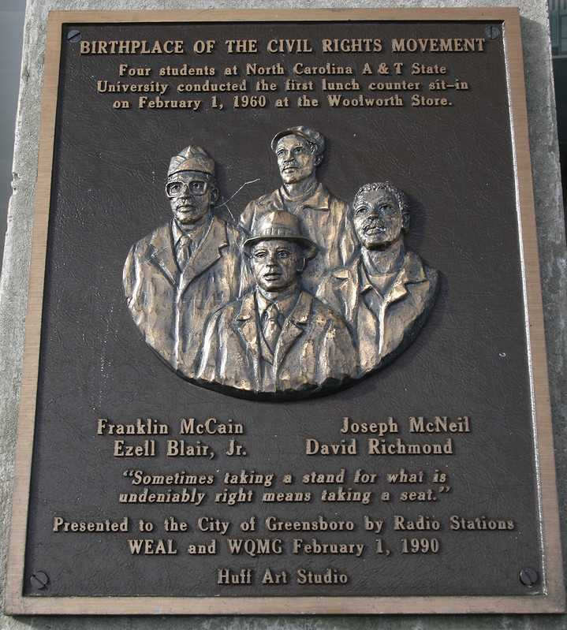
King, D. B. (2008, Nov. 28). Photo of Greensboro plaque. Flickr. https://www.flickr.com/photos/bootbearwdc/3069248769

Photograph: Katz Drug Store Sit-In
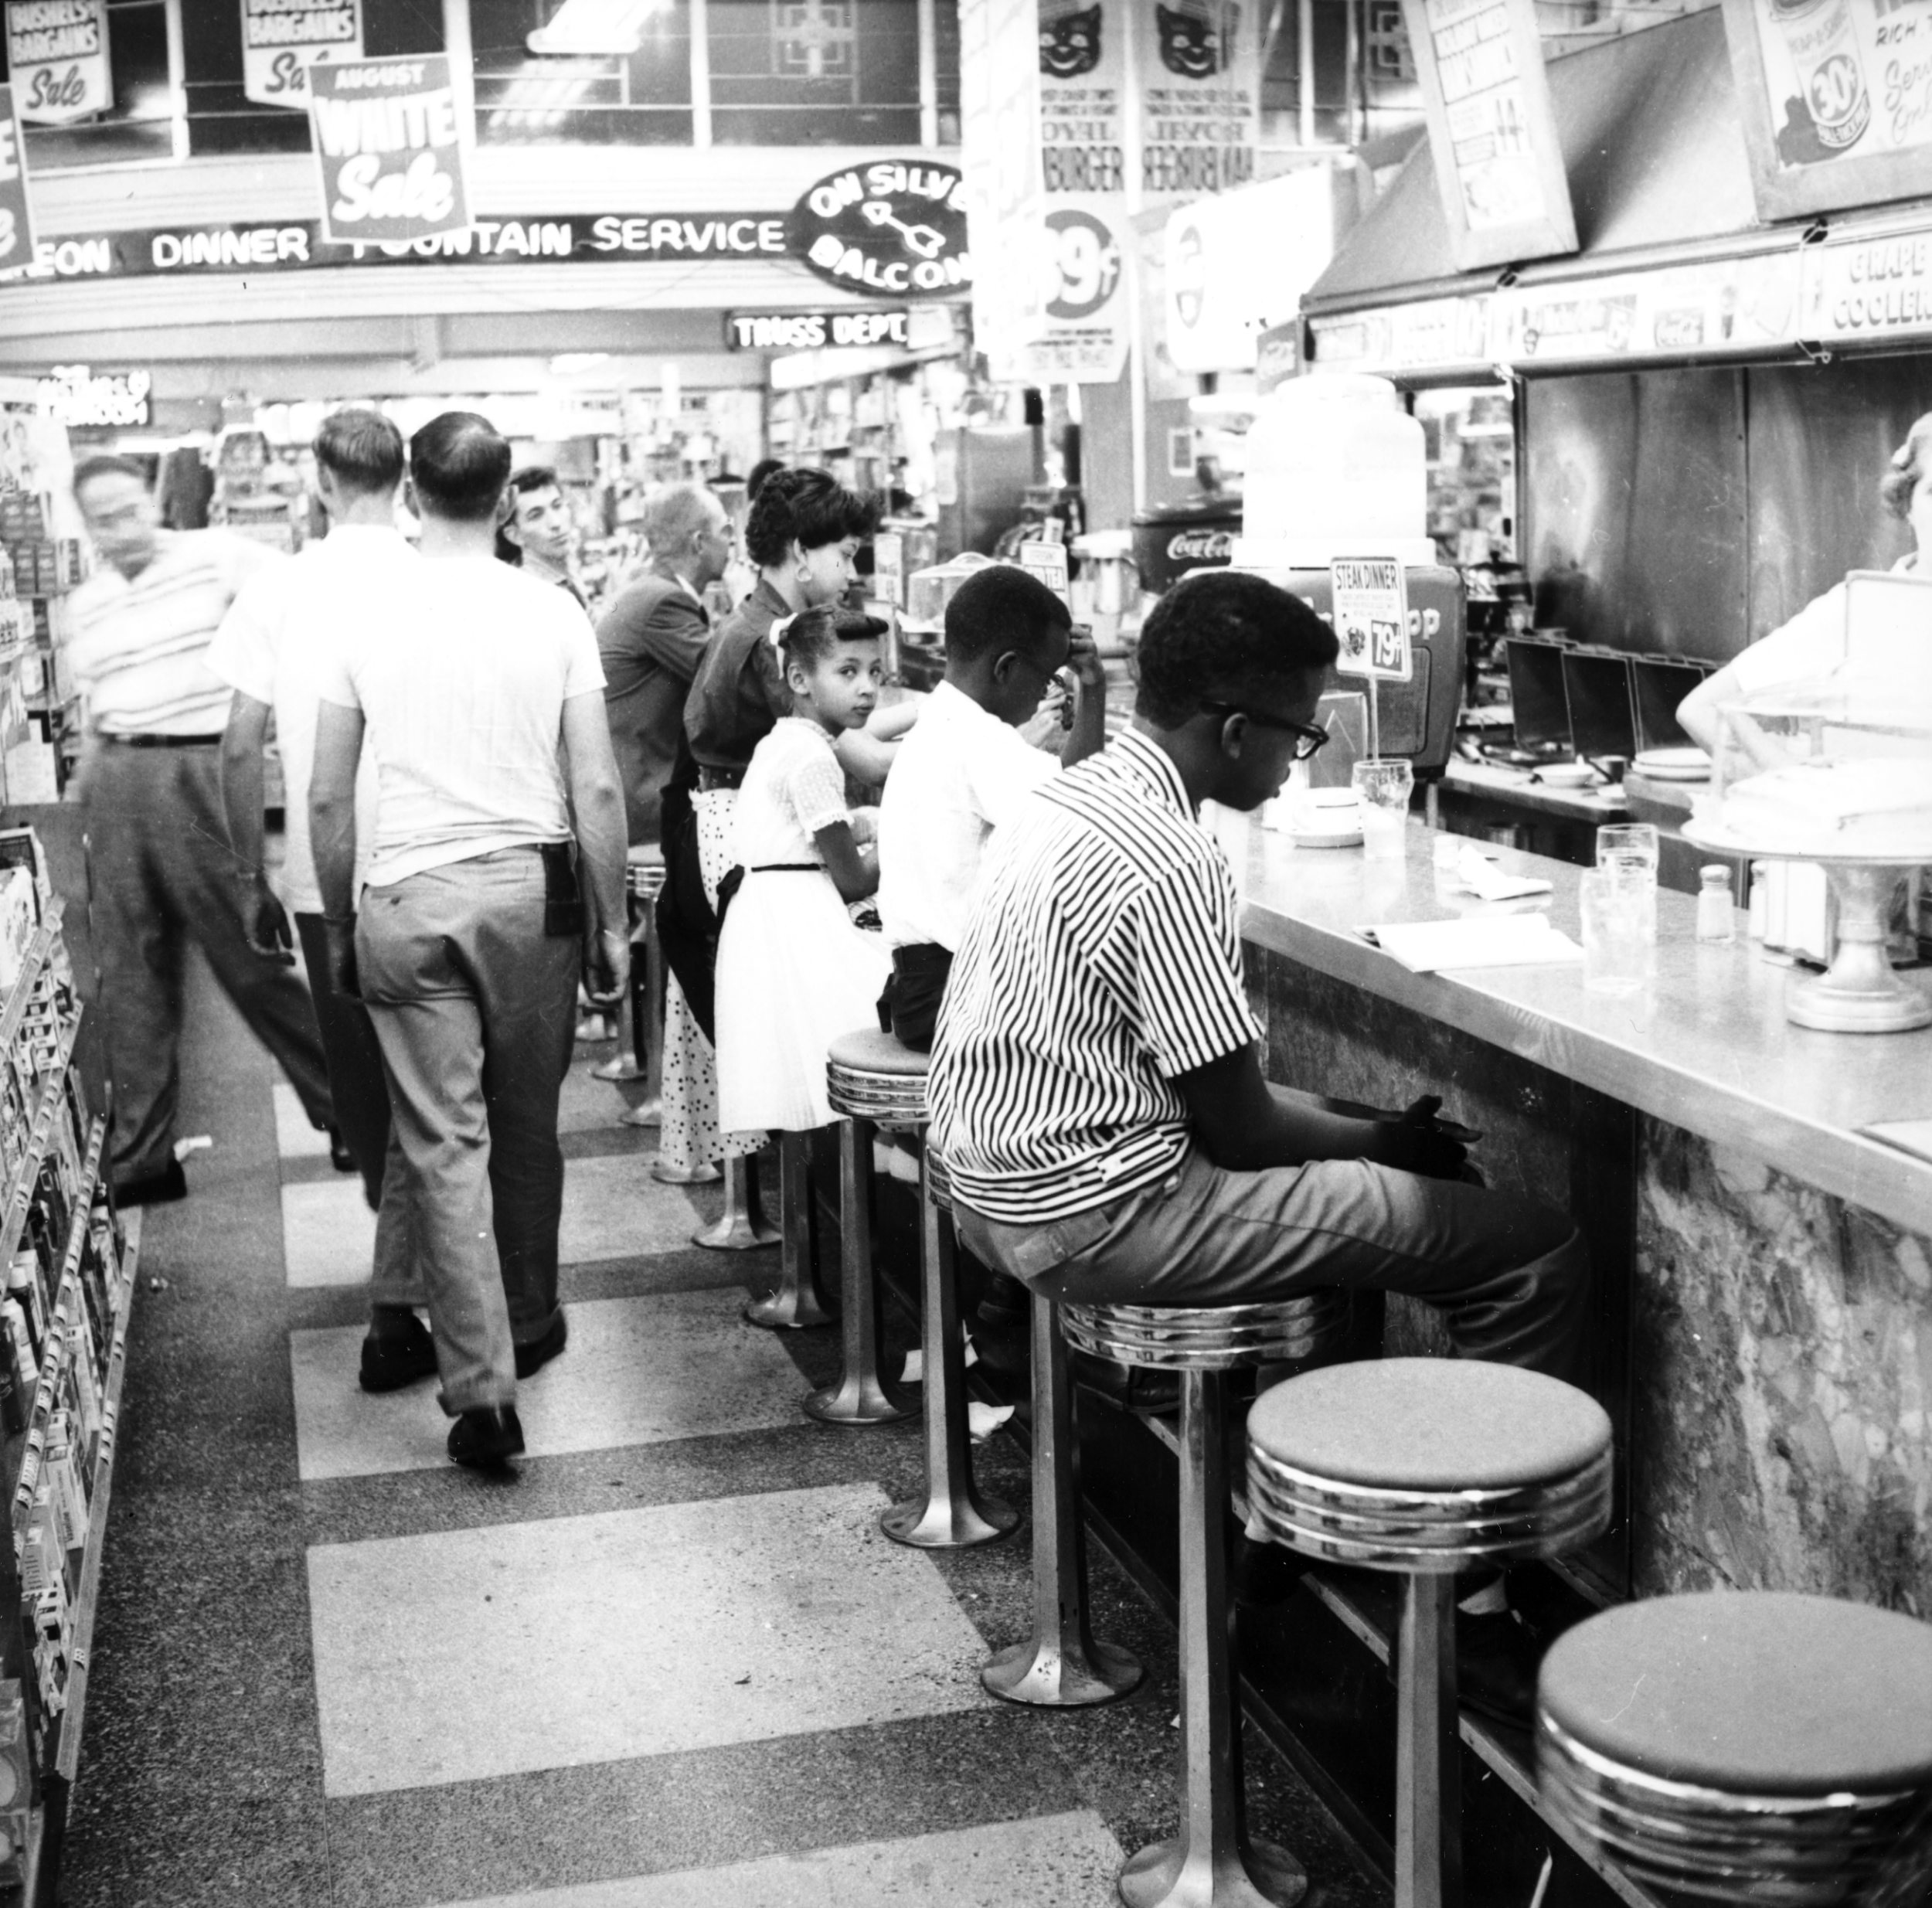
Melton, J. (1958, Aug. 26). Photo of a group at Katz Drug, 200 W Main, Oklahoma City, OK, during an African American Civil Rights protest. From the John Melton Collection. Courtesy of the Oklahoma Historical Society, 20246.38.395.T.

