George McLaurin

Secondary Source: “Separate and Unequal”

By Emma Keith
One in 12,174.
That’s what George McLaurin became Oct. 14, 1948, when he began classes at OU: drifting alone, one dark face in a sea of 12,173 white ones.
Oct. 14 was a hopeful moment for McLaurin, the first black student at a previously all-white institution.
“This is a happy day in my life,” he told Sooner Magazine. “If things continue the way they have gone today, I think everything is going to be all right.”
McLaurin fought for admission to OU leading up to that day — when he first applied earlier in 1948, he was denied based on his race. McLaurin went to court with the issue, and in a Sept. 29, 1948 verdict, he was victorious when a federal court ruled that denying him admission was unconstitutional.
The Oklahoma State Regents ordered his admission Oct. 11, 1948, but with this victory, McLaurin was still far from an integrated education — his case was still to undergo another appeal that would not grant him that victory until 1950.
While McLaurin’s exclusion from OU was deemed unconstitutional, segregation at OU was still lawful. Thus, his education at OU was separate and unequal — he learned in a closet looking out over the room where his white classmates sat; he dined at separate tables at separate times; he used a different table in the library to study.
McLaurin, a doctoral student at OU’s College of Education, was not new to the struggles of segregation — at the time he began classes, he was about 61 years old, by the estimates of OU historian David Levy (though Levy said there is contention over McLaurin’s exact age at that point). He had already earned his master’s in education from the University of Kansas and taught at Langston University, Oklahoma’s historically all-black institution, for 33 years. […]
In 1946, a young black student named Ada Lois Sipuel Fisher applied to OU’s all-white law school and was rejected on the basis of race. Sipuel Fisher’s case was taken up by the NAACP in a case headed by Thurgood Marshall (who later became the first African-American Supreme Court justice), but it did not successfully make it through the Supreme Court until 1948.
Although she would not be admitted to OU’s School of Law until 1949, Sipuel Fisher’s case set the precedent for McLaurin’s admission to OU — she won her court case in January 1948, while his first case and the start of his education at the institution took place in September and October of that year.
McLaurin soon followed in Sipuel Fisher’s footsteps when he and the NAACP joined forces to dismantle segregation at OU in 1949.
While there were other black students attempting to challenge segregation at OU (more black students joined McLaurin later in the 1948-1949 school year), the NAACP chose McLaurin to represent its cause “because he was old and married and dignified and always in a suit and tie,” Levy said. McLaurin mitigated racist arguments that black men were attempting to access college campuses to prey on white women.
While McLaurin’s first attempts to challenge discrimination were denied at the state level by the Oklahoma District Court, Marshall brought McLaurin’s case out of the state system and, eventually, up to the Supreme Court.
In McLaurin’s case, the NAACP was attempting a different strategy toward approaching segregation, Levy said. It wanted McLaurin’s case to make clear that although OU might claim to provide “separate but equal” accommodations for black students, education under segregation would never truly be equal — the physical, mental and social restraints of segregation would always hold black students back.
“They made the usual argument, that McLaurin was not being treated equally… but they decided, for the knockout punch, that they wanted the high court to rule that segregation, even when facilities are substantially equal, was unconstitutional,” Levy said.
McLaurin’s case worked in conjunction with another NAACP case at the University of Texas, Sweatt v. Painter, that was attempting to desegregate UT’s law school while proving segregation could never provide equal opportunities for black students. Sweatt’s case, also to be seen before the Supreme Court, would be decided the same day as McLaurin’s.
The reality of McLaurin’s initial victory in admittance to OU was not met with complete hostility on campus. Surveys at the time of McLaurin’s entrance to OU found most students favored admittance of black students but not necessarily desegregation, Levy said.
“On campus, there was substantial support for integration,” Levy said. “There were some surveys done — none of them terribly scientifically — but in general, the results seemed to be that probably more than half the students favored admitting blacks.”
While he certainly faced opposition at OU, McLaurin’s segregation was not necessarily OU’s choice. Administrators caught fostering a desegregated learning environment could be fined up to $100 by the state and charged with a separate crime each day they allowed the situation to continue, Levy said. Teachers and students faced a $50 and a $20 fine, respectively, as well as daily charges for allowing the same situation.
OU’s president at the time, George Lynn Cross, most certainly supported desegregation and was known as an ally to the NAACP, Levy said.
“I knew Cross quite well, and there’s no doubt that he favored integration,” Levy said.
McLaurin’s other support system came from his family, in which he was not the only trailblazer in education. In fact, his wife, Peninah McLaurin, attempted to gain entrance to OU more than 20 years before he did, in 1923, according to her obituary from The Oklahoman.
While denied that opportunity, Peninah McLaurin’s obituary describes her as the “guiding force” behind her husband’s eventual push for equality at OU, and “part of a husband-wife team credited with overcoming segregation in Oklahoma’s higher education with a Supreme Court ruling.”
Regardless of the forces that upheld him through it, McLaurin’s endurance of institutional segregation at OU ended June 5, 1950, when Chief Justice Fred Vinson read a decision declaring that the constraints of segregation governing McLaurin at OU “deprive him of his personal and present right to the equal protection of the laws.”
“Those who will come under his guidance and influence must be directly affected by the education he receives. Their own education and development will necessarily suffer to the extent that his training is unequal to that of his classmates. State-imposed restrictions which produce such inequalities cannot be sustained,” Vinson wrote in the court’s decision.
In this final appeal of his case, the Supreme Court ruled McLaurin must receive the same treatment — not just “equal” treatment — as his peers at OU.
The same day, Sweatt’s case received the same verdict: Heman Sweatt could not receive an equal education at the separate law school UT had provided him. In 1950, Sweatt would finally be admitted to the University of Texas’ School of Law.
George McLaurin’s legacy was set, and the significance of his and Sweatt’s cases were not soon to be lost. In fact, these cases set the scene for the landmark decision that came four years later.
In 1954, the Supreme Court struck down institutional segregation in education as unconstitutional with its Brown v. Board of Education of Topeka decision, a verdict that reversed a precedent set in 1896 with Plessy v. Ferguson. […]
Source: Keith, E. (2017, May 1-3). Separate and unequal. OU Daily. http://projects.oudaily.com/mclaurin/. Reprinted with permission.

Primary Source: “Negro Admitted to O.U.”

Sooner Magazine
Thursday, October 14, may have been just another school day for most of the approximately 12,000 students at O.U., but it was a milestone in the life of one of them. For G.W. McLaurin, 54-year-old retired Negro professor, it was his first day of school in a University that had previously been for whites only.
This date was significant to all of Oklahoma. For the first time in the history of education in the state, a Negro had been admitted to school attendance with whites.
McLaurin was enrolled in school following a special called session of the University Board of Regents Sunday, October 10. At this session, the Regents drafted instructions to President George L. Cross to admit McLaurin to the Graduate School of Education on a segregated basis.
His entry climaxed a fight through the courts on the part of the National Association for Advancement of Colored People. The fight in Oklahoma began almost three years ago when Ada Lois Sipuel Fisher, a graduate of Langston, Oklahoma’s university for Negroes, sued for admission to the O.U. School of Law. She carried her case to the United States Supreme Court. The high court ordered the State of Oklahoma to offer her facilities to study law equal to those offered whites. A law school for Negroes was opened in the State Capitol. However, this school is still unattended. It is contended by her attorneys and some professional men who have examined the Langston School of Law in the Capitol, that it is not equal to the O.U. law school with its many decades of reputation and traditions.
But, back to McLaurin. His case was different in that it was heard before a three-judge federal court in Oklahoma City. The tribunal declared that Oklahoma’s 41-year-old segregation law was unconstitutional insofar as it denied McLaurin equal educational opportunities. No facilities for graduate work are available at Langston.
The federal court did not directly order the Regents to admit McLaurin in to the University. It did, however, retain jurisdiction in the case and indicated in its ruling that it expected the Regents to admit McLaurin without direct compulsion.
The day before the Regents held their special meeting, an application on McLaurin’s behalf was filed in Washington. It was filed with Associate Justice Wiley Rutledge of the United States Supreme Court. This raised a possibility that the high court might order McLaurin’s immediate admittance to the University. Acting upon advice of Attorney General Mac Q. Williamson, the Regents ordered his admittance.
McLaurin was permitted to enroll on the final day of enrollment for the fall semester. He enrolled in 12 hours of work. When enrolled he was accompanied to the campus by Mrs.
McLaurin; Roscoe Dunjee, state spokesman for the National Association for Advancement of Colored People, and editor of the Black Dispatch, Oklahoma City newspaper, and Amos Hall, attorney in the case.
The day following enrollment, McLaurin reported to his first class. This class, as are all of his classes, was conducted in the southeast basement room of the Education Building. He sat in a little anteroom rather than in the main room with the white students. This complied with the segregation requirements made by the Board of Regents. Looking through the opened double doors, he had full view of the professor, Frank A. Balyeat… But for the glare of an occasional flashbulb fired by a photographer who sat in on the meeting, the class was not out of the ordinary. From observing the members of the class, one would never guess that a change had been made. After class, Dr. Balyeat stopped by McLaurin’s desk to inquire if he were able to hear and see well. McLaurin assured him he could. Class over, the Negro student returned by bus to his home in Oklahoma City.
About enrollment day, the scholarly McLaurin, who is working on his Doctorate in education, had this to say, “University officials have been very co-operative. The enrollment has been about the same routine that I expected. This is a happy day in my life. If things continue the way they have gone today, I think everything is going to be all right.”
When queried about McLaurin’s being segregated at O.U., Attorney Hall answered, “Frankly, we are not concerned about segregation. Working that out is up to the University officials. We are interested in his getting an equal education. McLaurin is here in school. That is our concern.”
McLaurin is the father of three children, all of whom have Master’s Degrees. One son, Dunbar, has a Ph.D. from the University of Illinois. He is employed in New York City. A daughter, Phyllis, has a Master’s from Howard University, Negro university in Washington, D.C. She is a secretary to Dunbar. Another son, Geoffre, has a Master’s from the University of Kansas, and has done graduate work at both Colorado and Illinois. Geoffre graduated from the Army military government school at Harvard University, and is now stationed in Manila.
O.U.’s newest student says that “for the time being” he will live in Oklahoma City and commute to school. He is enthused and appears very grateful to the Regents and President Cross for permitting his enrollment. For him it has been a long fight, but he has won his objective—an opportunity for an education in Oklahoma.
Source: Negro admitted to O.U. (1948, Oct.). Sooner Magazine, 21(2), 9, 22. Courtesy of University Archives Vertical File: Desegregation, Western History Collections, University of Oklahoma Libraries.

Primary Source: Notes from Meeting of the OU Board of Regents, October 10, 1948

Speech delivered by OU Financial Vice President Roscoe Cate
After careful study of the situation, including conferences with Vice President C.M. Franklin, Dean L.H. Snyder of the Graduate College, Dean J.E. Fellows, Dean of Admissions and Records, Professor H.E. Wrinkle, Chairman of the College of Education Interim Committee, and Professor John F. Bender, potential advisor to McLaurin, I am of the opinion that the Board may, if it so desires, plan for complete segregation of McLaurin by the second semester; but that if McLaurin is admitted for this present semester, only partial segregation will be possible.
I respectfully recommend that alternative Plan No. 1 given below be approved by the Board of Regents to meet the immediate situation during the present semester.
Plan 1. Permit McLaurin to attend classes now being offered in the College of Education, but segregate him in a specified portion of each classroom. Require McLaurin to use a separate toilet marked “colored,” which can be provided in the Education Building if the Regents so desire.
Plan 2. Attempt to provide complete segregation by arranging separate classes and other separate facilities for McLaurin. Complete segregation presumably would require the following:
- The arranging of separate classes for McLaurin, to be taught either by the present faculty members in addition to their existing heavy teaching loads, or by additional staff as soon as additional staff could be secured.
- A separate classroom for use exclusively by McLaurin.
- Separate library facilities
- Separate toilet facilities
It is assumed that the University would not be under obligation to provide either food service or housing for McLaurin, since the University provides services of this kind for only a small portion of the student body.

IMMEDIATE PROBLEMS OF COMPLETE SEGREGATION UNDER PLAN 2
Although no serious difficulty would arise in connection with providing a small separate classroom for segregated classes for McLaurin, or in providing separate toilet facilities, the following problems incident to complete segregation at this time would be serious:
- Attempting to provide segregated library facilities for a Negro graduate student would create almost insuperable problems for the reason that a graduate student ordinarily is given stack privileges in order to make personal selection of books for reading and research.
- Asking the present Education faculty to add separate classes for McLaurin in their heavy teaching loads would be inequitable. Including the position of Dean, there are now four vacancies on the Education faculty which we have been unable to fill with properly qualified persons. The staff shortage has already placed an extra burden on present faculty members in Education.
- Attempting to find an additional faculty member of the rank of associate or full professor qualified to teach the doctoral degree courses in which McLaurin would be enrolling would be extremely difficult, if not impossible. Probably the earliest date an additional staff member could be secured would be the beginning of the second semester of the present school year.
- The arranging of separate classes for McLaurin would prevent his participation in seminar discussions which are considered an essential and important part of course work at the graduate level. For this reason, complete segregation might result in additional litigation charging the University with failure to provide “equal educational opportunities.”
With respect to the possible cost of completely segregated classes, President Cross estimates that at least $6,000 per academic year would be needed to employ an additional faculty member qualified to teach graduate work at the doctoral level to McLaurin, and that another $1,000 of additional expense would be incurred in connection with the administration of segregated classes and the maintenance of separate facilities for him. This cost is for McLaurin only. If other Negroes are enrolled in other departments, comparable professors at comparable salaries would have to be provided. Since expenses such as these were not anticipated when the State Regents for Higher Education made the 1948-49 budget allotment to the University of Oklahoma, approval of any such plan by the Board of Regents should include a request to Governor Turner for an allotment of money from the Governor’s contingency fund.
Source: Cate, R. (1948, Oct. 10) Meeting of the Board of Regents of the University of Oklahoma. Norman: Board of Regents. Courtesy of University Archives Vertical File: Desegregation, Western History Collections, University of Oklahoma Libraries.

Photographs: Three Angles of the “Partial Segregation” Enforced by the OU Board of Regents
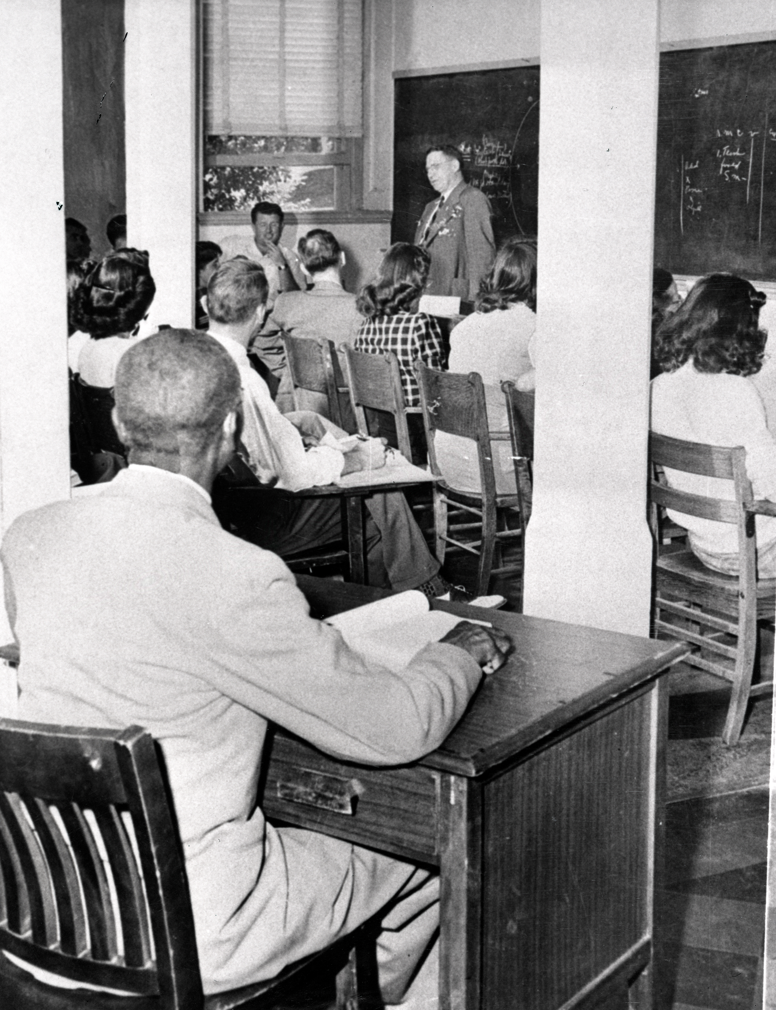
Photo of George McLaurin in the anteroom. Courtesy of Western History Collections, University of Oklahoma Libraries, Ada Lois Sipuel Fisher Collection #4
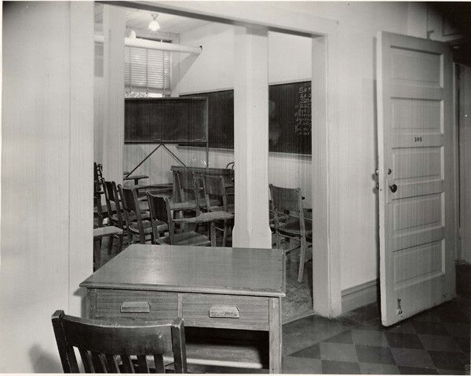
George W. McLaurin v. Oklahoma Board of Regents for Higher Education, Civil Case 4039; Civil Case Files, 1938 - 1996; Records of District Courts of the United States, Record Group 21. (2020, Jan. 7). Fort Worth, TX: National Archives at Fort Worth. https://www.docsteach.org/documents/document/mclaurin-v-ok-board-regents
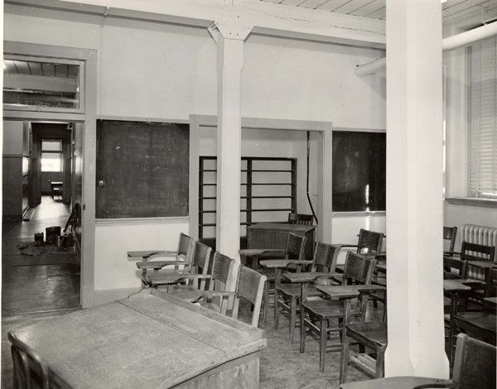
George W. McLaurin v. Oklahoma Board of Regents for Higher Education, Civil Case 4039; Civil Case Files, 1938 - 1996; Records of District Courts of the United States, Record Group 21. (2020, Jan. 7). Fort Worth, TX: National Archives at Fort Worth. https://www.docsteach.org/documents/document/mclaurin-v-ok-board-regents

