Samuel W. Tucker

Secondary Source: “Out of the Attic: Samuel Tucker’s 1939 Library Sit-In”

By Office of Historic Alexandria Staff
This year’s Black History Month holds special meaning to Alexandrians as we celebrate two seminal moments in local Black history. Aug. 21 will be the 80th anniversary of the library sit-in, a precursor to the events and tactics of the Civil Rights Movement in the 1950s and 60s…
On Aug. 21, 1939, five young men walked in separately to the new Kate Waller Barrett Branch Library on Queen Street and asked for a library card. Their names were Otto Tucker, William “Buddy” Evans, Edward Gaddis, Morris Murray and Clarence “Buck” Strange. Fourteen-year-old Bobby Strange kept a lookout for the leader of the group, the lawyer Samuel W. Tucker.
Each of the five men were told that they would not be issued a library card because they were Black. Each one then went quietly to a shelf, pulled out a book and read quietly. When asked by the library staff to leave, they asked as they had been instructed, “What would happen if we don’t leave?”
Tucker waited to call the local press until Bobby informed him that the police were on their way to arrest the young men. He notified The Washington Post, The Times Herald, The Washington Tribune and The African-American. The five men were arrested and charged with disorderly conduct, probably because they couldn’t be charged with anything else.
In court, Tucker made two points. First, that the young men had been anything but disorderly. Second, that it was illegal for the Alexandria Library to deny residents library cards, regardless of race. Rather than siding for or against Tucker, the judge avoided issuing a ruling, which prevented Tucker from declaring a victory, but also saved the young men from fines or imprisonment.
Rather than allow African Americans to use the new library, the all-White Library Board hurriedly built the Robert Robinson Library. Samuel Tucker refused to ever set foot in the library his legal arguments built, insisting that having a library to read in wasn’t the same as being treated equally. The letter where Tucker states his reason for refusing to use the Robert Robinson Library is part of the collection at Special Collections as are the annual reports for the Robinson Library.

Unlike Tucker, many African Americans went to the Robinson Library to utilize the only library they had access to. Some of the library patrons surely used it as a starting point in order to insist on greater rights in the decades to come, despite the humbleness of the hastily constructed building.
Gladys Davis, who retired from the library system with more than 50 years of service, was one of the early librarians at the Robinson Library. In 2007, city council honored her for her 60 years of service to the Alexandria Library System.
Today, the Robinson Library is a gallery in the Alexandria Black History Museum. Like the young men whose brave actions created the city’s demand for a segregated library, the Robinson Library saw big changes in Alexandria’s Black history over the coming decades. It remains a reminder of Alexandria’s segregated past, and the brave men and women who worked to end it.
Source: Office of Historic Alexandria. (2019, Feb. 14). Out of the attic: Samuel Tucker’s 1939 library sit-in. The Alexandira Times. https://www.alexandriava.gov/uploadedFiles/historic/info/attic/2019/Attic20190214SitIn.pdf. Reprinted with permission.

Primary Source: Samuel W. Tucker’s Letter to Librarian Katharine Scoggin

916 Queen Street
Alexandria, Virginia
February 13, 1940
Miss Katharine H. Scoggin
Alexandria Library
Alexandria, Virginia

My dear Miss Scoggin:

Together with copy of letter from the City Manager to you dated January 26, 1940, I am in receipt of your letter of February 9 with reference to my application for library privileges, filed January 30, 1940.
I refuse and will always refuse to accept a card to be used at the library to be constructed and operated at Alfred and Wythe Streets in lieu of card to be used at the existing library on Queen Street for which I have made application. Continued delay – beyond the close of this month – in issuing to me a card for use at the library on Queen Street will be taken as a refusal to do so, whereupon I will feel justified in seeking the aid of court to enforce my right.
A letter is being sent to the City Manager on this subject, a copy of which I am herewith enclosing.

Very truly yours,

SAMUEL WILBERT TUCKER

Source:.Tucker, S.W. (1940, Feb. 13). [Letter to Alexandria Library]. Alexandria Library Special Collections Document of the Month. https://alxndria.ent.sirsi.net/custom/web/lhsc/sitin/tuckerletter/doc.html

Primary Source: “Va. Library War in Court Again”

The Afro-American
ALEXANDRIA, Va. — The untainted admission that being colored was the true basis of charges of disorderly conduct laid against five young men who entered the local public library, was forced from the police department here, Tuesday.
The charges were placed against them because they refused to leave the library, supported by public funds, at the request of Miss Katharine Scoggin, white, librarian.
The five defendants who appeared for arraignment were; Otto L. Tucker, 22, 916 Queen Street; Clarence Strange, 21, 807 Duke Street; Morris L. Murray, 22, 813 Princess Street; Edward Gaddis, 21, 335 N. Patrick Street, and William Edwards, 19, 610 S. Fairfax Street.

One Stood Trial for All
Mr. Murray stood trial, at which time S. W. Tucker, attorney representing all of the defendants, told the court he would stipulate that whatever decision was rendered in Murray’s case would apply to the other defendants.
Police testified they were called in to request the men to leave the library because their presence there caused embarrassment to the white patrons of the library, after the librarian could not get the men to leave.
After they were too long making up their minds to leave the library, police demanded that they leave and the men complied immediately.
They were arrested as they started out of the door.

No Disturbance
The officers admitted that the young men were silent, refused to talk about the situation, and accompanied the officers to the police headquarters, where they were charged.
The attorney for the defendants brought out, on cross examination, that if the defendants had been white, they would not have been arrested under similar circumstances.
The judge admitted that he could not concede that the disorderly conduct charge was proved, but the cases were continued until August 29, in order that the commonwealth attorneys may have an opportunity to present any law which the defendants may have violated.

Long Fight
The action of the young men in entering the library, while not admitted by counsel, was believed to be part of the fight which Alexandria citizens are carrying on to break down the lily-white policy maintained at the institution, which is supported out of tax payers’ funds.
Source: The Afro-American. (1939, Sept. 2). Va. library war in court again. https://news.google.com/newspapers?id=3E9AAAAAIBAJ&sjid=RgMGAAAAIBAJ&pg=4450,821689&dq=alexandria+library&hl=en

Photographs: Front Pages from The Alexandria Gazette
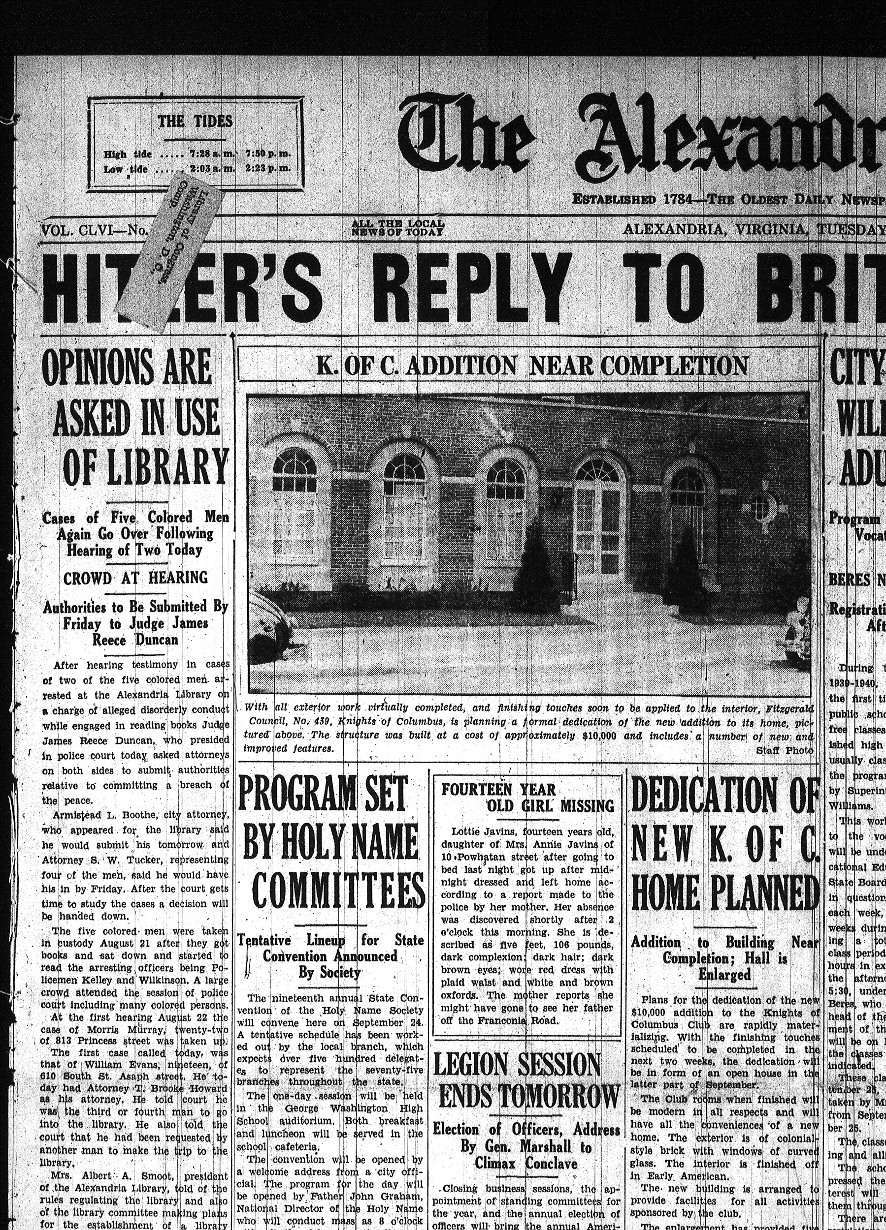
The Alexandria Gazette. (1939, Aug. 29). Courtesy of Alexandria Library Local History & Special Collections.
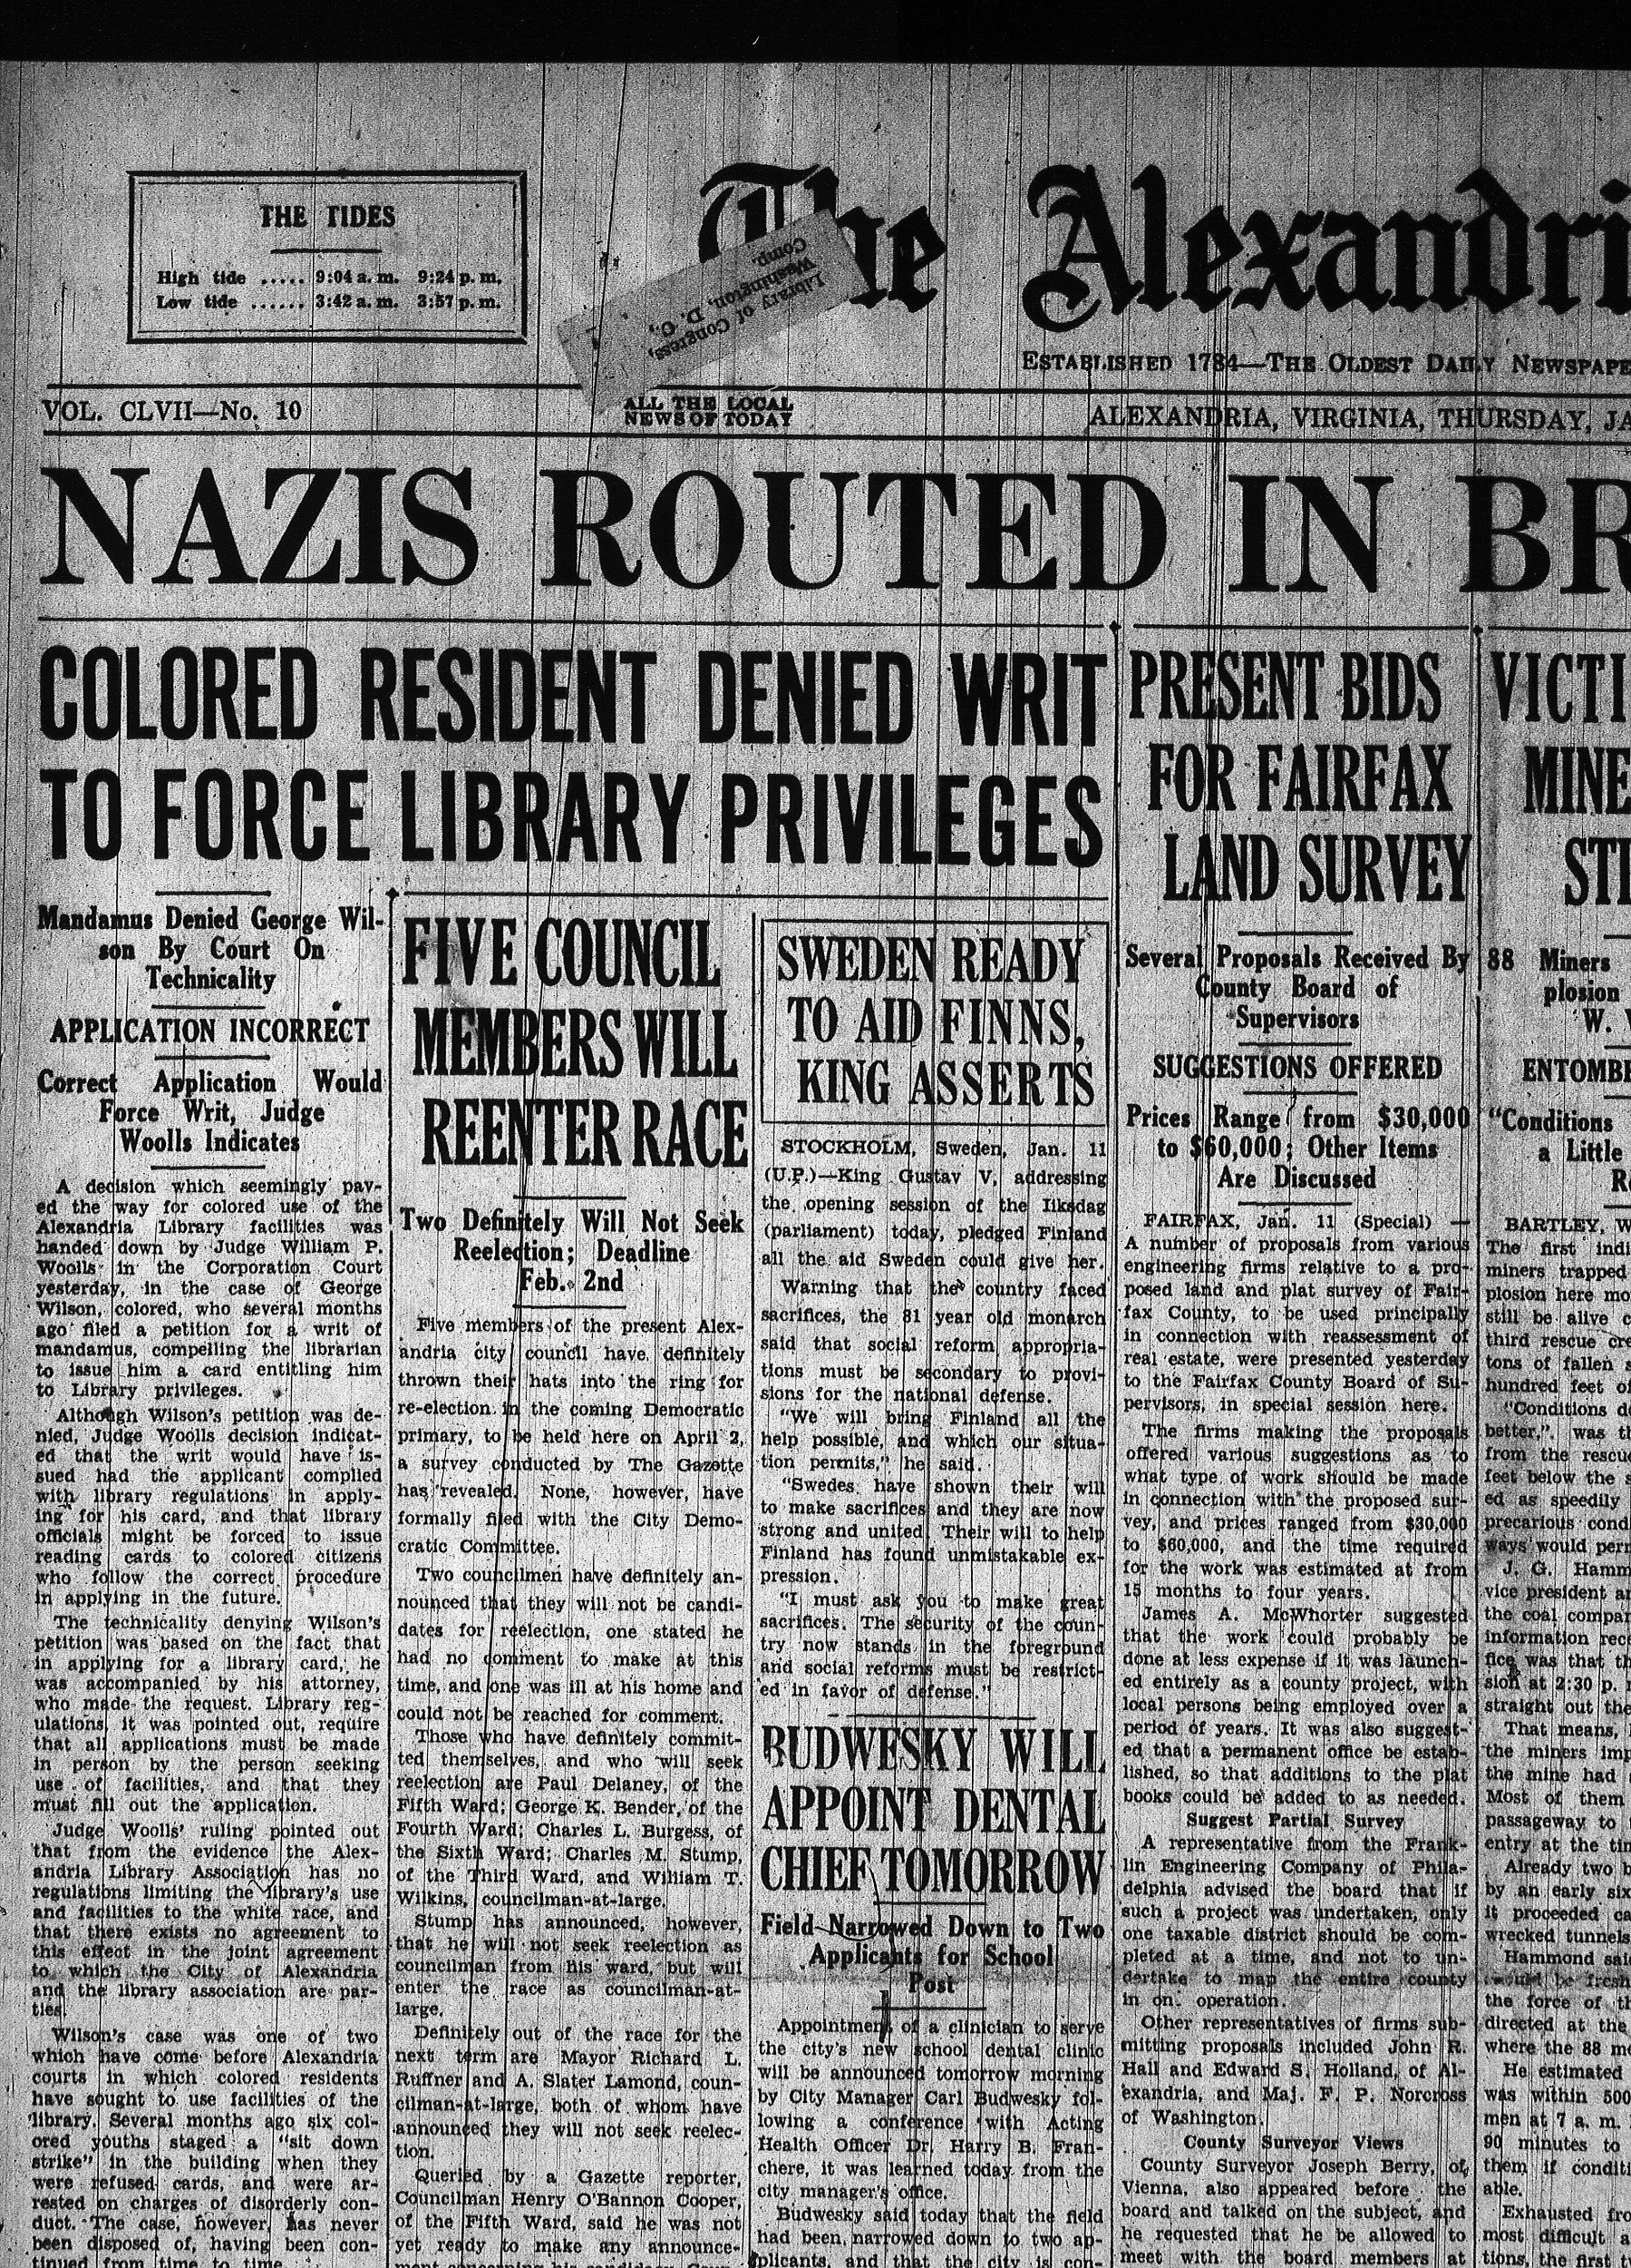
The Alexandria Gazette. (1940, Jan. 11). Courtesy of Alexandria Library Local History & Special Collections.

