Making Connections Between Texts, Self, and World (Teacher)
Directions: Look at the “Responsibilities of Citizenship Survey Results” below. This survey was conducted by the Pew Research Center. After reviewing the data, craft a text-to-texts response and either a text-to-self or a text-to-world response. Use the prompts on the following pages to help you structure your response. Your response should be 3–5 complete sentences.

Responsibilities of Citizenship Survey Results
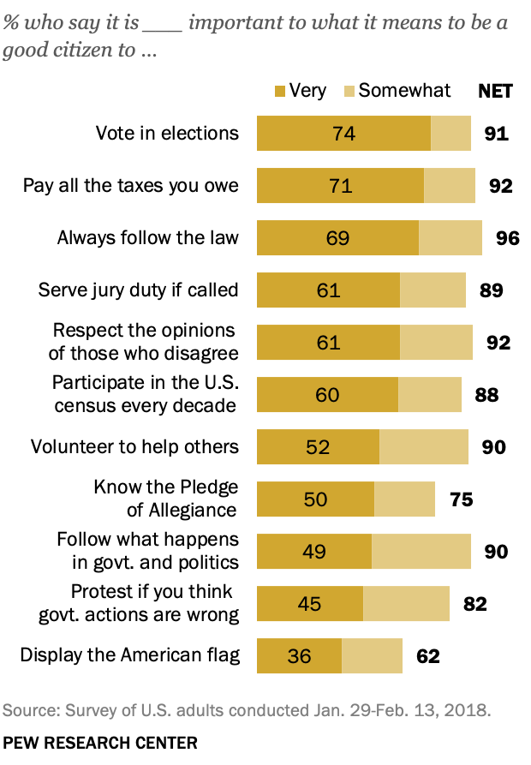
Source: Pew Research Center. (2018, April 26). The responsibilities of citizenship. The Public, the Political System, and American Democracy. https://www.pewresearch.org/politics/2018/04/26/9-the-responsibilities-of-citizenship/

- Text-to-Texts: How do the ideas in the survey results remind you of the ideas in “Responsibilities of U.S. Citizens” or President Obama’s Farewell Address?
- What I observed in the survey results reminds me of __________________________________________________________________ (something from “Responsibilities of U.S. Citizens” or President Obama’s Farewell Address because…
- The ideas in the survey are similar to the ideas in “Responsibilities of U.S. Citizens” or President Obama’s Farewell Address because…
- The ideas in the survey are different from the ideas in “Responsibilities of U.S. Citizens” or President Obama’s Farewell Address because…
The ideas in the survey results are similar to the ideas in the documents we analyzed because both sets of ideas highlighted how important it is for citizens to be engaged in our democracy and voting in elections. In the survey, 74% of people believed that voting was very important, which is what was the most important responsibility of citizenship according to the survey.
- Text-to-Self: How do the ideas in the “Responsibilities of Citizenship Survey Results” relate to your own life, ideas, and experiences?
- What I observed reminds me of/makes me think about…
- I agree with/understand what I observed because in my own life…
- I don’t agree with what I observed because in my own life…
I agree with the results of the survey that said voting is the most important action we can take as citizens because our votes elect our leaders who make laws and decisions for us and determine decisions for our communities at the local, state, and national levels.
- Text-to-World: How do the ideas in the “Responsibilities of Citizenship Survey Results” relate to the world of the past, present, and future?
- What I observed makes me think about _________________________________ (an event from the past) because…
- What I observed makes me think about _________________________________ (an event from today related to my own community, nation, or the world) because…
- What I observed makes me wonder about the future because…
The survey results make me think about how, even though a significant majority of people who responded to this survey noted that voting was one of the most important things we can do to exercise our power as citizens, the U.S. often has an embarrassingly low voter turnout, especially in local elections where our votes can potentially make the biggest difference.
Adapted from: Facing History and Ourselves. (2020 September). Text-to-text, text-to-self, text-to-world. Facing history. https://www.facinghistory.org/sites/default/files/TexttoText_handout_v.final_.pdf

