Making Connections Between Texts, Self, and World
Directions: Look at the “Responsibilities of Citizenship Survey Results” below. This survey was conducted by the Pew Research Center. After reviewing the data, craft a text-to-texts response and either a text-to-self or a text-to-world response. Use the prompts on the following pages to help you structure your response. Your response should be 3–5 complete sentences.

Responsibilities of Citizenship Survey Results
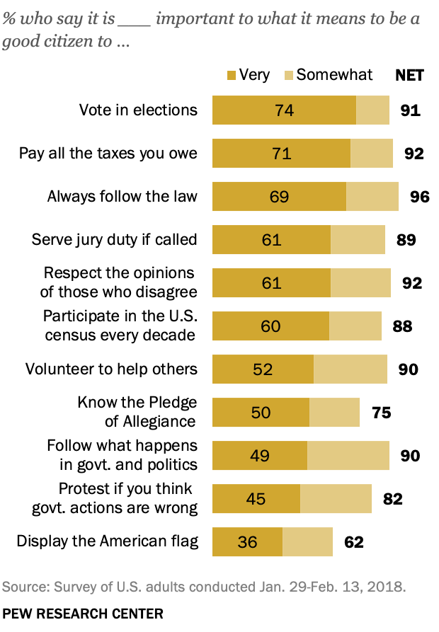
Source: Pew Research Center. (2018, April 26). The responsibilities of citizenship. The Public, the Political System, and American Democracy. https://www.pewresearch.org/politics/2018/04/26/9-the-responsibilities-of-citizenship/

- Text-to-Texts: How do the ideas in the survey results remind you of the ideas in “Responsibilities of U.S. Citizens” or President Obama’s Farewell Address?
- What I observed in the survey results reminds me of __________________________________________________________________ (something from “Responsibilities of U.S. Citizens” or President Obama’s Farewell Address because…
- The ideas in the survey are similar to the ideas in “Responsibilities of U.S. Citizens” or President Obama’s Farewell Address because…
- The ideas in the survey are different from the ideas in “Responsibilities of U.S. Citizens” or President Obama’s Farewell Address because…

- Text-to-Self: How do the ideas in the “Responsibilities of Citizenship Survey Results” relate to your own life, ideas, and experiences?
- What I observed reminds me of/makes me think about…
- I agree with/understand what I observed because in my own life…
- I don’t agree with what I observed because in my own life…

- Text-to-World: How do the ideas in the “Responsibilities of Citizenship Survey Results” relate to the world of the past, present, and future?
- What I observed makes me think about _________________________________ (an event from the past) because…
- What I observed makes me think about _________________________________ (an event from today related to my own community, nation, or the world) because…
- What I observed makes me wonder about the future because…

Adapted from: Facing History and Ourselves. (2020 September). Text-to-text, text-to-self, text-to-world. Facing history. https://www.facinghistory.org/sites/default/files/TexttoText_handout_v.final_.pdf

