Text-to-texts, -self, and -world handout
Directions: Look at the Responsibilities of Citizenship Survey Results below. This survey was conducted by the Pew Research Center. After reviewing the data, craft a text-to-texts response and either a text-to-self or a text-to-world response. Use the prompts on the following pages to help you structure your response. (You don’t have to answer every prompt provided, but you can use a prompt as a sentence starter if you wish.) Record your responses in the space provided.

Responsibilities of Citizenship Survey Results
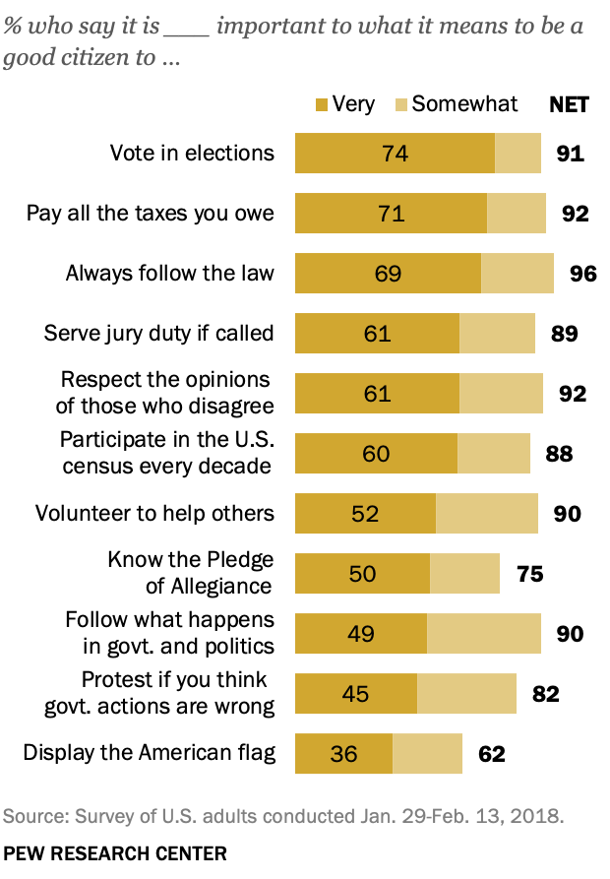
Source: Pew Research Center. (2018 April). 9. The responsibilities of citizenship. Pew Research Center. https://www.pewresearch.org/politics/2018/04/26/9-the-responsibilities-of-citizenship/
- Text-to-Texts: How do the ideas in the Responsibilities of Citizenship Survey Results remind you of the ideas in “Responsibilities of U.S. Citizens” or “President Obama’s Farewell Address”?
- What I observed in the Responsibilities of Citizenship Survey Results reminds me of _____(something from “Responsibilities of U.S. Citizens” or “President Obama’s Farewell Address”)_____ because…
- The ideas in the survey are similar to the ideas in “Responsibilities of U.S. Citizens” or “President Obama’s Farewell Address” because…
- The ideas in the survey are different than the ideas in “Responsibilities of U.S. Citizens” or “President Obama’s Farewell Address” because…

- Text-to-Self: How do the ideas in the Responsibilities of Citizenship Survey Results relate to your own life, ideas, and experiences?
- What I observed reminds me of/makes me think about…
- I agree with/understand what I just observed because in my own life…
- I don’t agree with what I just observed because in my own life...

- Text-to-World: How do the ideas in the Responsibilities of Citizenship Survey Results relate to the world—past, present, and future?
- What I just observed makes me think about _____(an event from the past)_____ because…
- What I observed make me think about _____(an event from today related to my own community, nation, or world)_____ because…
- What I just observed makes me wonder about the future because…

Adapted from: Facing History and Ourselves. (2020 September). Text-to-text, text-to-self, text-to-world handout. Facing history. https://www.facinghistory.org/sites/default/files/TexttoText_handout_v.final_.pdf

