Text-to-texts, -self, and -world handout (Teacher)
Directions: Look at the Responsibilities of Citizenship Survey Results below. This survey was conducted by the Pew Research Center. After reviewing the data, craft a text-to-texts response and either a text-to-self or a text-to-world response. Use the prompts on the following pages to help you structure your response. (You don’t have to answer every prompt provided, but you can use a prompt as a sentence starter if you wish.) Record your responses in the space provided.

Responsibilities of Citizenship Survey Results
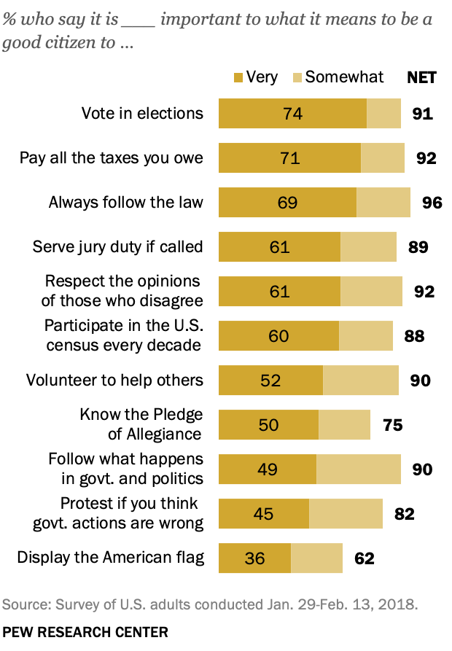
Source: Pew Research Center. (2018 April). 9. The responsibilities of citizenship. Pew Research Center. https://www.pewresearch.org/politics/2018/04/26/9-the-responsibilities-of-citizenship/
- Text-to-Texts: How do the ideas in the Responsibilities of Citizenship Survey Results remind you of the ideas in “Responsibilities of U.S. Citizens” or “President Obama’s Farewell Address”?
- What I observed in the Responsibilities of Citizenship Survey Results reminds me of _____(something from “Responsibilities of U.S. Citizens” or “President Obama’s Farewell Address”)_____ because…
- The ideas in the survey are similar to the ideas in “Responsibilities of U.S. Citizens” or “President Obama’s Farewell Address” because…
- The ideas in the survey are different than the ideas in “Responsibilities of U.S. Citizens” or “President Obama’s Farewell Address” because…

The ideas in the survey results are similar to the ideas in the documents we analyzed because both highlighted how important it is for citizens to be engaged in our democracy and to vote in elections. In the survey, 74% of people believed that voting was very important—that is the most important responsibility of citizenship overall, according to the people surveyed.

- Text-to-Self: How do the ideas in the Responsibilities of Citizenship Survey Results relate to your own life, ideas, and experiences?
- What I observed reminds me of/makes me think about…
- I agree with/understand what I just observed because in my own life…
- I don’t agree with what I just observed because in my own life...

I agree with the result of this survey that voting is the most important action we can take as citizens. This is because our votes both elect our leaders who make laws and decisions for us and determine decisions for our communities at the local, state, and national level.

- Text-to-World: How do the ideas in the Responsibilities of Citizenship Survey Results relate to the world—past, present, and future?
- What I just observed makes me think about _____(an event from the past)_____ because…
- What I observed make me think about _____(an event from today related to my own community, nation, or world)_____ because…
- What I just observed makes me wonder about the future because…

These survey results make me think about how, even though a significant majority of people who responded to this survey noted that voting was one of the most important things we can do to exercise our power as citizens, the U.S. often has embarrassingly low voter turnout, especially in local elections where our votes can potentially make the most difference.

Adapted from: Facing History and Ourselves. (2020 September). Text-to-text, text-to-self, text-to-world handout. Facing history. https://www.facinghistory.org/sites/default/files/TexttoText_handout_v.final_.pdf

