Student Reading 4

Earthquakes Continue To Decrease in Oklahoma for Third Straight Year
March 14, 2019; updated March 14, 2019
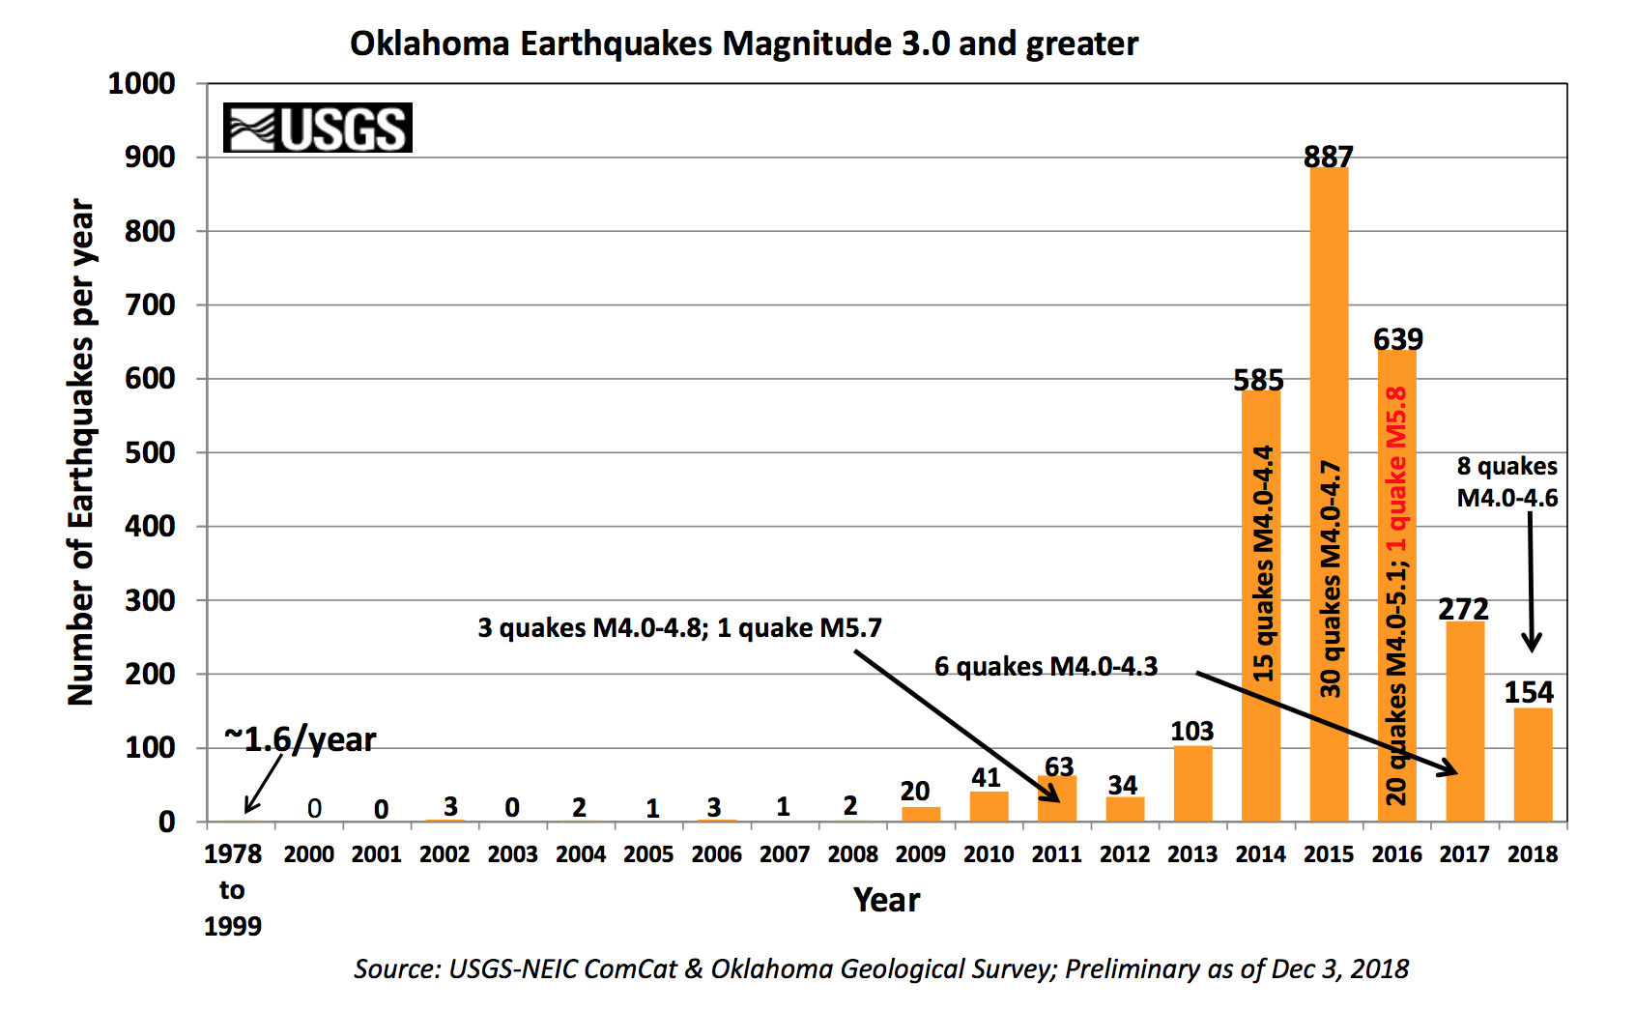
The state of Oklahoma has seen less earthquakes for the third year in a row.

Oklahoma has seen a decrease in the frequency of earthquakes for the third year in a row, according to the United States Geological Survey.
There were 154 total earthquakes in 2018, 272 in 2017 and 639 in 2016, compared to 887 earthquakes in 2015, according to United States Geological Survey.
Xiaowei Chen, an OU geology and geophysics professor, said the reason for the decrease in earthquake frequency stems from the reduction of wastewater injections.
Since 2015, the Oklahoma Corporation Commission has been shutting down wastewater disposal wells across the state or cutting wastewater disposal amounts.
“The Oklahoma Corporation Commission has regulated the wastewater disposal situation, and they require them to decrease the injection volume, so this decline in wastewater injections has led to a decrease in the seismicity rate,” Chen said. “It's kind of the same reason causing seismicity to increase that is causing the seismicity to decrease.”
Jacob Walter, Oklahoma seismologist and head of the Oklahoma Geological Survey, said specifically the shutdown and reduced volume of injections into Arbuckle disposal wells has led to the decline in earthquakes.
“Wastewater injection influences the stability of fault zones deep underground,” Walter said. “Fault zones that may not have had any slip on them in recent geologic time might be reactivated because the increased pressure within the fault zone actually alleviates the friction that held those faults stable previously. When that friction is relieved, the fault slips and causes the earthquake.”
There has been past debate about whether or not hydraulic fracking is the cause of earthquakes in Oklahoma, but according to the United States Geological Survey, only 1 to 2 percent of earthquakes in Oklahoma are linked to hydraulic fracking, and the rest are induced by wastewater disposal.
Hydraulic fracking is a process in which fluid is injected under high pressure into rocks loaded with oil, and the process produces some wastewater. The wastewater is then removed and pumped underground below groundwater into wells, according to a study from the American Association for the Advancement of Science.
However, wastewater disposal wells are created to hold the wastewater from drilling many wells, so much more water goes into them than into a fracked gas or oil well, according to the study.
Wastewater disposal wells also operate longer than hydraulic fracking, which makes them even more likely to induce earthquakes, according to the United States Geological Survey.
Chen said Oklahoma has a history of earthquakes, but the current rate of them is still high.
“Oklahoma does have a history of earthquakes since the 1950s, but they were relatively very low seismicity rates,” Chen said. “Currently, even though the seismicity rate has declined, it's still much higher than the past seismicity rates in Oklahoma.”
Walter said the magnitude of earthquakes in Oklahoma, which is based on the energy released in an earthquake, has not been increasing.
In 2015, there were 30 earthquakes between magnitude 4 and 4.7, 20 earthquakes between magnitude 4 and 5.1 and one earthquake with a magnitude of 5.8 in 2016, according to United States Geological Survey.
However, in 2017, there were only six earthquakes between magnitude 4 and 4.3, and in 2018, there were eight earthquakes between magnitude 4 and 4.6, according to United States Geological Survey.
“We had several moderate earthquakes that damaged buildings in 2016, including the Pawnee and Cushing earthquakes,” Walter said. “Since late 2016, there have been earthquakes that caused minor cosmetic damage.”
Walter said magnitude is also related to the area of the fault the earthquake slipped along and the slip that occurred during the earthquake. Because of this, larger magnitude earthquakes are larger slip patches on faults.
“It is possible that the area that slips is increased with longer-term injection because you have a broader area subject to the reduced effective stress on the stability of the fault,” Walter said.
“That is just one hypothesis out there about how larger magnitude earthquakes might be promoted by long-term (wastewater) disposal.”
Chen said while the seismicity rate in Oklahoma is decreasing, it does not mean earthquakes are going away.
“In an area of Colorado, the earthquakes lasted for 10 years, decades following the shutdown of the fluid injection site,” Chen said. “And in Texas, seismicity also continued for about seven years after the wastewater disposal was decreased. So we should still expect some continuing seismicity in the future.”
Chen said it is essential for Oklahomans to still prepare for future earthquakes.
“There is some possibility of larger earthquakes if the seismicity continues because we don't know when it will hit a larger fault,” Chen said. “And we still don't have complete knowledge of the Oklahoma fault distribution.
Source:
Lewis, B. (2019, March 14). Earthquakes continue to decrease in Oklahoma for third straight year. OU Daily. Retrieved March 4, 2022, from https://www.oudaily.com/news/earthquakes-continue-to-decrease-in-oklahoma-for-third-straight-year/article_00cefc9c-467f-11e9-b984-2bebe425ee8e.html

