Lesson Handout

Engage
- Look at the pictures to the right and identify the “neon color(s).” Why is the word “neon” used to describe color?

- A planet’s atmosphere is being analyzed to determine whether it could support intelligent life. From most to least important for supporting life, rank the following gases (nitrogen, oxygen, carbon dioxide, neon, helium, hydrogen). Justify your ranking.

- Describe or draw the spectra made by observing white and neon light with spectroscopes.

- What are the safety concerns with electrifying gases in glass tubes?

Explore
Before you begin, gather the necessary materials:
- A data table
- A spectroscope
- Colored pencils, pens, or markers to record your observations in color
Procedure:
- Practice using the spectroscope by looking at sunlight (but don’t look directly at the sun!) and/or an overhead light. The spectroscope will turn the light into a rainbow spectrum. Point the spectroscope slit at the light source and then, without moving the spectroscope, move your eye to the side to view the spectrum. Get help if you can’t see the rainbows.
- Look at the light emitted by gases in glass tubes. In the provided data table, record your observations under the following conditions:
- Record the color of the gases when the electricity is off.

- Describe the color you see without the spectroscope when electricity has been applied to the samples.

- Use the spectroscope to observe lines of color emitted by the electrified gases. Use colored pens/pencils/markers to draw the spectrum and (if possible with the spectroscope and as directed) record the wavelengths of the color lines in the spectra.

- When you are finished observing the tubes, form peer groups to compare data. Help classmates who may have been rushed or missed a sample to complete their data set.

Explain
- Were any of the gases particularly difficult or easy to observe with the spectroscope? Explain.

- Do the different types of gases emit similar colors or different colors? Which color(s) in the pictures from question 1 in the Engage section is/are true “neon” color(s)?

- Does each electrified gas make one color or a mixture of colors? Justify your answer in words or by drawing a diagram.

- Which gas sample emitted (showed) the fewest lines of color when observed by a spectroscope? Which gas sample emitted the most lines?
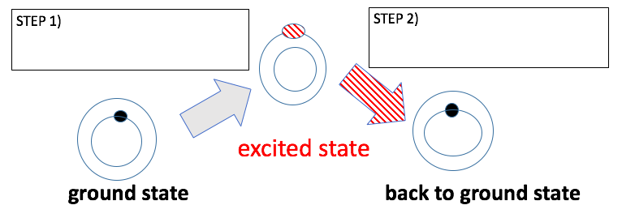
- The Bohr diagram below shows an electron (shaded circle) in different electron shells in a gas atom. Each thin circle represents an energy level where you might find the electron. What do you think is the difference between a “ground state” and an “excited state” electron?

- Electricity plays a role as an external energy source during only “step 1” or “step 2.” Which step requires electricity (external energy)? Explain your guess.
- Light is released only during “step 1” or “step 2.” Which step releases light energy from the atom to the surrounding environment? Explain your guess.
- Fill in the two boxes in the diagram above with a word or two to summarize the change connected by arrows. Later, we will introduce science words for these changes.
- Why do different atoms emit different specific colors? It is good to guess or research this.
- Can atoms release non-visible electromagnetic radiation as well as visible light?

Extend
- Using the data below, make a sketch to predict emission spectra for Venus, Earth, and Mars. Look up the emission spectra for any type of gas you did not get to observe during the lab.
Planet | Venus | Earth | Mars
Surface Pressure (relative to Earth) | 90 | 1 | 0.007
Carbon Dioxide (CO₂) | 96.5% | 0.03% | 95%
Nitrogen (N₂) | 3.5 % | 78% | 2.7%
Oxygen (O₂) | Trace | 21% | 0.13%
Argon (Ar) | 0.07% | 0.9% | 1.5%

- Which components in each atmosphere make intelligent life more or less likely on these planets? Design an experiment to use emission spectra of atmospheres to search for intelligent life on other planets.

- The Northern Lights (Aurora Borealis) are produced by excited gases. Which kinds of gases get excited? Where do the gases get excitation energy needed to make Northern Lights? Why is this phenomenon observed at the poles and not at the equator?

- When sharing data, do you think it is better to describe line spectra qualitatively or quantitatively (numerically)? Justify your answer by proposing the best way to share data.

Excited hydrogen atoms emit four wavelengths of visible light (plus many colors of non-visible electromagnetic radiation). The energy these light photons possess is small, so many physicists use the electron-volt (eV; 1eV = 1.6x10⁻⁹ J) energy unit to measure these energies. The equation for calculating the energy (in eV) for light at a given wavelength (nm) is:
Energy = 1240 eV•nm $÷$ wavelength
- Use the equation to calculate the energy for the colors in the table. Enter the data into the table.

- Based on your calculations, summarize the relationship between wavelength and energy in a single sentence.

Color of Hydrogen emission line | Wavelength (nm) | Energy (eV)
Red | 656.2
Blue-green | 486.1
Blue-violet | 434.0
Violet | 410.1

Evaluate
- Now that you have collected your data, add a title to the data table. In science, titles are descriptive and detailed to summarize the key result indicated by the data. Share your title in a tweet.
- Share the results of your assigned Extend question research in peer groups.
- You have been asked to design a sign for the school that uses electrified gas tubes to produce the desired colors. Draw a diagram to show the design for your sign. Make sure to label the gas used for each part of the sign. Research to find gases that can make colors you haven’t seen yet but want to include.

Image Sources
[pikisuperstar]. (n.d.). Neon alphabet [Image]. Freepik. https://www.freepik.com/free-vector/neon-alphabet_4171931.htm#page=1&query=neon%20alphabet&position=0
[katemangostar]. (n.d.). Multicolored firework brick background neon style [Image]. Freepik. https://www.freepik.com/free-vector/multicolored-firework-brick-background-neon-style_2553671.htm#page=1&query=multicolored%20firework%20brick&position=0

