SAMPLE DATA
Before electricity is applied, all gases will be colorless. They need electricity for excitation.
After electricity is applied, colors appear as shown below.
Type of Gas | Colors Observed without Spectroscope | Colors Observed with Spectroscope
Hydrogen | 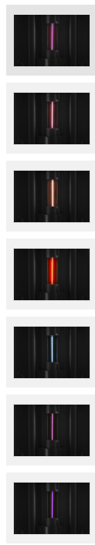 | 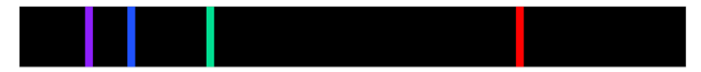
Nitrogen |  | 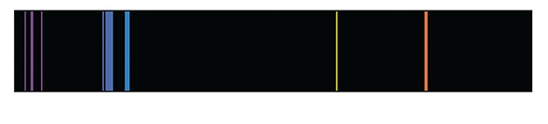
Helium |  | 
Neon |  | 
Carbon Dioxide |  | Image Sources:  NASA Space Telescope Science Institute. (2019, June 6). Spectra showing different elements [Image]. Hubblesite. https://hubblesite.org/image/4511/category/115-spectra  Noschese 180. (2014). Emission spectra. A picture-a-day for the school year [Image]. https://noschese180.files.wordpress.com/2014/12/  emission_spec.png  University of Texas. (n.d.). Line spectra in hydrogen [Image]. Chemistry 301 https://ch301.cm.utexas.edu/atomic/index.php#H-atom/line-spectra.html  Vernier. (n.d.). Spectrum tubes [Image]. Vernier. https://www.vernier.com/product/spectrum-tubes/
Air
Argon

