MATH MINDSETS
Seven Math Mindset Messages
- All students can learn math to the highest levels.
- Mistakes are valuable.
- Questions are important.
- Math is about creativity and making sense.
- Math is about connections and communicating.
- Value depth over speed.
- Math class is about learning, not performing.

Student Profiles

Amber

- Comes in for non-required tutoring frequently.  - Doesn’t always get the best grades but takes initiative to reflect on her mistakes.  “Math is really hard—that’s why I need to keep practicing. I know one day this will get easier for me.”  - Can you think of a student who could be “Amber”?  - Think about your current teaching practices and focuses. What are you doing already to support this student?  - Which of the seven mindset messages does this student display?  - Which of the seven mindset messages does this student need more support with? | 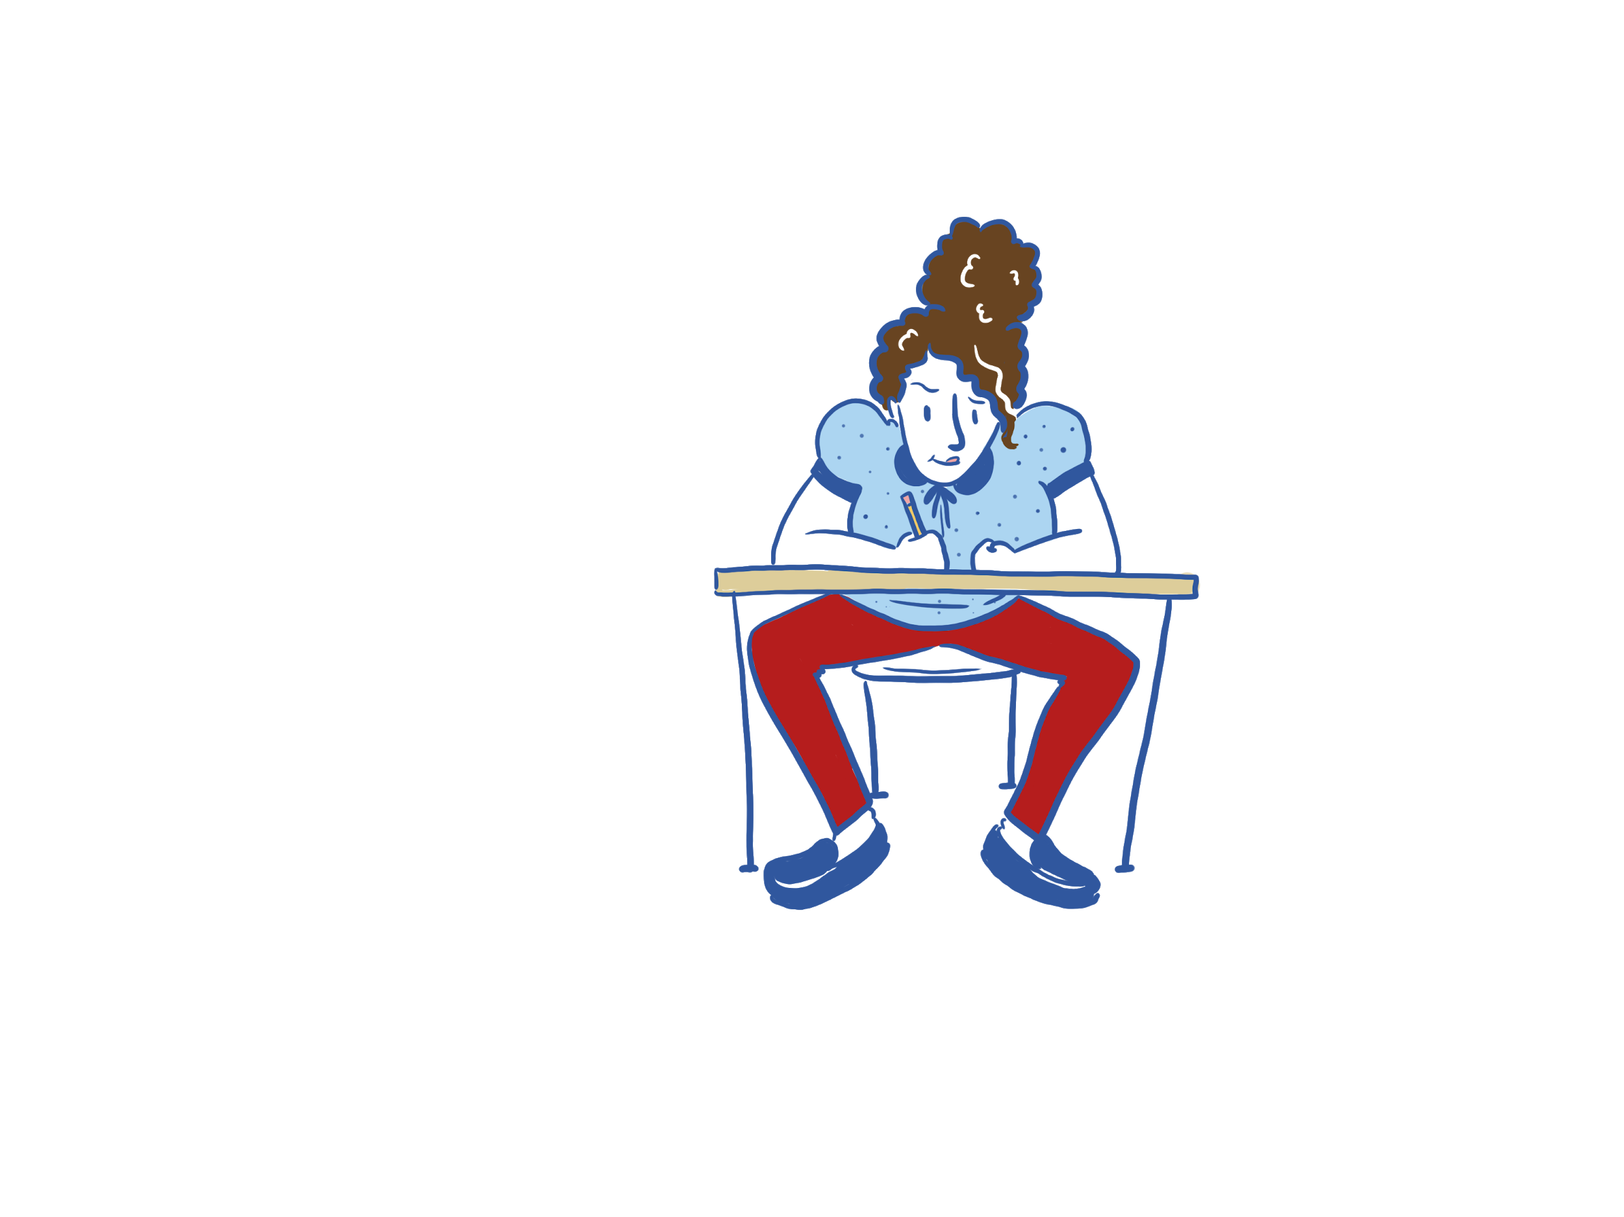

MATH MINDSETS
Seven Math Mindset Messages
- All students can learn math to the highest levels.
- Mistakes are valuable.
- Questions are important.
- Math is about creativity and making sense.
- Math is about connections and communicating.
- Value depth over speed.
- Math class is about learning, not performing.

Mariah
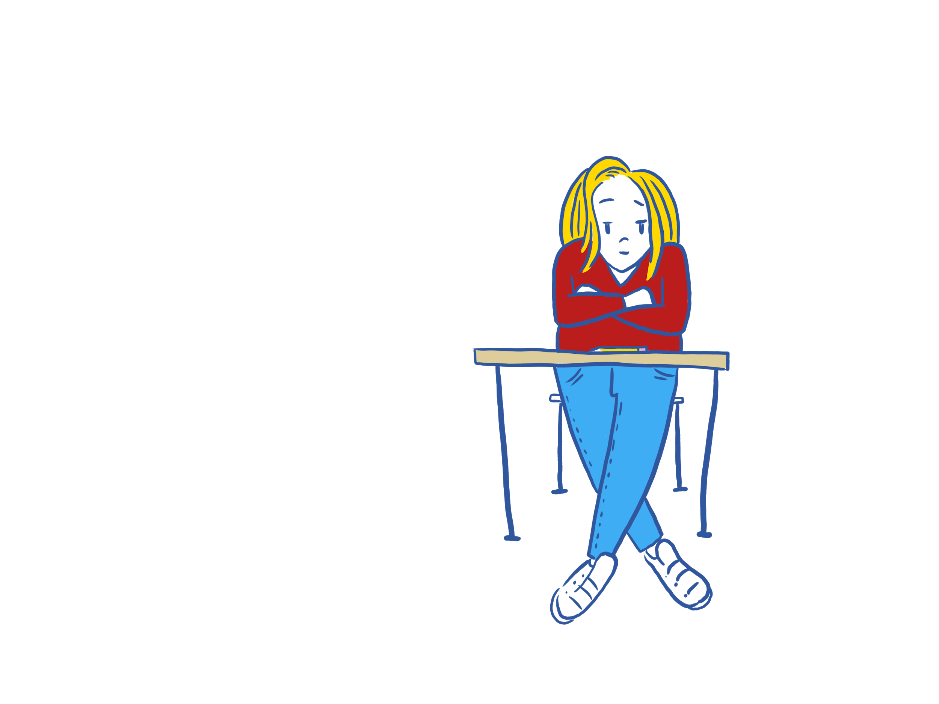 | - Has a 98% average in the class but never asks for help or answers a question.  - Has been labeled as gifted. Does very well but struggles the moment she doesn’t understand something.  “I have to get this done correctly the first time. Otherwise, someone will think I don’t know what I am doing!”  - Can you think of a student who could be “Mariah”?  - Think about your current teaching practices and focuses. What are you doing already to support this student?  - Which of the seven mindset messages does this student display?  - Which of the seven mindset messages does this student need more support with?

MATH MINDSETS
Seven Math Mindset Messages
- All students can learn math to the highest levels.
- Mistakes are valuable.
- Questions are important.
- Math is about creativity and making sense.
- Math is about connections and communicating.
- Value depth over speed.
- Math class is about learning, not performing.

Alex
- Is always polite and seems to be on task.  - Consistently gets bad grades on assignments and tests.  “I don’t get these problems, and I never will. Why should I even bother?”  - Can you think of a student who could be “Alex”?  - Think about your current teaching practices and focuses. What are you doing already to support this student?  - Which of the seven mindset messages does this student display?  - Which of the seven mindset messages does this student need more support with? | 

MATH MINDSETS
Seven Math Mindset Messages
- All students can learn math to the highest levels.
- Mistakes are valuable.
- Questions are important.
- Math is about creativity and making sense.
- Math is about connections and communicating.
- Value depth over speed.
- Math class is about learning, not performing.

Brittany
 | - Does well but makes sloppy mistakes because she wants to rush through her work.  - Understands the concepts easily and gets good grades regularly.  “My teacher said I need to show my work when I am doing math. Although this comes easily to me, I know that I need to work out the problems on paper. This way, if I make a mistake, I can find it and fix it!”  - Can you think of a student who could be “Brittany”?  - Think about your current teaching practices and focuses. What are you doing already to support this student?  - Which of the seven mindset messages does this student display?  - Which of the seven mindset messages does this student need more support with?

Message for Growth Mindset  (from Jo Boaler) | Description | Example Activity
All students can learn math  to the highest levels. | - This is a belief; it builds and builds over time.  - Every chance you get, encourage students’ beliefs that they can succeed.  - Switch your praise to focus on students’ work and effort rather than their “ability” or “smarts.” | Walking the Line: The Math Spectrum
Mistakes are valuable. | - Deeper learning happens from reflecting on a process to improve.  - Help students believe that they are on a path of growth and learning. Emphasize mistakes are not signs that they aren’t good enough. | My Favorite Mistake
Questions are important. | - Students asking their own math questions keeps them engaged and wanting to learn more.  - However, it can feel intimidating to be asked any math question.  - Build students’ self-confidence in not knowing all the answers to allow space for more of their questions. | Click Battle: Desmos

Message for Growth Mindset  (from Jo Boaler) | Description | Example Activity
Math is about creativity and making sense. | - Math is more than just remembering formulas.  - Visual representations of math processes spark connections between topics.  - Student-constructed representations are the most beneficial.  - Catchy phrases alone do not deepen knowledge. | Sum of Exterior Angle Theorem: GeoGebra
Math is about connections and communicating. | - Every subtopic in mathematics is connected and learning to see that connection is a skill.  - Communication means more than speaking so be creative in ways that students “show.”  - Student-selected representations of knowledge help both you and them to see their learning. | Card Sort
Value depth over speed. | - No matter how the standards are interpreted, depth always matters more than breadth.  - The things we remember most are those that have deep meaning or high impact—math is no different.  - Being bold enough to make that your focus can require a scary leap of faith. | Nine Digit Fraction: NCTM Illuminations
Math class is about learning, not performing. | - The phrase “show your work” is so frequently used for a reason; the process matters more than the answer.  - Grade for reflection rather than for achievement. It might take longer, but it is more valuable for your students. | Math Interview

Wrapping Up
- Based on your exploration of the activities, which one would you most like to incorporate into your classroom to support the growth mindset of your students?

- Why did you pick this activity?

Resources
Boaler, J. (2022). Mathematical mindsets: Unleashing students' potential through creative mathematics, inspiring messages and innovative teaching (2nd ed.). Jossey-Bass.
Brzezinski, T. (n.d.). Polygons: Exterior angles - REVAMPED. GeoGebra. https://www.geogebra.org/m/mKzJCf5p
Desmos Classroom. (n.d.). Click battle.
https://teacher.desmos.com/activitybuilder/custom/59233ca25ebd6c10d1af9c05?collections=featured-collections%2C5e72d28669f1f80f4025bcc1
K20 Center. (n.d.). Card sort. Strategies. https://learn.k20center.ou.edu/strategy/147
K20 Center. (n.d.). My favorite mistake. Strategies. https://learn.k20center.ou.edu/strategy/115
K20 Center. (2021, March 19). Walking the line: The math spectrum. 5E Lesson. https://learn.k20center.ou.edu/lesson/431
K20 Center. (2021, Sep 21). K20 Center 10 minute timer [Video]. https://www.youtube.com/watch?v=9gy-1Z2Sa-c&ab_channel=K20Center
NCTM Illuminations. (n.d.). Brain teasers: Nine digit fraction. https://illuminations.nctm.org/BrainTeasers.aspx?id=4714

