RESOURCE NOTE SHEET
Resource | Direct Link &  QR Code | What Did I Explore? | How Can This EdTech Integrate With My Content?
MIT Scratch Task Cards | 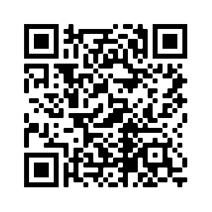
Scratch | 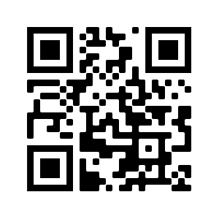
Thingiverse | 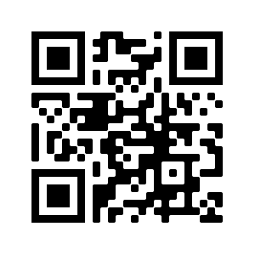
Tinkercad | 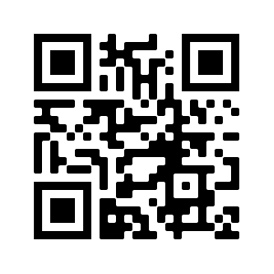
Swivl Bot | 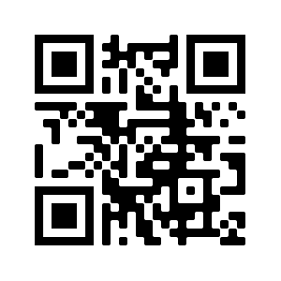

INSTRUCTIONAL STRATEGY NOTE SHEET
Strategy | How Was It Used? | How Can I Use It?

Technology Stations

First Word, Last Word

Four Corners/

Anchor Chart

Gallery Walk

3-2-1

I Notice…I Wonder…

