RESOURCE NOTE SHEET
Resource | Direct Link &  QR Code | What Did I Explore? | How Can This EdTech Integrate With My Content?
MIT Scratch Task Cards | 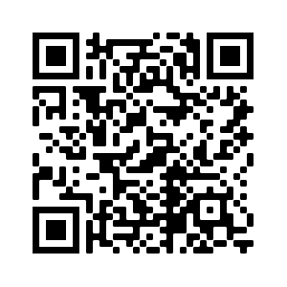
Scratch | 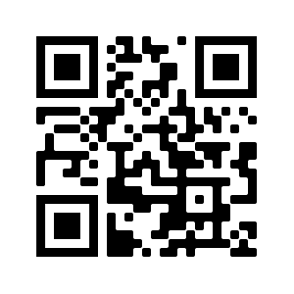
Thingiverse | 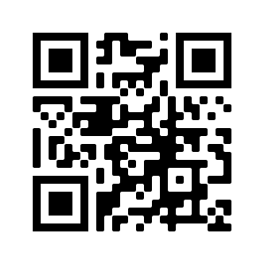
Tinkercad | 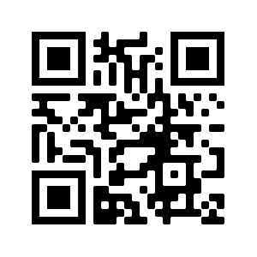
Swivl Bot | 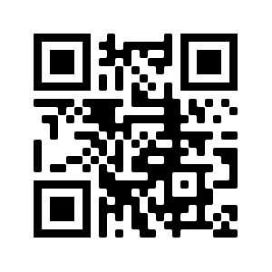

INSTRUCTIONAL STRATEGY NOTE SHEET
Strategy | How Was It Used? | How Can I Use It?
Technology Stations
First Word, Last Word
Four Corners/
Anchor Chart
Gallery Walk
3-2-1
I Notice…I Wonder…

