Picture a
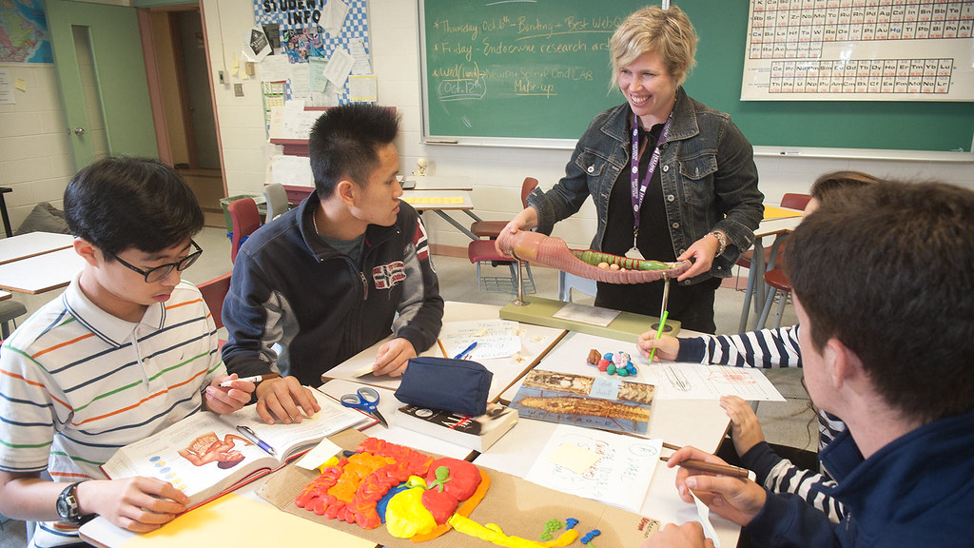
Government of Prince Edward Island. (2016). High school students in various classroom settings [Image]. Creative commons.
https://search.creativecommons.org/photos/a4254a18-eea3-43b1-b1c7-341caf90da6c

