Picture a
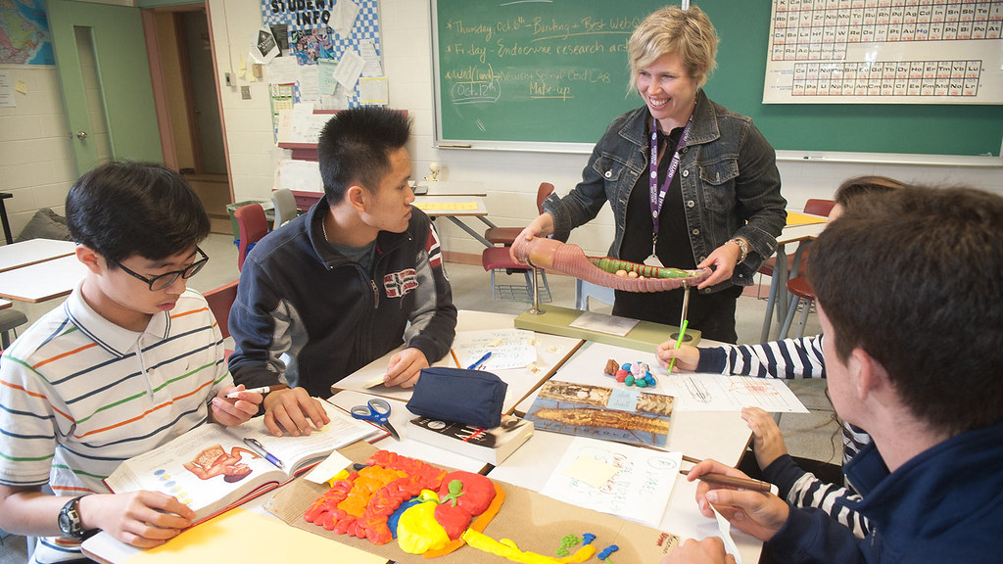
Image Source: Government of Prince Edward Island. (2016). High school students in various classroom settings. [image]. Creative commons.
Retrieved from https://search.creativecommons.org/photos/a4254a18-eea3-43b1-b1c7-341caf90da6c

