Picture b
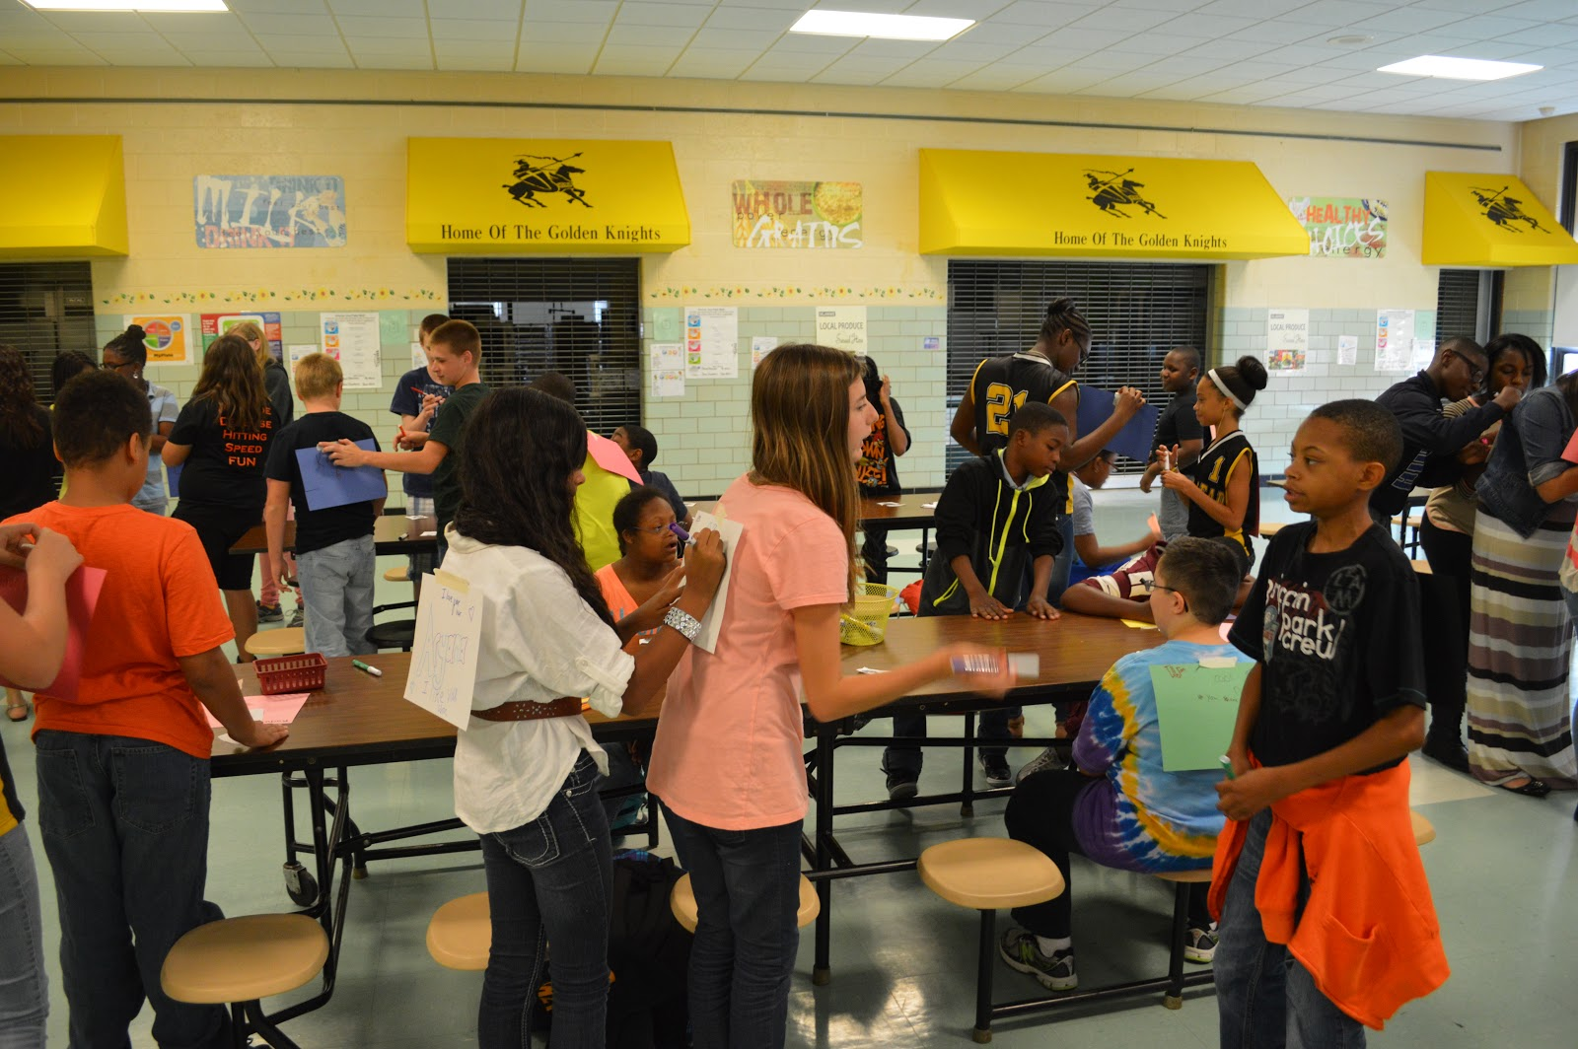
Image Source: George Reed Middle School (2013). Best buddies Delaware [Image]. Flickr. https://www.flickr.com/photos/bestbuddiesde/10074314494/in/photostream/

