Picture b
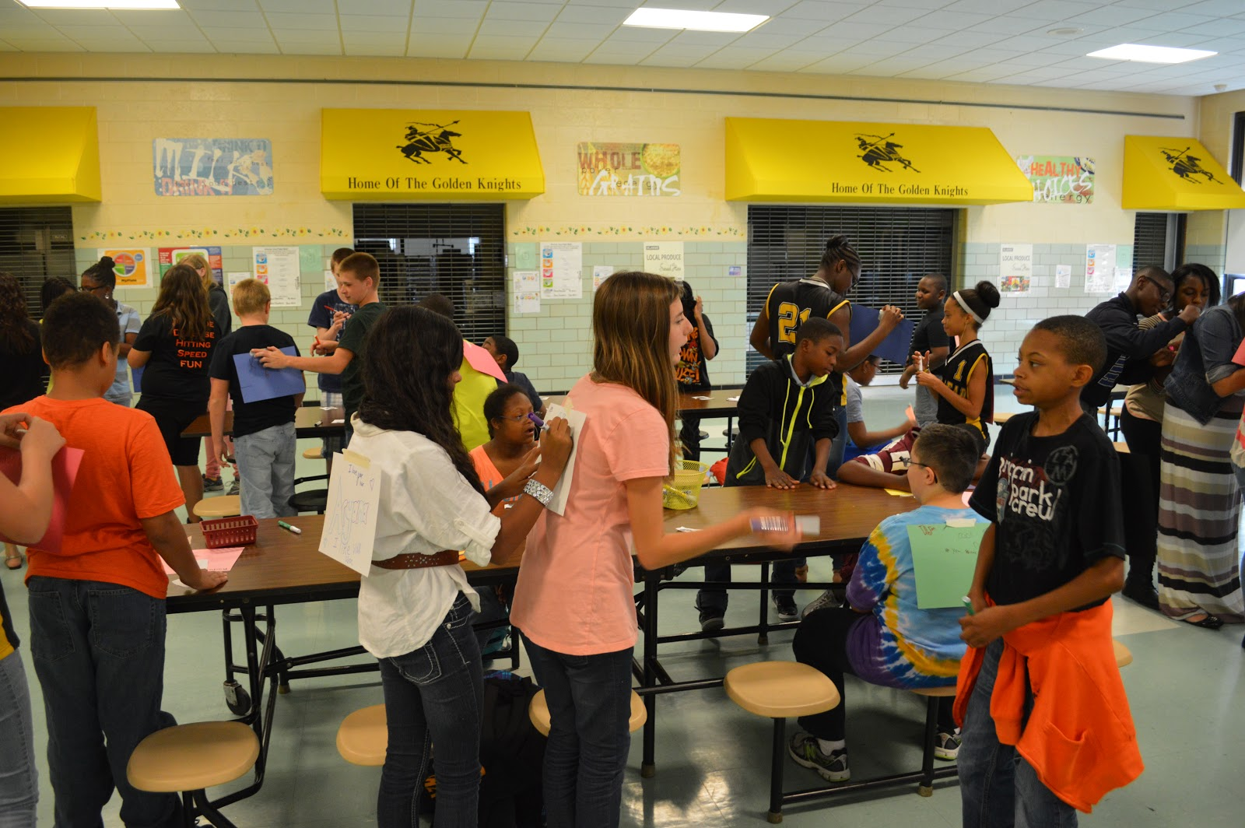
Image Source: George reed middle school (2013). Best buddies Delaware [image]. Flickr.com.
Retrieved from: https://www.flickr.com/photos/bestbuddiesde/10074314494/in/photostream/

