Picture c
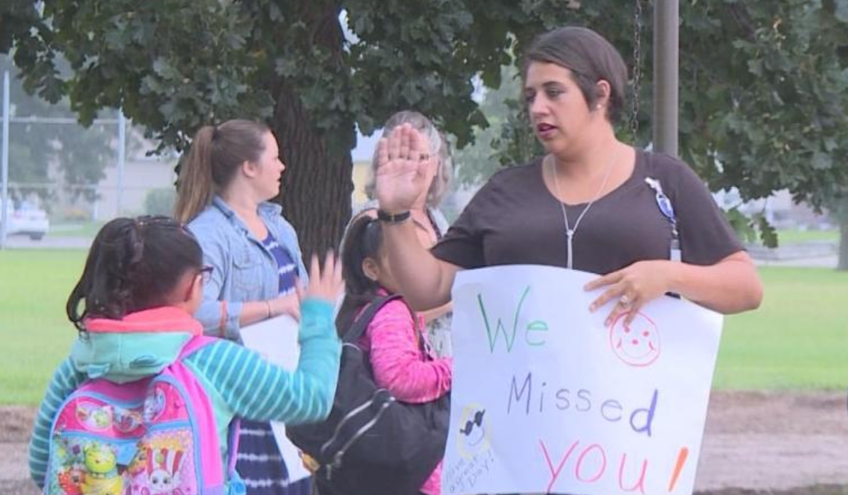
Image Source: Siebring, E. (2019). Teachers welcome students back to school in North Platte. KNOP-TV. [Image].
Retrieved from https://www.knopnews2.com/content/news/Teachers--welcome-students-back-to-school-in-North-Platte-554214081.html

