pass the problem #1
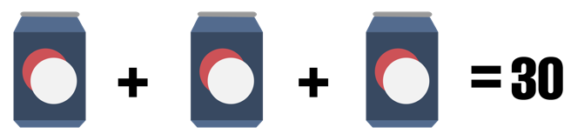
Solve Part 1 below, showing all your work. Then, pass the problem to another pair in your group. Check the work already completed before moving on to the next portion of the problem. Then, pass the problem again and repeat. When your problem returns to you, check all the work and discuss any differences with your group.

Part 1

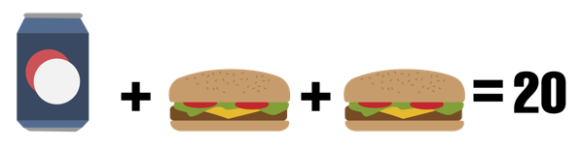
Part 2

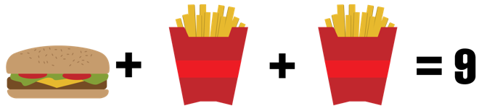
Part 3

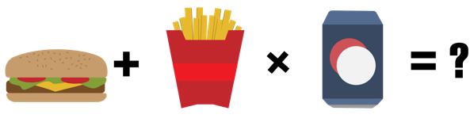
Part 4

Pass the Problem #2
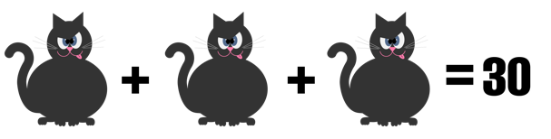
Solve Part 1 below, showing all your work. Then, pass the problem to another pair in your group. Check the work already completed before moving on to the next portion of the problem. Then, pass the problem again and repeat. When your problem returns to you, check all the work and discuss any differences with your group.

Part 1

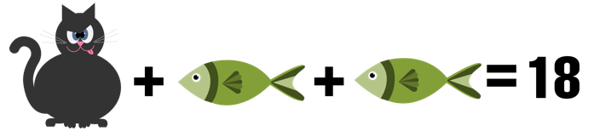
Part 2

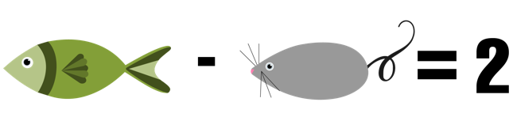

Part 3

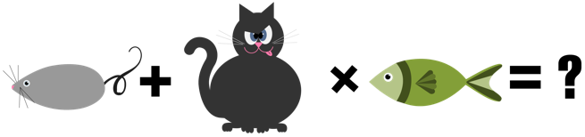
Part 4

Pass the Problem #3
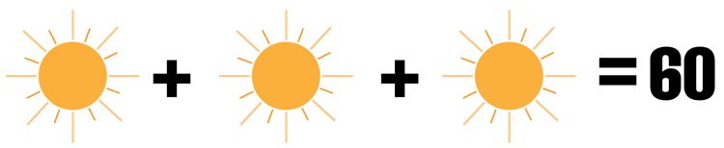
Solve Part 1 below, showing all your work. Then, pass the problem to another pair in your group. Check the work already completed before moving on to the next portion of the problem. Then, pass the problem again and repeat. When your problem returns to you, check all the work and discuss any differences with your group.

Part 1

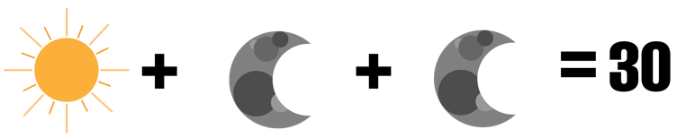
Part 2


Part 3

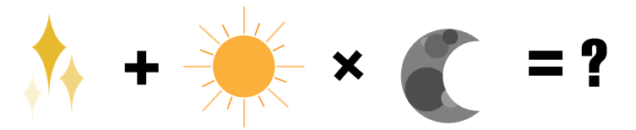
Part 4

