Excerpt from How People Learn (Bransford, 2004)
Chapter 6: The Design of Learning Environments
In this chapter we discuss implications of new knowledge about learning for the design of learning environments, especially schools. New developments in the science of learning raise important questions about the design of learning environments—questions that suggest the value of rethinking what is taught, how it is taught, and how it is assessed. The focus in this chapter is on general characteristics of learning environments that need to be examined in light of new developments in the science of learning.

CHANGES IN EDUCATIONAL GOALS
The learning goals for schools have undergone major changes during the past century. Everyone expects much more from today’s schools than was expected 100 years ago. A fundamental tenet of modern learning theory is that different kinds of learning goals require different approaches to instruction; new goals for education require changes in opportunities to learn.
Consider this description of changes in the definition of literacy and the goals for achieving it over the last two centuries in America.

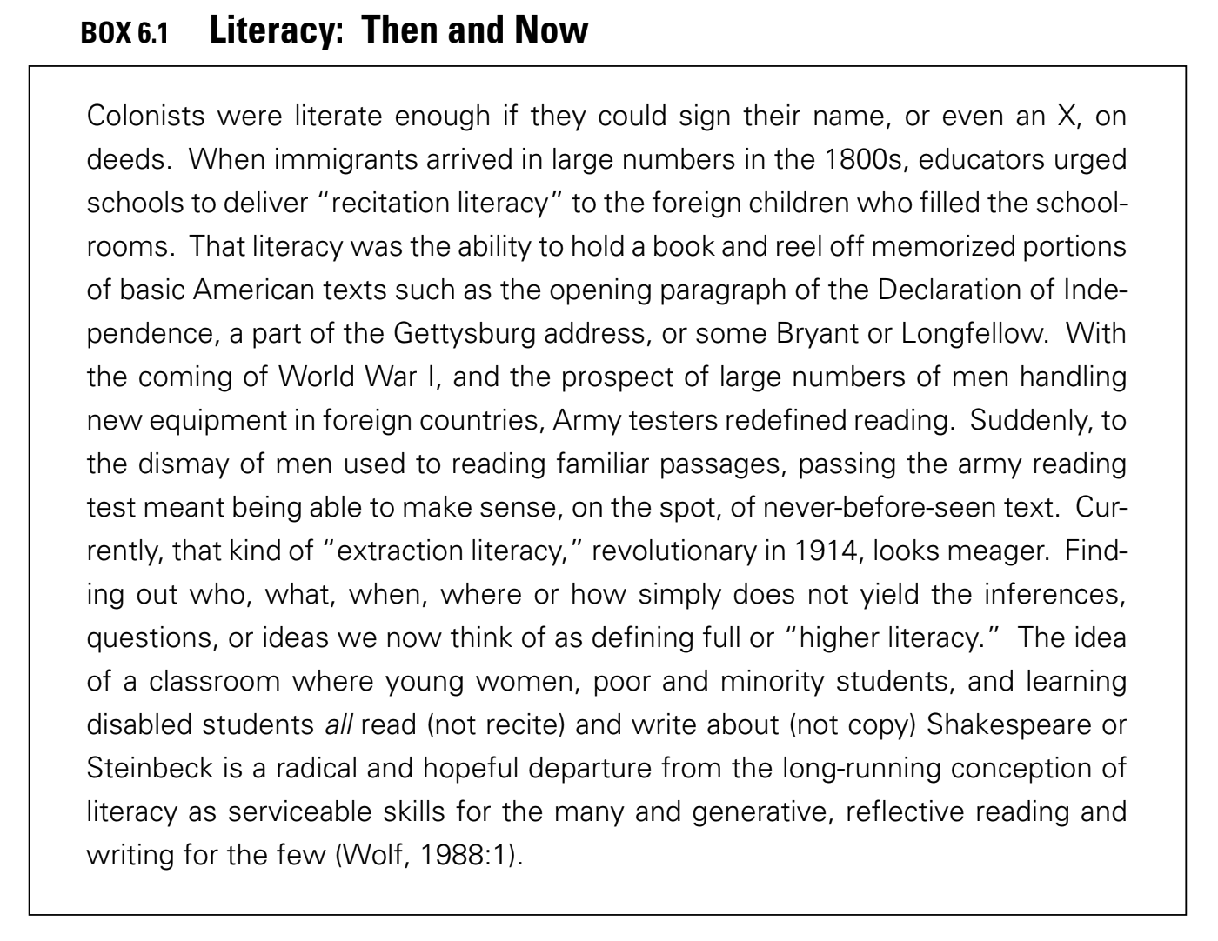
Today, students need to understand the current state of their knowledge and to build on it, improve it, and make decisions in the face of uncertainty. These two notions of knowledge were identified by John Dewey (1916) as “records” of previous cultural accomplishments and engagement in active processes as represented by the phrase “to do.” For example, doing mathematics involves solving problems, abstracting, inventing, proving. Doing history involves the construction and evaluation of historical documents. Doing science includes such activities as testing theories through experimentation and observation. Society now envisions graduates of school systems who can identify and solve problems and make contributions to society throughout their lifetime. To achieve this vision requires rethinking what is taught, how teachers teach, and how what students learn is assessed.
The remainder of this chapter is organized around Figure 6.1 below, which illustrates four perspectives on learning environments that seem particularly important given the principles of learning discussed in earlier chapters. Although we discuss these perspectives separately, they need to be conceptualized as a system of interconnected components that mutually support one another. We first discuss each perspective separately and then describe how they interrelate.
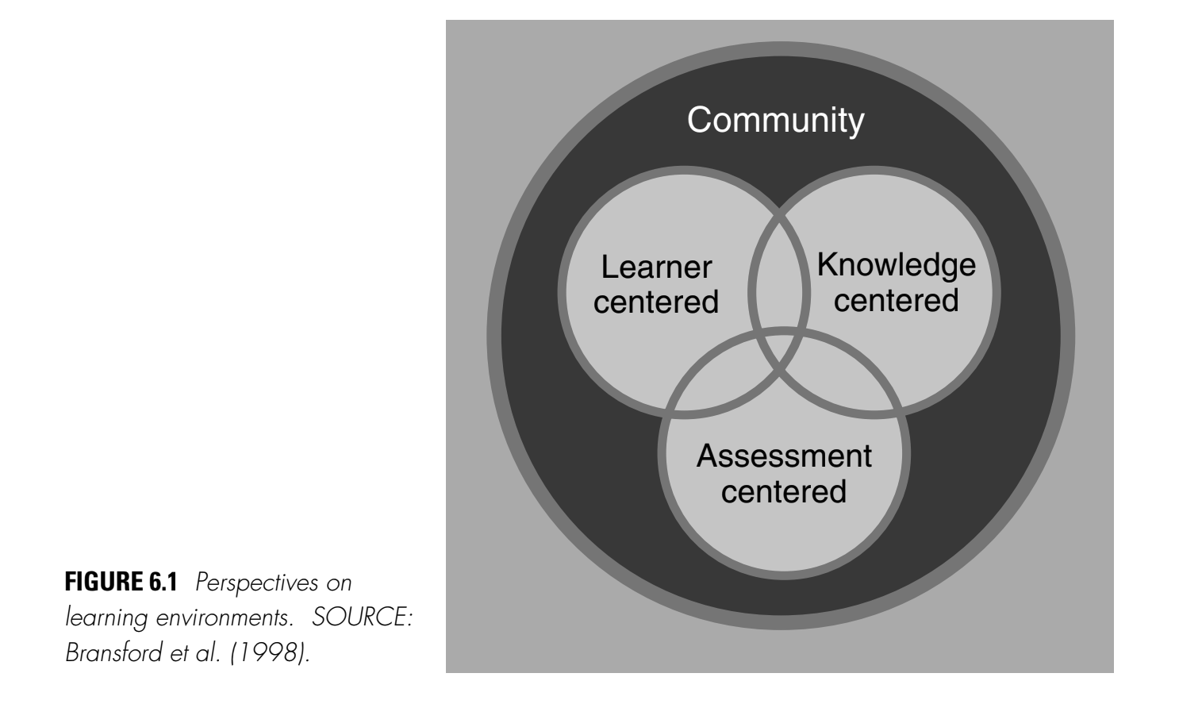

LEARNER-CENTERED ENVIRONMENTS
We use the term “learner centered” to refer to environments that pay careful attention to the knowledge, skills, attitudes, and beliefs that learners bring to the educational setting. This term includes teaching practices that have been called “culturally responsive,” “culturally appropriate,” “culturally compatible,” and “culturally relevant” (Ladson-Billings, 1995). The term also fits the concept of “diagnostic teaching” (Bell et al.,1980): attempting to discover what students think in relation to the problems on hand, discussing their misconceptions sensitively, and giving them situations to go on thinking about which will enable them to readjust their ideas. Teachers who are learner centered recognize the importance of building on the conceptual and cultural knowledge that students bring with them to the classroom.
Learner-centered instruction also includes a sensitivity to the cultural practices of students and the effect of those practices on classroom learning. For example, in a study of the Kamehameha School in Hawaii (Bell, 1985), teachers were deliberate in learning about students’ home and community cultural practices and language use. They incorporated them in classroom literacy instruction by including students’ home experiences as a part of the discussion of reading materials. These students demonstrated significant improvement in standardized test performance in reading.
Learner-centered teachers also respect the language practices of their students because they provide a basis for further learning. For example, in science, one standard way of talking in both school and professional science is impersonal and expository, without any reference to personal or social intentions or experiences (Lemke, 1990; Wertsch, 1991). This way, which predominates in schools, privileges middle-class, mainstream ways of knowing and constitutes a barrier for students from other backgrounds who do not come to school already practiced in “school talk” (Heath, 1983). To assist students in developing conceptual understanding, everyday and academic discourses should be coordinated.
Overall, learner-centered environments include teachers who are aware that learners construct their own meanings, beginning with the beliefs, understandings, and cultural practices they bring to the classroom. If teaching is conceived as constructing a bridge between the subject matter and the student, learner-centered teachers keep a constant eye on both ends of the bridge. The teachers attempt to get a sense of what students know and can do as well as their interests and passions—what each student knows, cares about, is able to do, and wants to do. Accomplished teachers “give learners reason,” by respecting and understanding learners’ prior experiences and understandings, assuming that these can serve as a foundation on which to build bridges to new understandings.

KNOWLEDGE-CENTERED ENVIRONMENTS
Environments that are solely learner centered would not necessarily help students acquire the knowledge and skills necessary to function effectively in society. The ability of experts to think and solve problems is not simply due to a generic set of “thinking skills” or strategies but, instead, requires well-organized bodies of knowledge that support planning and strategic thinking. Knowledge-centered environments take seriously the need to help students become knowledgeable by learning in ways that lead to understanding and subsequent transfer. Current knowledge on learning and transfer and development provide important guidelines for achieving these goals.
Knowledge-centered environments intersect with learner-centered environments when instruction begins with a concern for students’ initial preconceptions about the subject matter. People construct new knowledge based on their current knowledge. Without carefully considering the knowledge that students’ bring to the learning situation, it is difficult to predict what they will understand about new information that is presented to them. Knowledge-centered environments also include an emphasis on sense-making—on helping students become metacognitive by expecting new information to make sense and asking for clarification when it doesn’t.
There are interesting new approaches to the development of curricula that support learning with understanding and encourage sense making. One is “progressive formalization,” which begins with the informal ideas that students bring to school and gradually helps them see how these ideas can be transformed and formalized. Instructional units encourage students to build on their informal ideas in a gradual but structured manner so that they acquire the concepts and procedures of a discipline.
Central to curriculum frameworks such as “progressive formalization” are questions about what is developmentally appropriate to teach at various ages. Such questions represent another example of overlap between learner-centered and knowledge-centered perspectives. Older views that young children are incapable of complex reasoning have been replaced by evidence that children are capable of sophisticated levels of thinking and reasoning when they have the knowledge necessary to support these activities. An impressive body of research shows the potential benefit of early access by students to important conceptual ideas. In classrooms using a form of “cognitively guided” instruction in geometry, second-grade children’s skills for representing and visualizing three-dimensional forms exceeded those of comparison groups of undergraduate students at a leading university (Lehrer and Chazan, 1998). Young children have also demonstrated powerful forms of early algebraic generalization (Lehrer and Chazan, 1998). Forms of generalization in science, such as experimentation, can be introduced before the secondary school years through a developmental approach to important mathematical and scientific ideas (Schauble et al., 1995; Warren and Rosebery, 1996). Such an approach entails becoming cognizant of the early origins of students’ thinking and then identifying how those ideas can be fostered and elaborated (Brown and Campione, 1994).
Attempts to create environments that are knowledge centered also raise important questions about how to foster an integrated understanding of a discipline. Many models of curriculum design seem to produce knowledge and skills that are disconnected rather than organized into coherent wholes. Traditional curricula often fail to help students “learn their way around” a discipline. The curricula include the familiar scope and sequence charts that specify procedural objectives to be mastered by students at each grade: though an individual objective might be reasonable, it is not seen as part of a larger network. Yet it is the network, the connections among objectives, that is important. This is the kind of knowledge that characterizes expertise. Stress on isolated parts can train students in a series of routines without educating them to understand an overall picture that will ensure the development of integrated knowledge structures and information about conditions of applicability.
An alternative to simply progressing through a series of exercises that derive from a scope and sequence chart is to expose students to the major features of a subject domain as they arise naturally in problem situations. Activities can be structured so that students are able to explore, explain, extend, and evaluate their progress. Ideas are best introduced when students see a need or a reason for their use—this helps them see relevant uses of knowledge to make sense of what they are learning.
A challenge for the design of knowledge-centered environments is to strike the appropriate balance between activities designed to promote understanding and those designed to promote the automaticity of skills necessary to function effectively without being overwhelmed by attentional requirements. Students for whom it is effortful to read, write, and calculate can encounter serious difficulties learning. The importance of automaticity has been demonstrated in a number of areas.

ASSESSMENT-CENTERED ENVIRONMENTS
In addition to being learner centered and knowledge centered, effectively designed learning environments must also be assessment centered. The key principles of assessment are that they should provide opportunities for feedback and revision and that what is assessed must be congruent with one’s learning goals.
It is important to distinguish between two major uses of assessment. The first, formative assessment, involves the use of assessments (usually administered in the context of the classroom) as sources of feedback to improve teaching and learning. The second, summative assessment, measures what students have learned at the end of some set of learning activities. Examples of formative assessments include teachers’ comments on work in progress, such as drafts of papers or preparations for presentations. Examples of summative assessments include teacher-made tests given at the end of a unit of study and state and national achievement tests that students take at the end of a year. Ideally, teachers’ formative and summative assessments are aligned with the state and national assessments that students take at the end of the year; often, however, this is not the case. Issues of summative assessment for purposes of national, state, and district accountability are beyond the scope of this volume; our discussion focuses on classroom-based formative and summative assessments.
Formative Assessments and Feedback
Studies of adaptive expertise, learning, transfer, and early development show that feedback is extremely important. Students’ thinking must be made visible (through discussions, papers, or tests), and feedback must be provided. Given the goal of learning with understanding, assessments and feedback must focus on understanding, and not only on memory for procedures or facts (although these can be valuable, too). Assessments that emphasize understanding do not necessarily require elaborate or complicated assessment procedures. Even multiple-choice tests can be organized in ways that assess understanding.
Opportunities for feedback should occur continuously, but not intrusively, as a part of instruction. Effective teachers continually attempt to learn about their students’ thinking and understanding. They do a great deal of monitoring of both group work and individual performances, and they attempt to assess students’ abilities to link their current activities to
other parts of the curriculum and their lives. The feedback they give to students can be formal or informal. Effective teachers also help students build skills of self-assessment. Students learn to assess their own work, as well as the work of their peers, in order to help everyone learn more effectively. Such self-assessment is an important part of the metacognitive approach to instruction.
In many classrooms, opportunities for feedback appear to occur relatively infrequently. Most teacher feedback—grades on tests, papers, worksheets, homework, and on report cards—represent summative assessments that are intended to measure the results of learning. After receiving grades, students typically move on to a new topic and work for another set of grades. Feedback is most valuable when students have the opportunity to use it to revise their thinking as they are working on a unit or project. The addition of opportunities for formative assessment increases students’ learning and transfer, and they learn to value opportunities to revise. Opportunities to work collaboratively in groups can also increase the quality of the feedback available to students, although many students must be helped to learn how to work collaboratively. New technologies provide opportunities to increase feedback by allowing
students, teachers, and content experts to interact both synchronously and asynchronously.
A challenge of implementing good assessment practices involves the need to change many teachers’, parents’, and students’ models of what effective learning looks like. Many assessments developed by teachers overly emphasize memory for procedures and facts. In addition, many standardized tests that are used for accountability still overemphasize memory for isolated facts and procedures, yet teachers are often judged by how well their students do on such tests. One mathematics teacher consistently produced students who scored high on statewide examinations by helping students memorize a number of mathematical procedures that typically appeared on the examinations, but the students did not really understand what they were doing, and often could not answer questions that required an understanding of mathematics. Appropriately designed assessments can help teachers realize the need to rethink their teaching practices.

COMMUNITY-CENTERED ENVIRONMENTS
New developments in the science of learning suggest that the degree to which environments are community centered is also important for learning. Especially important are norms for people learning from one another and continually attempting to improve. We use the term community centered to refer to several aspects of community, including the classroom as a community, the school as a community, and the degree to which students, teachers, and administrators feel connected to the larger community of homes, businesses, states, the nation, and even the world.

Classroom and School Communities
At the level of classrooms and schools, learning seems to be enhanced by social norms that value the search for understanding and allow students (and teachers) the freedom to make mistakes in order to learn. Different classrooms and schools reflect different sets of norms and expectations. For example, an unwritten norm that operates in some classrooms is never to get caught making a mistake or not knowing an answer. This norm can hinder students’ willingness to ask questions when they do not understand the material or to explore new questions and hypotheses. Some norms and expectations are more subject specific. For example, the norms in a mathematics class may be that mathematics is knowing how to compute answers; a much better norm would be that the goal of inquiry is mathematical understanding. Different norms and practices have major effects on what is taught and how it is assessed. Sometimes there are different sets of expectations for different students. Teachers may convey expectations for school success to some students and expectations for school failure to others. For example, girls are sometimes discouraged from participating in higher level mathematics and science. Students, too, may share and convey cultural expectations that prohibit the participation of girls in some classes.
Classroom norms can also encourage modes of participation that may be unfamiliar to some students. For example, some groups rely on learning by observation and listening and then becoming involved in ongoing activities; school-like forms of talking may be unfamiliar for the children whose community has only recently included schools. Box 6.3 below describes an example of this cultural mismatch.
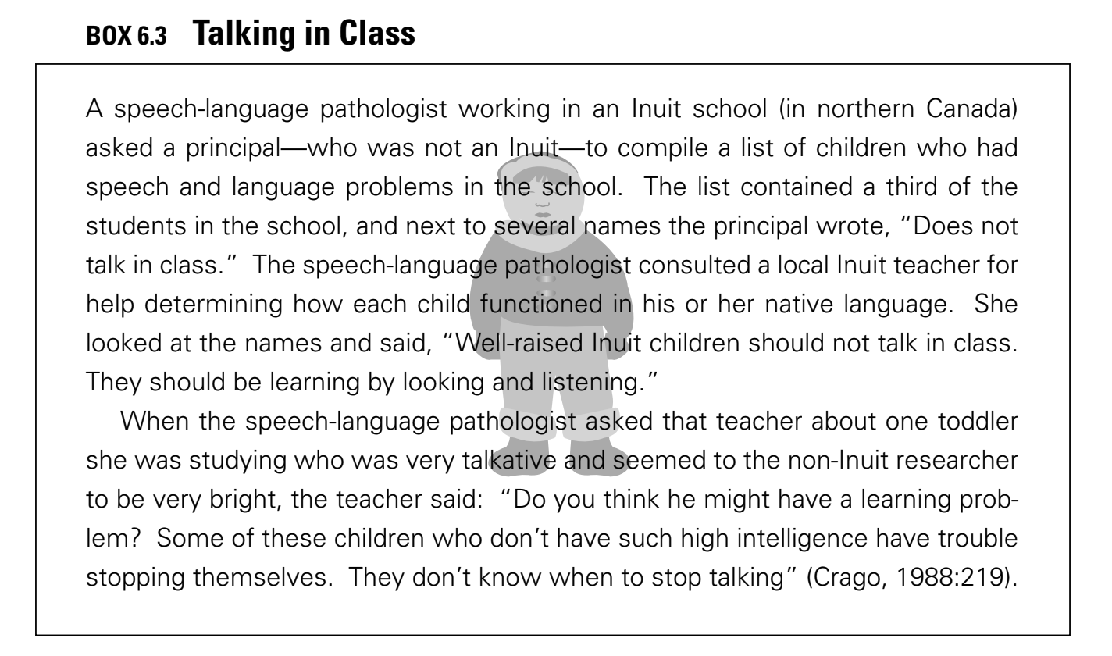
The sense of community in classrooms is also affected by grading practices, and these can have positive or negative effects depending on the students. For example, Navajo high school students do not treat tests and grades as competitive events the way that Anglo students do. An Anglo high school counselor reported that Navajo parents complained about their children being singled out when the counselor started a “high achiever” bulletin board and wanted to post the pictures of students with B averages or better. The counselor “compromised” by putting up happy stickers with the students’ names on them. A Navajo student, staring at the board said, “The board embarrasses us, to be stuck out like that” (Deyhle and Margonis, 1995). More broadly, competition among students for teacher attention, approval, and grades is a commonly used motivator in U.S. schools. And in some situations, competition may create situations that impede learning. This is especially so if individual competition is at odds with a community ethic of individuals’ contributing their strengths to the community (Suina and Smolkin, 1994).
The sense of community in a school also appears to be strongly affected by the adults who work in that environment. Studies by Bray (1998) and Talbert and McLaughlin (1993) emphasize the importance of teacher learning communities. Barth (1988) states:
“The relationship among adults who live in a school has more to do with the character and quality of the school and with the accomplishments of the students than any other factor.”
Connections to the Broader Community
An analysis of learning environments from the perspective of community also includes a concern for connections between the school environment and the broader community, including homes, community centers, after-school programs, and businesses. Learning takes time. Ideally, what is learned in school should be connected to out-of-school learning and vice versa. Often, however, this ideal is not reached. As John Dewey (1916) noted long ago:
“From the standpoint of the child, the great waste in school comes from his inability to utilize the experience he gets outside . . . while on the other hand, he is unable to apply in daily life what he is learning in school. That is the isolation of the school—it’s isolation from life.”
The importance of connecting the school with outside learning activities can be appreciated by considering Figure 6.3, which shows the percentage of time during a typical school year that students spend in school, sleeping, and engaged in other activities. The percentage of time spent in school is comparatively small. If students spend one-third of their non-sleeping time outside of school watching television or engaging with social media, this means that they spend more time in these activities in a year than they spend in school.
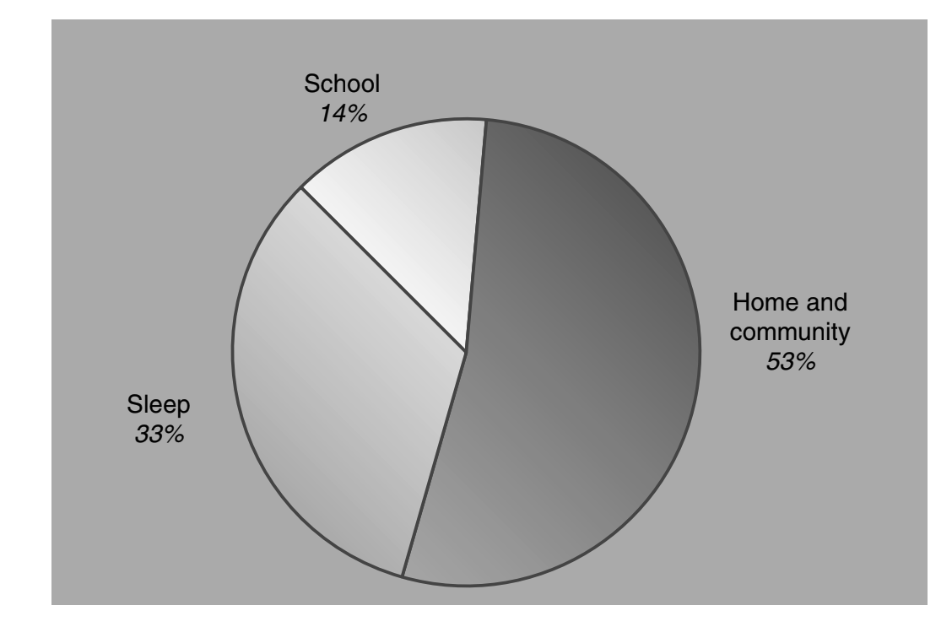

Figure 6.3 Comparison of time spent in school, home and community, and sleep. Percentages were calculated using 180 school days each year estimated to be 6.5 hours in length.

A key environment for learning is the family. Even when family members do not focus consciously on instructional roles, they provide resources for children’s learning, activities in which learning occurs, and connections to community. Children also learn from the attitudes of family members toward skills and values of schooling.
The success of the family as a learning environment, especially in children’s early years, has provided inspiration and guidance for some of the changes recommended in schools. The phenomenal development of children from birth to age 4 or 5 is generally supported by family interactions in which children learn by engaging with and observing others in shared endeavors. Conversations and other interactions that occur around events of interest with trusted and skilled adult and child companions are especially powerful environments for children’s learning. Many of the recommendations for changes in schools can be seen as extensions of the learning activities that occur within families. In addition, recommendations to include families in classroom activities and planning hold promise of bringing together two powerful systems for supporting children’s learning.

Children participate in many other institutions outside their homes that can foster learning. Some of these institutions have learning as part of their goals, including many after-school programs, organizations, museums, and religious groups. Connections to experts outside of school can also have a positive influence on in-school learning because they provide opportunities for students to interact with parents and other people who take an interest in what students are doing. It can be very motivating, both to students and teachers, to have opportunities to share their work with others.
The idea of outside audiences who present challenges (complete with deadlines) has been incorporated into a number of instructional programs. Working to prepare for outsiders provides motivation that helps teachers maintain student interest. In addition, teachers and students develop a better sense of community as they prepare to face a common challenge. Students are also motivated when they share with outside audiences who do not come to the classroom but will see their projects. New technologies that enhance the ability to connect classrooms to others in the school, to parents, business leaders, college students, content area experts, and others around the world can increase access to knowledge and provide a means for promoting learning.

THE IMPORTANCE OF ALIGNMENT
In the beginning of this chapter we noted that the four perspectives on learning environments (the degree to which they are learner, knowledge, assessment, and community centered) would be discussed separately but ultimately needed to be aligned in ways that mutually support one another. Alignment is as important for schools as it is for organizations in general. A key aspect of curriculum development and assessment is the idea of aligning goals for learning with what is taught, how it is taught, and how it is assessed (both formatively and summatively). Without this alignment, it is difficult to know what is being learned. Students may be learning valuable information, but one cannot tell unless there is alignment between what they are learning and the assessment of that learning. Similarly, students may be learning things that others don’t value unless curricula and assessments are aligned with the broad learning goals of communities.
A systems approach to promote coordination among activities is needed to design effective learning environments. Many schools have checklists of innovative practices, such as the use of collaborative learning, teaching for understanding and problem solving, and using formative assessment. Often, however, these activities are not coordinated with one another. Teaching for understanding and problem solving may be “what we do on Fridays”; collaborative learning may be used to promote memorization of fact-based tests; and formative assessments may focus on skills that are totally disconnected from the rest of the students’ curriculum. In addition, students may be given opportunities to study collaboratively for tests yet be graded on a curve so that they compete with one another rather than trying to meet particular performance standards. In these situations, activities in the classroom are not aligned.
Activities within a particular classroom may be aligned yet fail to fit with the rest of the school. And a school as a whole needs to have a consistent alignment. Some schools communicate a consistent policy about norms and expectations for conduct and achievement. Others send mixed messages. For example, teachers may send behavior problems to the principal, who may inadvertently undermine the teacher by making light of the students’ behavior. Similarly, schedules may or may not be made flexible in order to accommodate in-depth inquiry, and schools may or may not be adjusted to minimize disruptions, including non-academic “pullout” programs and even the number of classroom interruptions made by a principal’s overzealous use of the classroom intercom. Overall, different activities within a school
may or may not compete with one another and impede overall progress. When principals and teachers work together to define a common vision for their entire school, learning can improve.
Activities within schools must also be aligned with the goals and assessment practices of the community. Ideally, teachers’ goals for learning fit with the curriculum they teach and with the school’s goals which, in turn, fit the goals implicit in the tests of accountability used by the school system. Often these factors are out of alignment. Effective change requires a simultaneous consideration of all these factors. New scientific findings about learning provide a framework for guiding systemic change.

CONCLUSION
The goals and expectations for schooling have changed quite dramatically during the past century, and new goals suggest the need to rethink such questions as what is taught, how it is taught, and how students are assessed. We emphasized that research on learning does not provide a recipe for designing effective learning environments, but it does support the value of asking certain kinds of questions about the design of learning environments.

Four perspectives on the design of learning environments—the degree to which they are student centered, knowledge centered, assessment centered, and community centered—are important in designing these environments.
A focus on the degree to which environments are learner-centered is consistent with the strong body of evidence suggesting that learners’ use their current knowledge to construct new knowledge and that what they know and believe at the moment affects how they interpret new information. Sometimes learners’ current knowledge supports new learning, sometimes it hampers learning: effective instruction begins with what learners bring to the setting; this includes cultural practices and beliefs as well as knowledge of academic content.

Learner-centered environments attempt to help students make connections between their previous knowledge and their current academic tasks. Parents are especially good at helping their children make connections. Teachers have a harder time because they do not share the life experiences of each of their students. Nevertheless, there are ways to systematically become familiar with each student’s special interests and strengths.
Effective environments must also be knowledge-centered. It is not sufficient only to attempt to teach general problem solving and thinking skills; the ability to think and solve problems requires well-organized knowledge that is accessible in appropriate contexts. An emphasis on being knowledge-centered raises a number of questions, such as the degree to which instruction begins with students’ current knowledge and skills, rather than simply presents new facts about the subject matter. While young students are capable of grasping more complex concepts than was believed previously, those concepts must be presented in ways that are developmentally appropriate. A knowledge-centered perspective on learning environments also highlights the importance of thinking about designs for curricula. To what extent do they help students learn with understanding versus promote the acquisition of disconnected sets of facts and skills? Curricula that emphasize an excessively broad range of subjects run the risk of developing disconnected rather than connected knowledge; they fit well with the idea of a curriculum as being a well-worn path in a road. An alternative metaphor for curriculum is to help students develop interconnected pathways within a discipline so that they “learn their away around in it” and not lose sight of where they are.
Issues of assessment also represent an important perspective for viewing the design of learning environments. Feedback is fundamental to learning, but opportunities to receive it are often scarce in classrooms. Students may receive grades on tests and essays, but these are summative assessments that occur at the end of projects; also needed are formative assessments that provide students opportunities to revise and hence improve the quality of their thinking and learning. Assessments must reflect the learning goals that define various environments. If the goal is to enhance understanding, it is not sufficient to provide assessments that focus primarily on memory for facts and formulas. Many instructors have changed their approach to teaching after seeing how their students failed to understand seemingly obvious (to the expert) ideas.
The fourth perspective on learning environments involves the degree to which they promote a sense of community. Ideally, students, teachers, and other interested participants share norms that value learning and high standards. Norms such as these increase people’s opportunities to interact, receive feedback, and learn. There are several aspects of community, including the community of the classroom, the school, and the connections between the school and the larger community, including the home. The importance of connected communities becomes clear when one examines the relatively small amount of time spent in school compared to other settings. Activities in homes, community centers, and after-school clubs can have important effects on students’ academic achievement.
Finally, there needs to be alignment among the four perspectives of learning environments. They all have the potential to overlap and mutually influence one another. Issues of alignment appear to be very important for accelerating learning both within and outside of schools.

This document is an excerpt from How People Learn: Brain, Mind, Experience, and School, Chapter 6: The Design of Learning Environments. To view the entire chapter with references and citations, use this PDF Link: https://drive.google.com/file/d/1zAoyIN8jc8GwQ2ZzoaEhbt3uFScoqz28/view?usp=sharing

You may also download the entire book for free from The National Academies Press at this link: https://www.nap.edu/catalog/9853/how-people-learn-brain-mind-experience-and-school-expanded-edition

Citation:
National Research Council. 2000. How People Learn: Brain, Mind, Experience, and School: Expanded Edition. Washington, DC: The National Academies Press. https://doi.org/10.17226/9853.

