strategy QR Codes
Fear of Being Wrong
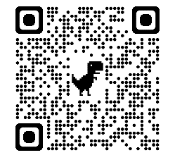  My Favorite Mistake  bit.ly/3qwblM2 |  | 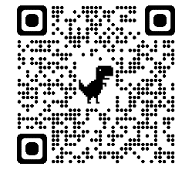  Collective Brain Dump  bit.ly/3HqTf4c |  |  | 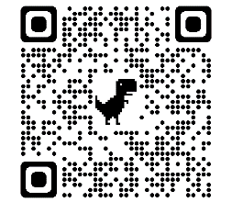  Fold the Line  bit.ly/3CqFL4K |  |  | 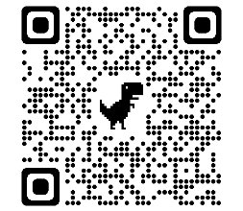  Stand Up, Sit Down  bit.ly/3ozjLzJ
No Peer-to-Peer Talk
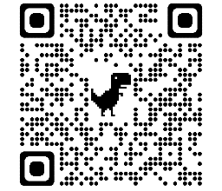  Appointment Clocks  bit.ly/2YHuxLn |  | 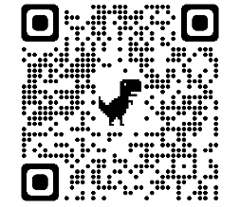  Chat Stations  bit.ly/3DlS6Zq |  |  | 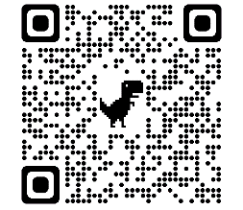  4-2-1  bit.ly/3cfVpFF |  |  | 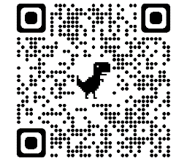  I Think/We Think  bit.ly/3HhfxVU
Off Task/Off Topic
Designing Group Work  (PDF, p.4-5)  bit.ly/3kxcsHy |  | 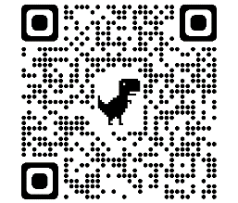  Three Stray, One Stays  bit.ly/327vDl3 |  |  | 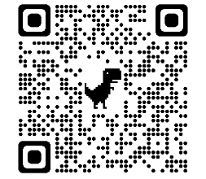  Inverted Pyramid  bit.ly/3CgeBgU |  |  | 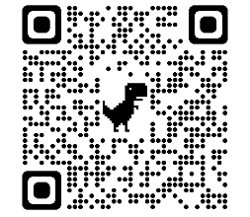  Strike Out!  bit.ly/3owE0hz
Lack of Response
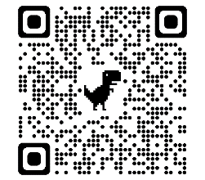  Talk Moves  bit.ly/3Df2p1b |  |  | 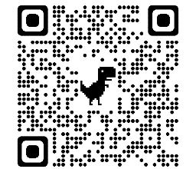  Establishing Norms  bit.ly/3kIy4Rw |  |  |  | 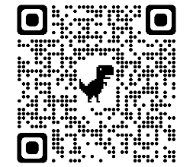  Standard Operating Procedure (SOP)  bit.ly/3kHNCos
Other Strategies
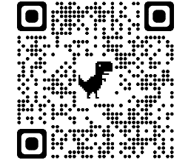  This Session Will Be a Success If…  bit.ly/3n9xWMk | 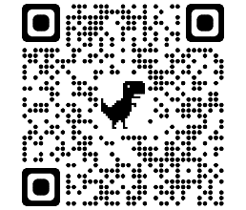  I Used To Think...but Now I Know  bit.ly/3qz12qQ |  |  | 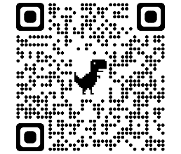  Four Corners  bit.ly/3F2y1aW |  | 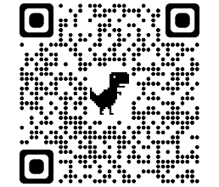Partner Speaks  bit.ly/3wIRive |  |  | 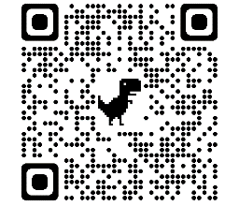Collaborative Word Clouds  bit.ly/3ktvQVN
Additional Resources
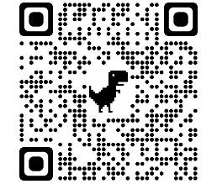  Ambitious Science Teaching: How Do I…?  bit.ly/3FrBYpZ | 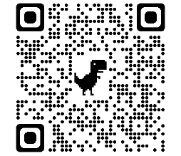  Talk Activities Flow Chart  bit.ly/3n7UYn0 |  |  | 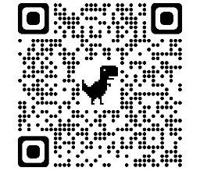  Accountable Talk Sourcebook  bit.ly/3CnC9Ak |  | 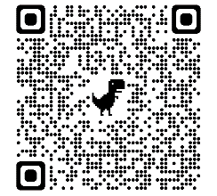  Talk as Assessment Opportunity  bit.ly/3ooT54D |  |  | 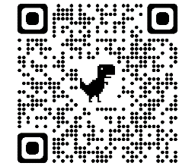Establishing Discussion Norms  bit.ly/3c4Vvj1

