CER (Claim, Evidence, Reasoning)

Explore the Billion-Dollar Weather and Climate Disasters Data - https://www.ncdc.noaa.gov/billions/mapping

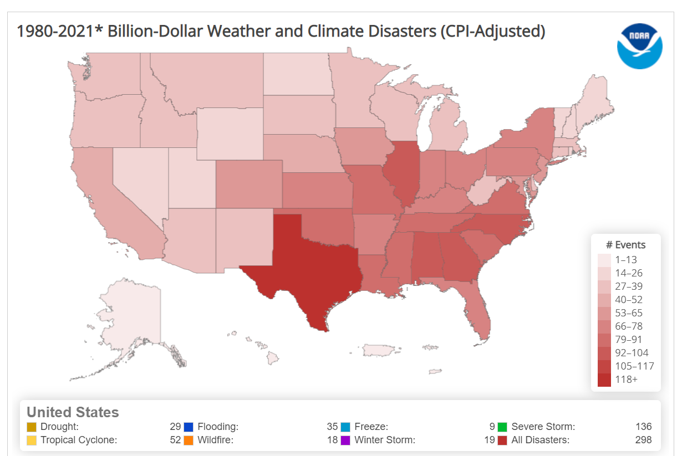

State your claim about severe weather events have changed over time:

Provide evidence from the website:

Provide your reasoning for how the evidence justifies your claim:

