VOCABULARY STRATEGIES LIST
Vocabulary Strategy | Website | QR Code
10,000 Pyramid | The Teacher Toolkit | 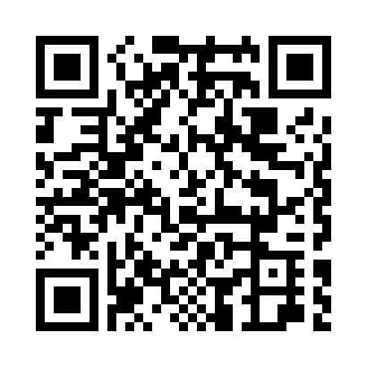
Academic Vocabulary Word Lists | Oklahoma State Department of Education | 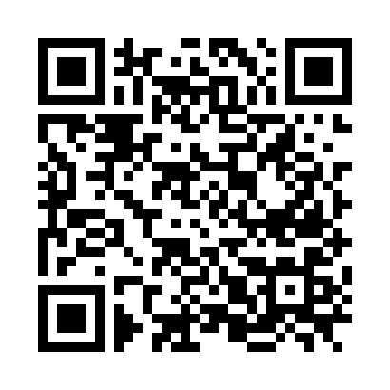
BAV Graphic Organizer | Oklahoma State Department of Education | 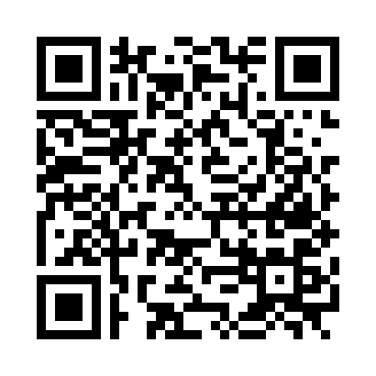
Building Academic Vocabulary Games | Oklahoma State Department of Education | 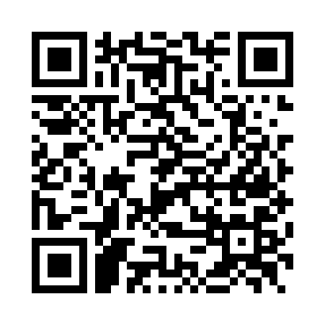
Cognitive Comics | K20 Center LEARN Strategies | 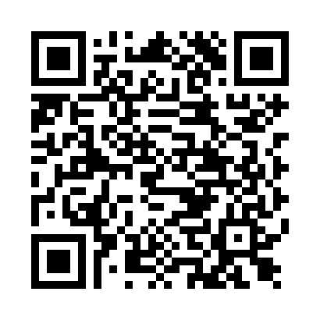
Kick Me | K20 Center LEARN Strategies | 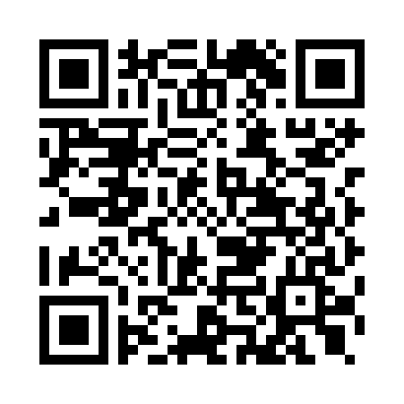
Quizlet | Quizlet | 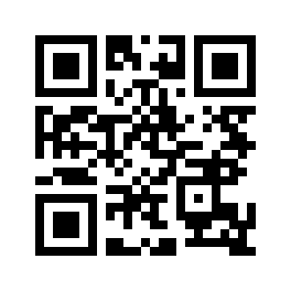
Quiz, Quiz, Trade | The Teacher Tool Kit | 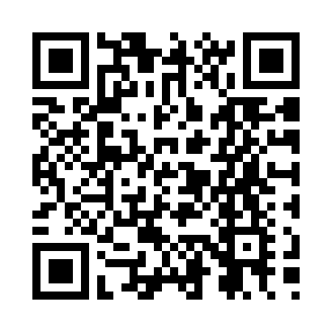
Rock and Roll Vocabulary | lead4ward | 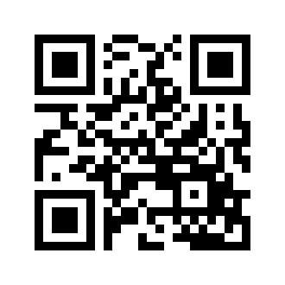
Talk a Mile a Minute | Snow, Vance and Associates | 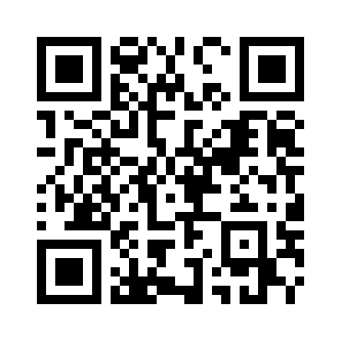
Vocabulary Book Foldable | University of Victoria | 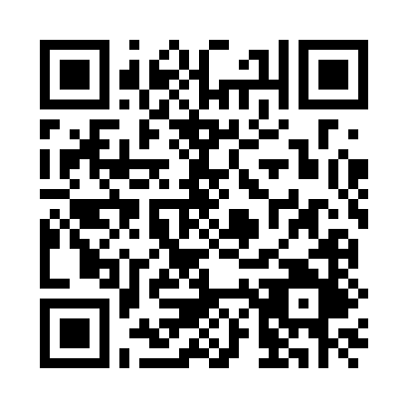
Vocabulary Charades | K20 Center LEARN Strategies | 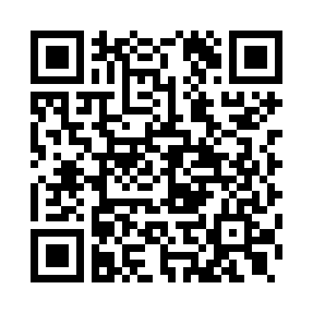
Vocabulary Taboo | Game on Family | 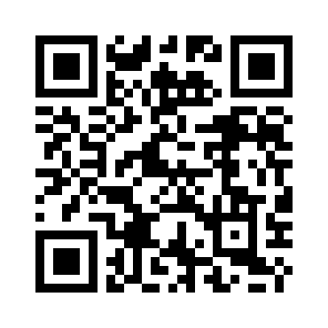
Word Splash | K20 Center LEARN Strategies | 