Growing Shapes
Objective:
Using algebraic reasoning, students discover growing patterns in various forms.
Materials:
- Record sheet
- Notebook paper
- Image of the growing pattern (pg. 61 and 220 from Boaler, J.)
- Linking cubes
- Pencil

Process:
- Display the growing pattern picture to the students, and give each student a record sheet.
- Ask the students, “How do you see the shapes growing?”
- In small groups (2–3 students per group), have the students discuss what they saw in the growing shape
- Students can draw or use linking cubes to show their growing shape
- As a whole class, display and discuss the different ways student discovered the growing pattern.
- Have students create their own growing pattern using the linking cubes and draw the first three images on a notebook paper.
- Have students switch pattern papers with a partner to see if their partner can discover their pattern.

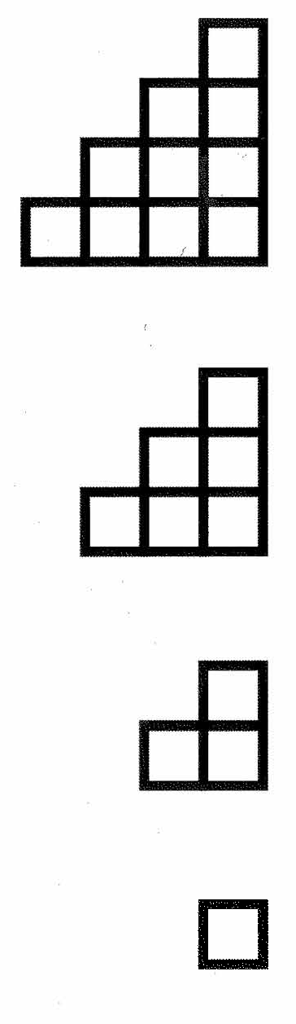

Resources
Boaler, J. (2016). Mathematical mindsets. Jossey-Bass.

