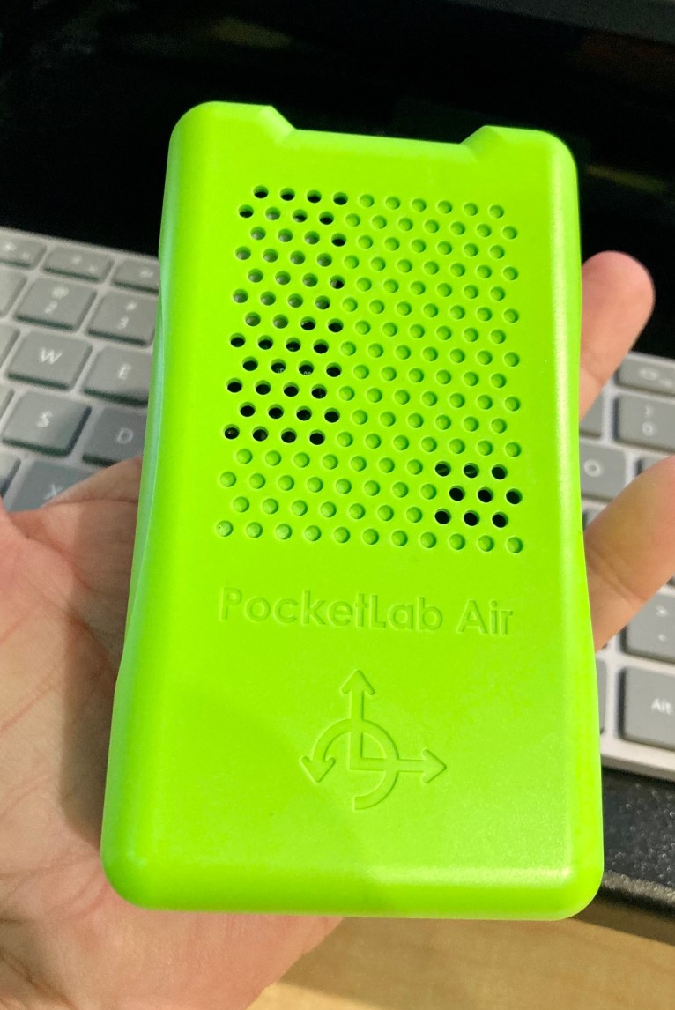
TASK CARD: AIR SENSOR
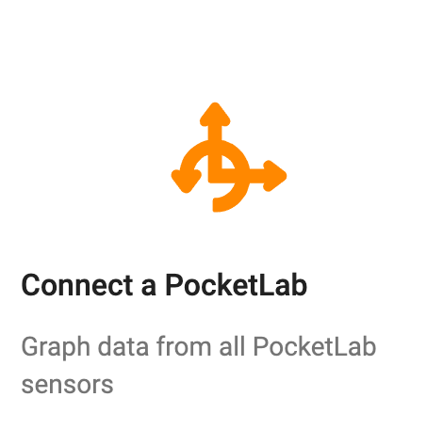
Directions
- Open the app and click on the “Connect a PocketLab” square at the top.
- Turn on PocketLab. It should appear in
the menu box. Click on “PL Air.”
Investigate
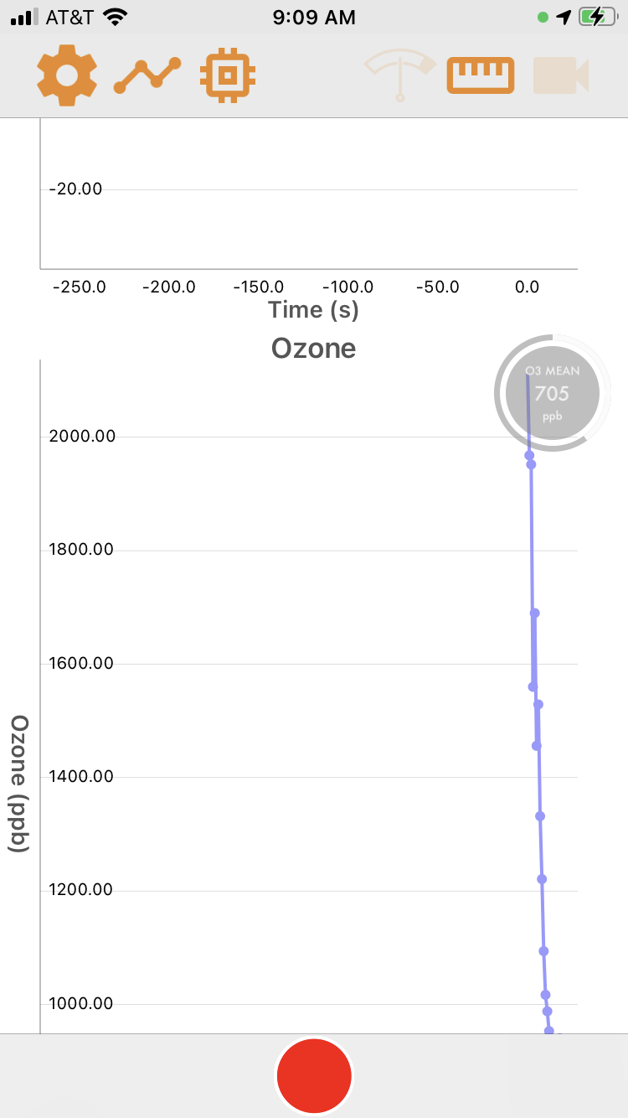
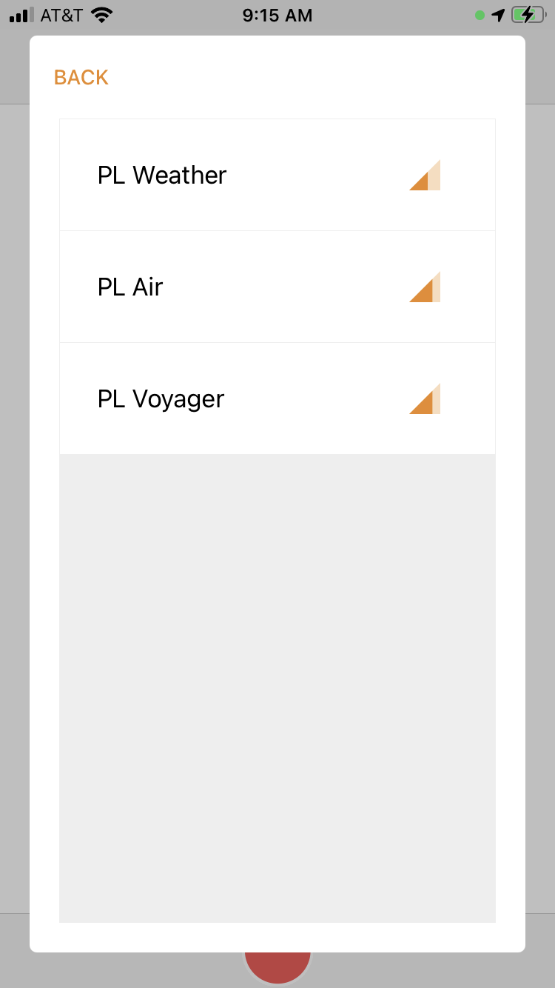
- Click on the graph icon at the top.
  - How many different types of data
can it collect?
  - How many graphs can it create at
one time?
- Click on the ruler icon at the top.
- How many different measurements can it take?
- What does this icon allow students to change?
- Using the graph icon, set some parameters, and hit the record button. Record for 30 seconds.
- Then, hit the stop button and look at your data.
- How can students change the x- and y-axis scales to see more in-depth data?
- Click on the share icon on the far right.
  - What two things can students do with their data?
  - Use the blue “clear” button at the bottom to clear the data you recorded.
- Click on the memory icon to the right of the graph icon at the top. What does this enable students to do?
- Free play…

PocketLab Measurements Explained: shorturl.at/yJKNV
TASK CARD: WEATHER SENSOR
Directions
- Open the app and click on the “Connect a PocketLab” square at the top.
- Turn on PocketLab. It should appear in
the menu box. Click on “PL Weather.”
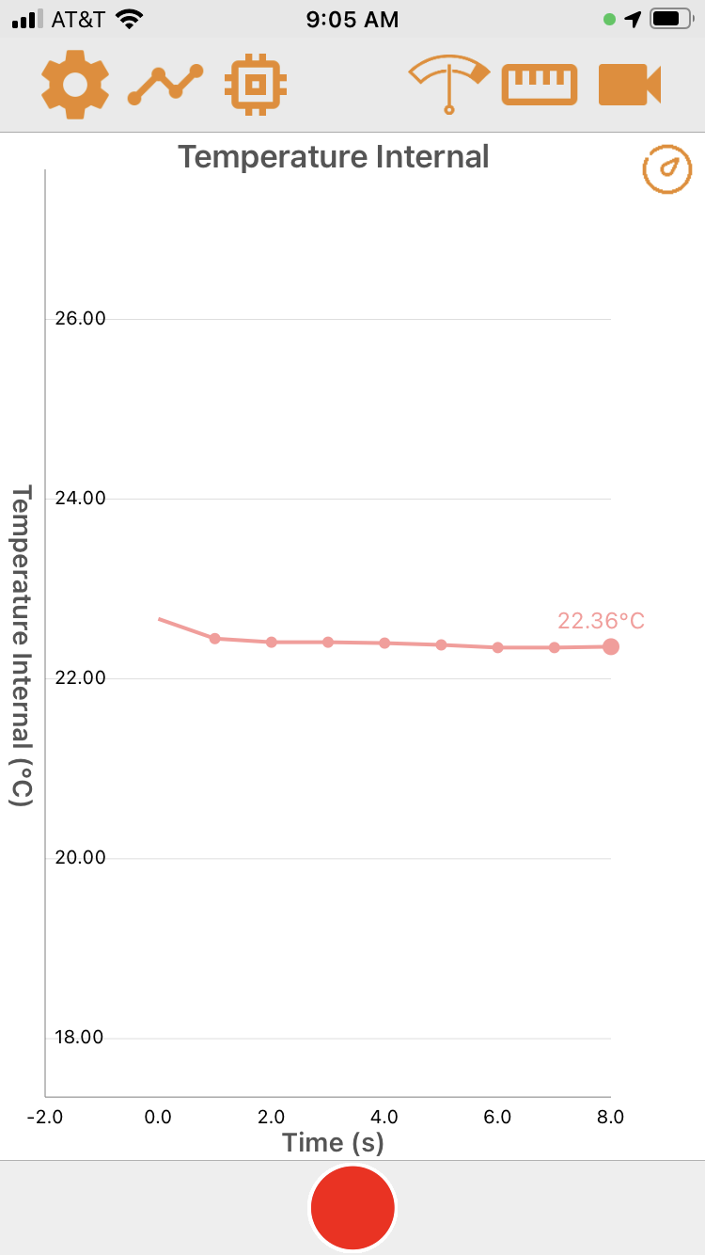
Investigate
- Click on the graph icon at the top.
  - How many different types of data
can it collect?
  - How many graphs can it create at
one time?
- Click on the ruler icon at the top.
  - How many different measurements
can it take?
  - What does this icon allow students
to change?
  - Using the graph icon, set some parameters, and hit the record button. Record for 30 seconds.
  - Then, hit the stop button and look at your data.
- Click on the share icon on the far right.
  - What two things can students do with their data?
  - Use the blue “clear” button at the bottom to clear the data you recorded.
- Click on the gas tank icon. What does this allow students to change?
- Click on the video icon. What happened?
- Free play…

PocketLab Measurements Explained: shorturl.at/yJKNV
TASK CARD: VOYAGER SENSOR
Directions
- Open the app and click on the “Connect a PocketLab” square at the top.
- Turn on PocketLab. It should appear in
the menu box. Click on “PL Voyager.”
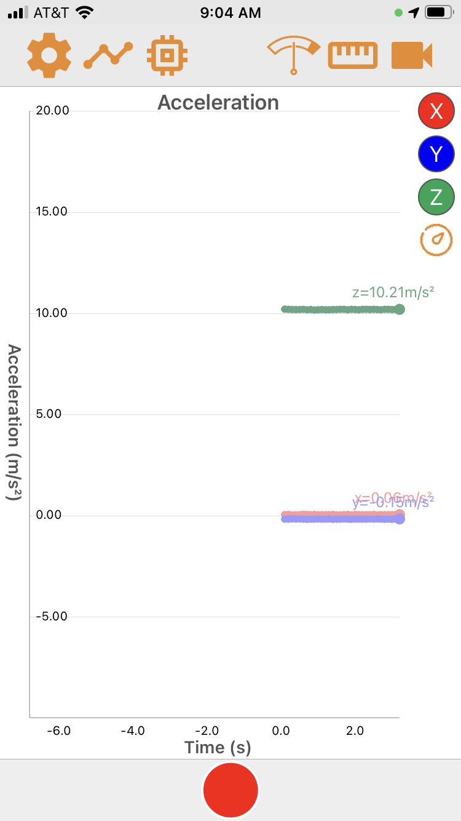
Investigate
- Click on the graph icon at the top.
  - How many different types of data
can it collect?
  - How many graphs can it create at
one time?
- Click on the ruler icon at the top.
  - How many different measurements
can it take?
  - What does this icon allow students
to change?
  - Using the graph icon, set some parameters, and hit the record button. Record for 30 seconds.
  - Then, hit the stop button and look at your data.
- Click on the share icon on the far right.
  - What two things can students do with their data?
  - Use the blue “clear” button at the bottom to clear the data you recorded.
- Click on the gas tank icon. What does this allow students to change?
- Click on the video icon. What happened?
- Free play…

Acceleration: shorturl.at/orPV2
RED X =
BLUE Y =
GREEN Z =

PocketLab Measurements Explained: shorturl.at/yJKNV

