Wave Stations

Station 1: Tuning Forks

Materials
- Two tuning forks
- Beaker of water

Procedure
- Take one tuning fork and hold it by the handle. Note the number listed on the bottom of the tuning fork. Tap the tuning fork lightly on a flat surface such as a table or a counter.
- Observe how the tuning fork vibrates and listen to the sound it makes.
- Again, lightly tap the tuning fork on the table or counter, but this time pay attention to what happens as you place the tip of the tuning fork against the surface of the water in the beaker.
- Repeat steps 1–3 with the other tuning fork.

Questions
- Compare the observations you made about the two different tuning forks. Is there a relationship between the sound a tuning fork makes and the number on the tuning fork? If so, what is the relationship?

- What happened to the water when you placed a tuning fork on its surface?

- Do you think the sound of the tuning forks is caused by vibration (producing waves)? Explain.

CLEAN THE LAB STATION AREA and RETURN ALL MATERIALS TO THEIR ORIGINAL POSITIONS before moving on to the next station.

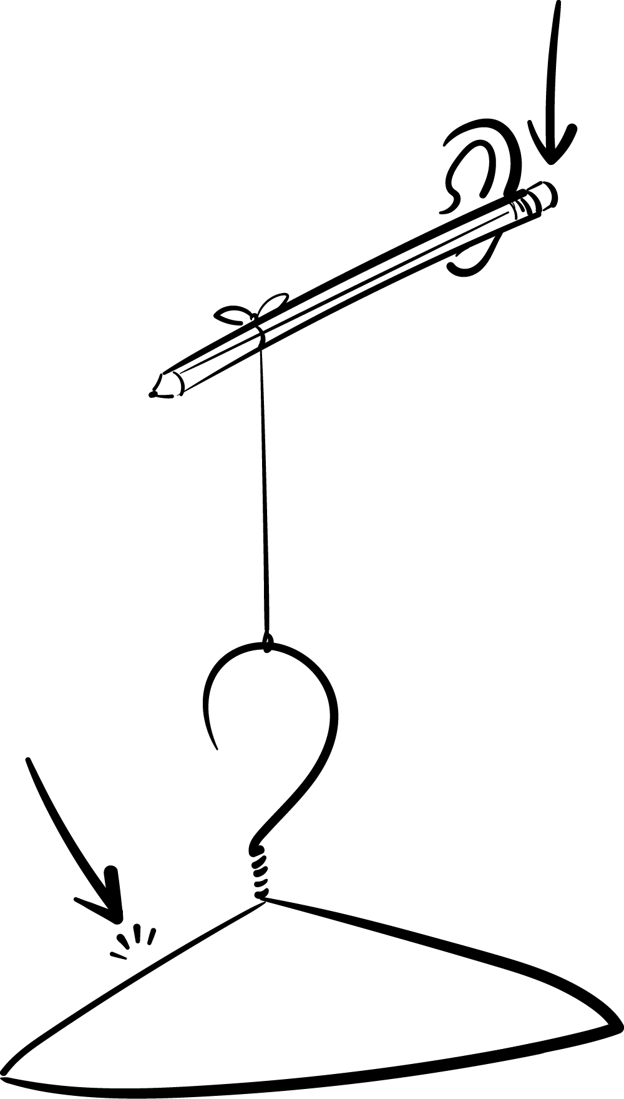
Station 2: Coat Hanger Apparatus

Materials
- Pencil with an eraser on the end
- Extra pencil
- Short piece of string
- Metal coat hanger

Procedure
- Pick up the coat hanger apparatus as shown in the diagram.
- Carefully place the pencil’s eraser end behind your ear.
Hold it there and swing the hanger, allowing it to hit a solid object, such as a wall. Another option is to hit the hanger with another pencil.

Questions
- When you followed the procedure, what did you hear?

- Where was the sound coming from?

- Why do you think you didn’t hear the coat hanger vibrations through the air?

- Explain how you think the vibrations reached your ear.

- What are some other objects you could hang from the string to yield similar results?

CLEAN THE LAB STATION AREA and RETURN ALL MATERIALS TO THEIR ORIGINAL POSITIONS before moving on to the next station.

Station 3: Paper Cup Phone

Materials
- A partner
- Two foam cups
- 10–20 feet of string
- Two paper clips

Procedure
- As shown in the diagram below, pull the two cups apart until the string is tight.
- Talk into one cup while your partner listens with the other cup.

Questions
- Why do you think the cup contraption seems to intensify the sound?

- Why might the sound travel better through the cup contraption than through the air?

- Do you think high pitches or low pitches are easier to hear? Why?

- What happens when the string is tight (as opposed to when it is loose)?

- What do you think would happen if the size of the cup changed? Explain your answer.

- If someone were to whisper from one corner of the classroom to the opposite corner, would it be heard through the cup contraption? What about through the air?

CLEAN THE LAB STATION AREA and RETURN ALL MATERIALS TO THEIR ORIGINAL POSITIONS before moving on to the next station.

Station 4: Petri Dish Water Waves

Materials
- Round, shallow dish filled with water
- Eyedropper
- Metric ruler

Procedure 1
- Use the eyedropper to take up water. Hold the eyedropper about 30 cm above the dish.
- Squeeze to let a drop hit the water in the dish near the middle.

Questions
- What happened when the water drop hit the surface of the water? Describe the shape of the wave that formed.

- What happened to the wave when it met the edge of the dish? Describe the shape of the wave after it reflected off the edge of the dish.

- Predict what will happen when you let a drop of water fall closer to the edge of the dish.

Procedure 2
Notice what happens to the wave when the water drop falls closer to the edge of the dish. Repeat and observe this step several times.

Questions
- Do your observations confirm the prediction you made above? Explain what happened.

- Is there a relationship between the angle at which a wave hits an obstacle and the reflection angle? If so, what is the relationship?

CLEAN THE LAB STATION AREA and RETURN ALL MATERIALS TO THEIR ORIGINAL POSITIONS before moving on to the next station.

Station 5: Rubber Bands

Materials
- Three rubber bands (one small, one medium, one thick)

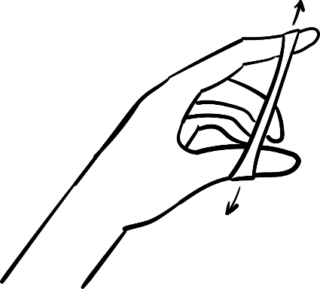
Procedure 1
- As shown in the diagram, take the small rubber band and stretch it slightly using your thumb and forefinger.
- Hold it up to your ear and use your other hand to pluck the rubber band.
- Stretch the rubber band further by widening the space between your forefinger and thumb. Repeat step 2.

Questions
- What happens to the sound, specifically pitch, as you stretch the rubber band more?

- What are the properties of the rubber band that change when you stretch it?

- When a guitar string is tightened, what property changes?

Procedure 2
Using different sizes of rubber bands, repeat steps 1–3 from above.

Questions
- Which size of rubber band produced the highest pitch?

- What size of rubber band produced the lowest pitch?

CLEAN THE LAB STATION AREA and RETURN ALL MATERIALS TO THEIR ORIGINAL POSITIONS before moving on to the next station.

Station 6: Metric Ruler Vibrations

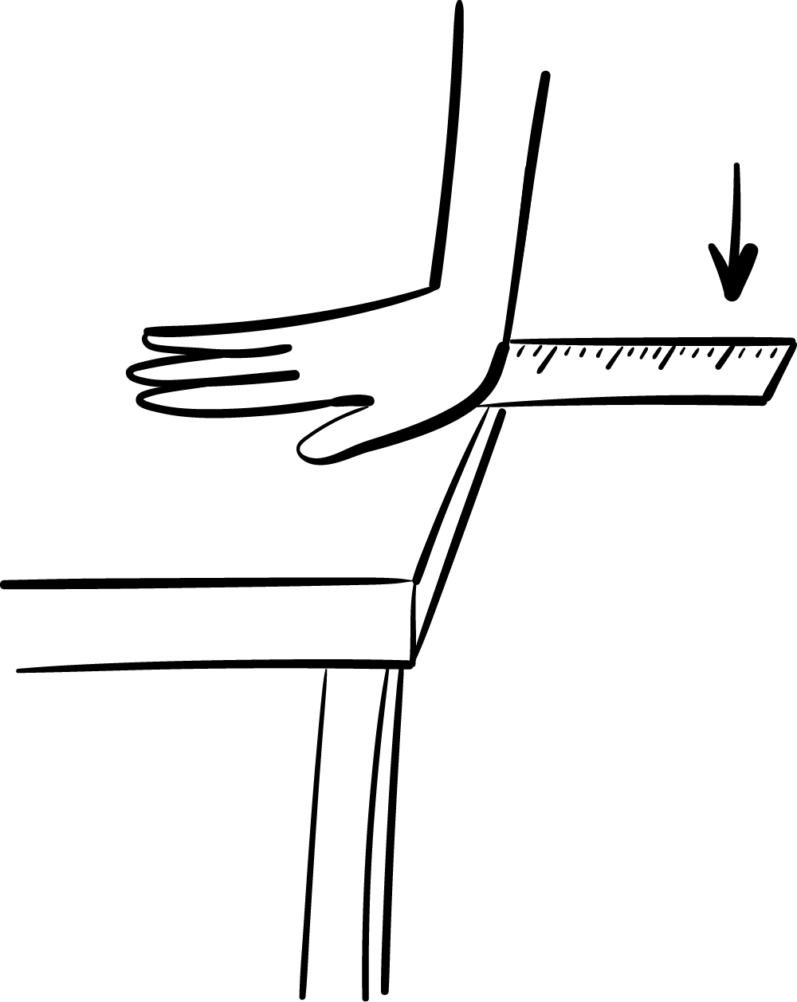
Materials
- Metric ruler
- Table or counter

Procedure 1
- Place the ruler on the edge of the table, letting about 5 cm hang off the edge.
- As shown in the diagram, hold the ruler on the table with one hand. With your other hand, pull up on the edge of the ruler and let go.
- Notice the sound it makes.

Question
What will happen to the pitch if more of the ruler is hanging off the table? Make a prediction.

Procedure 2
- Move the ruler so 10 cm hang off the table's edge and repeat steps 2–3 from above.
- Repeat more times while varying the length of the ruler that hangs off the table’s edge.

Questions
- How does the sound compare when more of the ruler hangs off the edge of the table?

- What happens to the pitch as you increase the length of the ruler hanging off the edge of the table?

CLEAN THE LAB STATION AREA and RETURN ALL MATERIALS TO THEIR ORIGINAL POSITIONS before moving on to the next station.

Station 7: Straws

Materials
- A partner
- Two straws
- Scissors

Procedure 1
- Flatten one end of each of the two straws. Cut the flattened ends into a point so that each straw looks like a flat pencil.
- Very carefully, put the flattened pointy end between your teeth.
- Tightly wrap your lips around the straw. Stop clenching the straw with your teeth, but keep your lips wrapped around it, and then blow.

Questions
- Describe the sound that is produced.

- Predict what will happen to the sound if you shorten the straw.

Procedure 2
- Use one of the straws to test the prediction you made. To do this, cut a piece off the blunt end of one of the straws.
- Have your partner listen as you blow into the pointy end of the shortened straw. Your partner should use the longer straw to compare the sound.

Questions
- Was your prediction correct? Explain.

- Attempt to explain what you noticed at this station using scientific terms like vibration, frequency, and sound.

- Based on your experience, what do you think you would hear if you used a straw that is 2 meters long? What about a straw that is 2 centimeters long?

CLEAN THE LAB STATION AREA and RETURN ALL MATERIALS TO THEIR ORIGINAL POSITIONS before moving on to the next station.

Station 8: Prisms

Materials
- Prism
- Flashlight
- Table or counter
- Sunlight

Procedure
- Set the prism on the table or counter.
- Using the flashlight, shine light through the prism until you see a rainbow. You might need to try several different angles.
- If sunlight shines into your classroom, also try to use the sunlight to make a rainbow.

Questions
- Does light travel through outer space? Explain your reasoning.

- Does sound travel through outer space? Explain your reasoning.

- If you were able to see a rainbow after the light traveled through the prism, why do you think that happened?

CLEAN THE LAB STATION AREA and RETURN ALL MATERIALS TO THEIR ORIGINAL POSITIONS before moving on to the next station.

