pass the problem
Simplify each expression with a partner. Take turns writing the next step in the simplifying process.
For question 1, Student A will write the first step, then pass the paper to Student B, who will write the second step, and so on. *Assume all variables are positive.

1) Student A starts – write the next step. |  |  | 2) Student B starts – write the next step.
 | 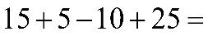 |  |  | 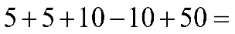
Student A, write 2-3 sentences explaining why you selected the method you chose to start question 1. |  |  | Student B, write 2-3 sentences explaining why you selected the method you chose to start question 2.

