ENGAGING STRATEGIES FOR CLASSROOM LIBRARIES
https://learn.k20center.ou.edu/strategies
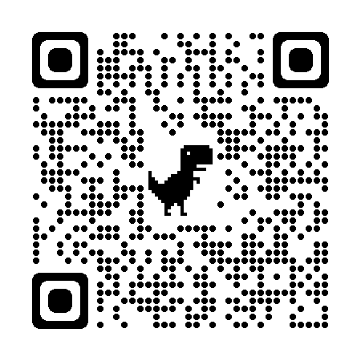

Discussion Strategies | Writing Strategies
- 30 second expert  - 5 Whys  - Collective Brain dump  - Chat stations  - Elbow partners  - Elevator speech  - 4 Corners  - Partner Speaks  - Preflection  - Snap, clap, pop  - S-I-T Surprising, Interesting, Troubling  - Say Something!  - Stand Up, Sit down  - Tableaus  - Tip of the Iceberg  - Think, Pair, Share  - Text Impressions  - Walk and Talk  - Two Stars and a Wish  - True for Who  - Tug of War  - Windows and Mirrors  - What? So What? Now What? | - Caption this  - Blackout poetry  - Commit and Toss  - Collaborative word clouds  - Cognitive comics  - It Says, I Say, So  - I Notice, I wonder  - Mind Maps  - KWHL  - Question Generating  - Picture notes  - Six Word memoirs  - Say Something!  - Quickwrite  - Stop and Jot  - Sociograms  - Thinking Notes  - Text Looping  - Vision boards  - Two Minute paper  - Tweet Up  - Window notes  - What do you meme?  - 3-2-1

