FLIPGRID HOW-TO GUIDE
Overview
Flipgrid is a video recording app that may be used to create video discussions. Teachers may create topics and provide prompts to guide student responses.
This tool may be used for a variety of learning activities throughout the 5E sequence:

● Engage/Opening
● Explore/Learning Activity
● Explain/Closing
● Extend/Additional Learning Activity
● Evaluate/Assessment

Create a Flipgrid Topic
Log in to Flipgrid. Visit Flipgrid.com and log in.
- If you have a Flipgrid account, click the Educator Login button.
- If you do not have an existing Flipgrid account, click the Educator Signup button. You may use Google or Microsoft credentials to sign up for an account.
Create New Discussion. Navigate to the Discussion tab [1] and select the Add a Topic button [2].

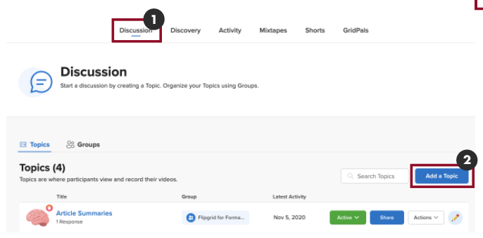

Topic Essentials [3]. The following fields are listed:
- Title.
- Prompt.
- Recording Time. Select a time limit for each discussion using the dropdown menu.
- Closed Captions.
Topic Moderation. Turn on this option to hide submitted videos from other students until they have been reviewed and approved by the teacher [4].
Media. Add media to the discussion topic by using one of the available apps [5].
Access Control. Change the privacy settings by selecting Public or Private [6]. Set up student access by choosing if students will use their school account credentials or create usernames. If students will use their student accounts, enter the school’s domain in the “Add or edit allow emails” field [6].
Create New Topic. Click the Create Topic button to complete creation of the topic [7]. The new topic should now appear on the home page.

Video Tutorial
Click here or scan the QR
to watch the video tutorial.

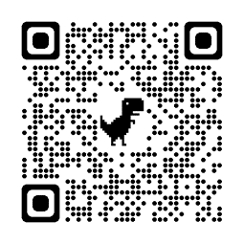

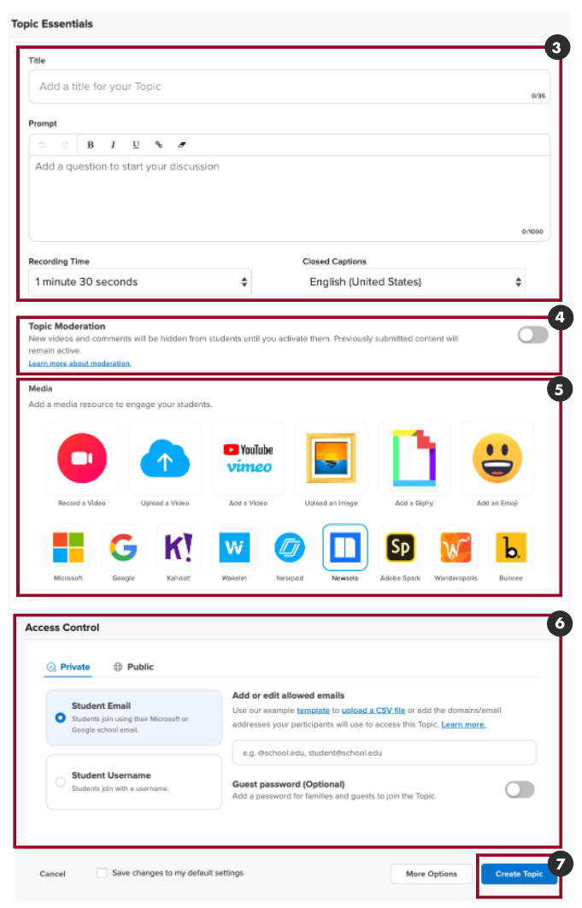

Flipgrid Sharing Options
The following sharing options may be used on their own or in combination based on the needs of your students.

Open Sharing Options. Click the Share button to open the sharing options [1]:

- Copy URL. Click the Copy button to automatically copy the URL to the clipboard [2].
- QR Code. Click the QR Code button to download an image of the QR Code [3].
- Embed Code. Click the Embed Code button to copy the embed code [4]. Note: It may not notify you, but the code is automatically copied to the clipboard.

Sharing Flipgrid in Canvas. Any of the above sharing options may be used to share Flipgrid discussions in Canvas. Feel free to use all three methods to provide your students with a variety of accessible options.

Share Flipgrid in Canvas: URL
Open Canvas Activity. Once the sharing option has been copied or downloaded from Flipgrid, navigate to Canvas and open the activity by clicking the title of the Canvas activity to which the Flipgrid will be added.

Edit. Click the Edit button to edit the activity [1].

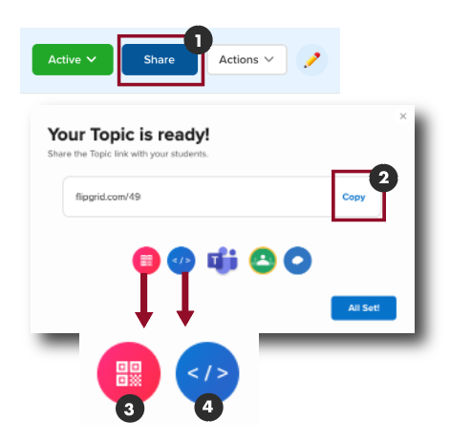

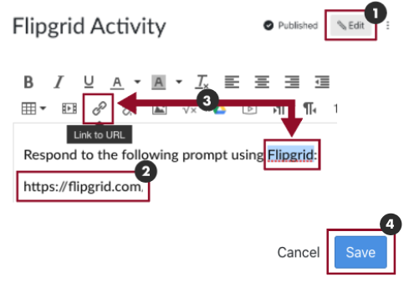

Share Using the URL. Copy the URL to the clipboard and paste the link into the body of the Canvas activity [2].

Tip: Shorten the URL by creating a hyperlink to text. Highlight the text to create the hyperlink, and then click the Link to URL icon [3]. A new dialog box will appear. Paste the URL in the field and click Insert Link.
Save Changes. Scroll to the bottom of the page and click the Save button to save the changes [4].
Share Flipgrid in Canvas: QR Code
Open Canvas Activity. Once the sharing option has been copied or downloaded from Flipgrid, navigate to Canvas and open the activity by clicking the title of the Canvas activity to which the Flipgrid will be added.
Edit. Click the Edit button to edit the activity [1].
Share Using the QR Code. Once the image of the QR code has been downloaded from Flipgrid, click the Embed Image icon to add the QR code to the body of the Canvas activity [2]. A new dialog box will appear. In the dialog box, select the Canvas tab [3]; then choose a destination folder [4]; and select Upload File [5]. Click the Update button to save [6].

Tip: Resize the image by clicking and dragging its corners.
Save Changes. Click the Save button to save the changes [7].

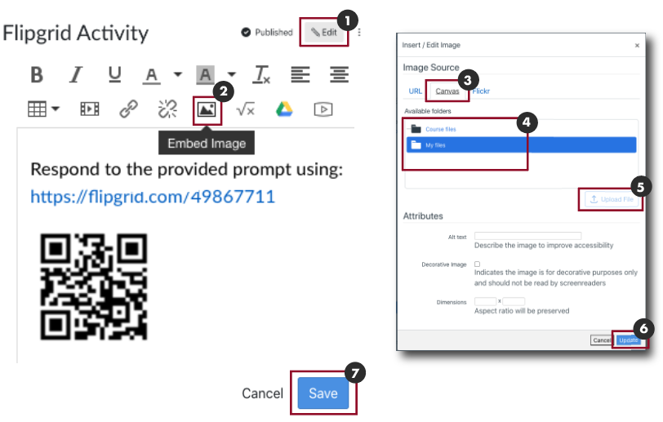

Share Flipgrid in Canvas: Embed
Open Canvas Activity. Once the sharing option has been copied or downloaded from Flipgrid, navigate to Canvas and open the activity by clicking the title of the Canvas activity to which the Flipgrid will be added.
Edit. Click the Edit button to edit the activity [1].
Share Using the Embed Code. Once the embed code has been copied from Flipgrid, click the HTML Editor link to open the HTML editor [2].
Paste the embed code into the HTML editor [3].
Click the Rich Content Editor to view the embedded Flipgrid [4].
View the embedded Flipgrid [5].
Save Changes. Click the Save button to save the changes [6].
Video Tutorial
Click here or scan the QR code
to watch the video tutorial.
