handshake handout – move, flip, and slide
JELLYFISH  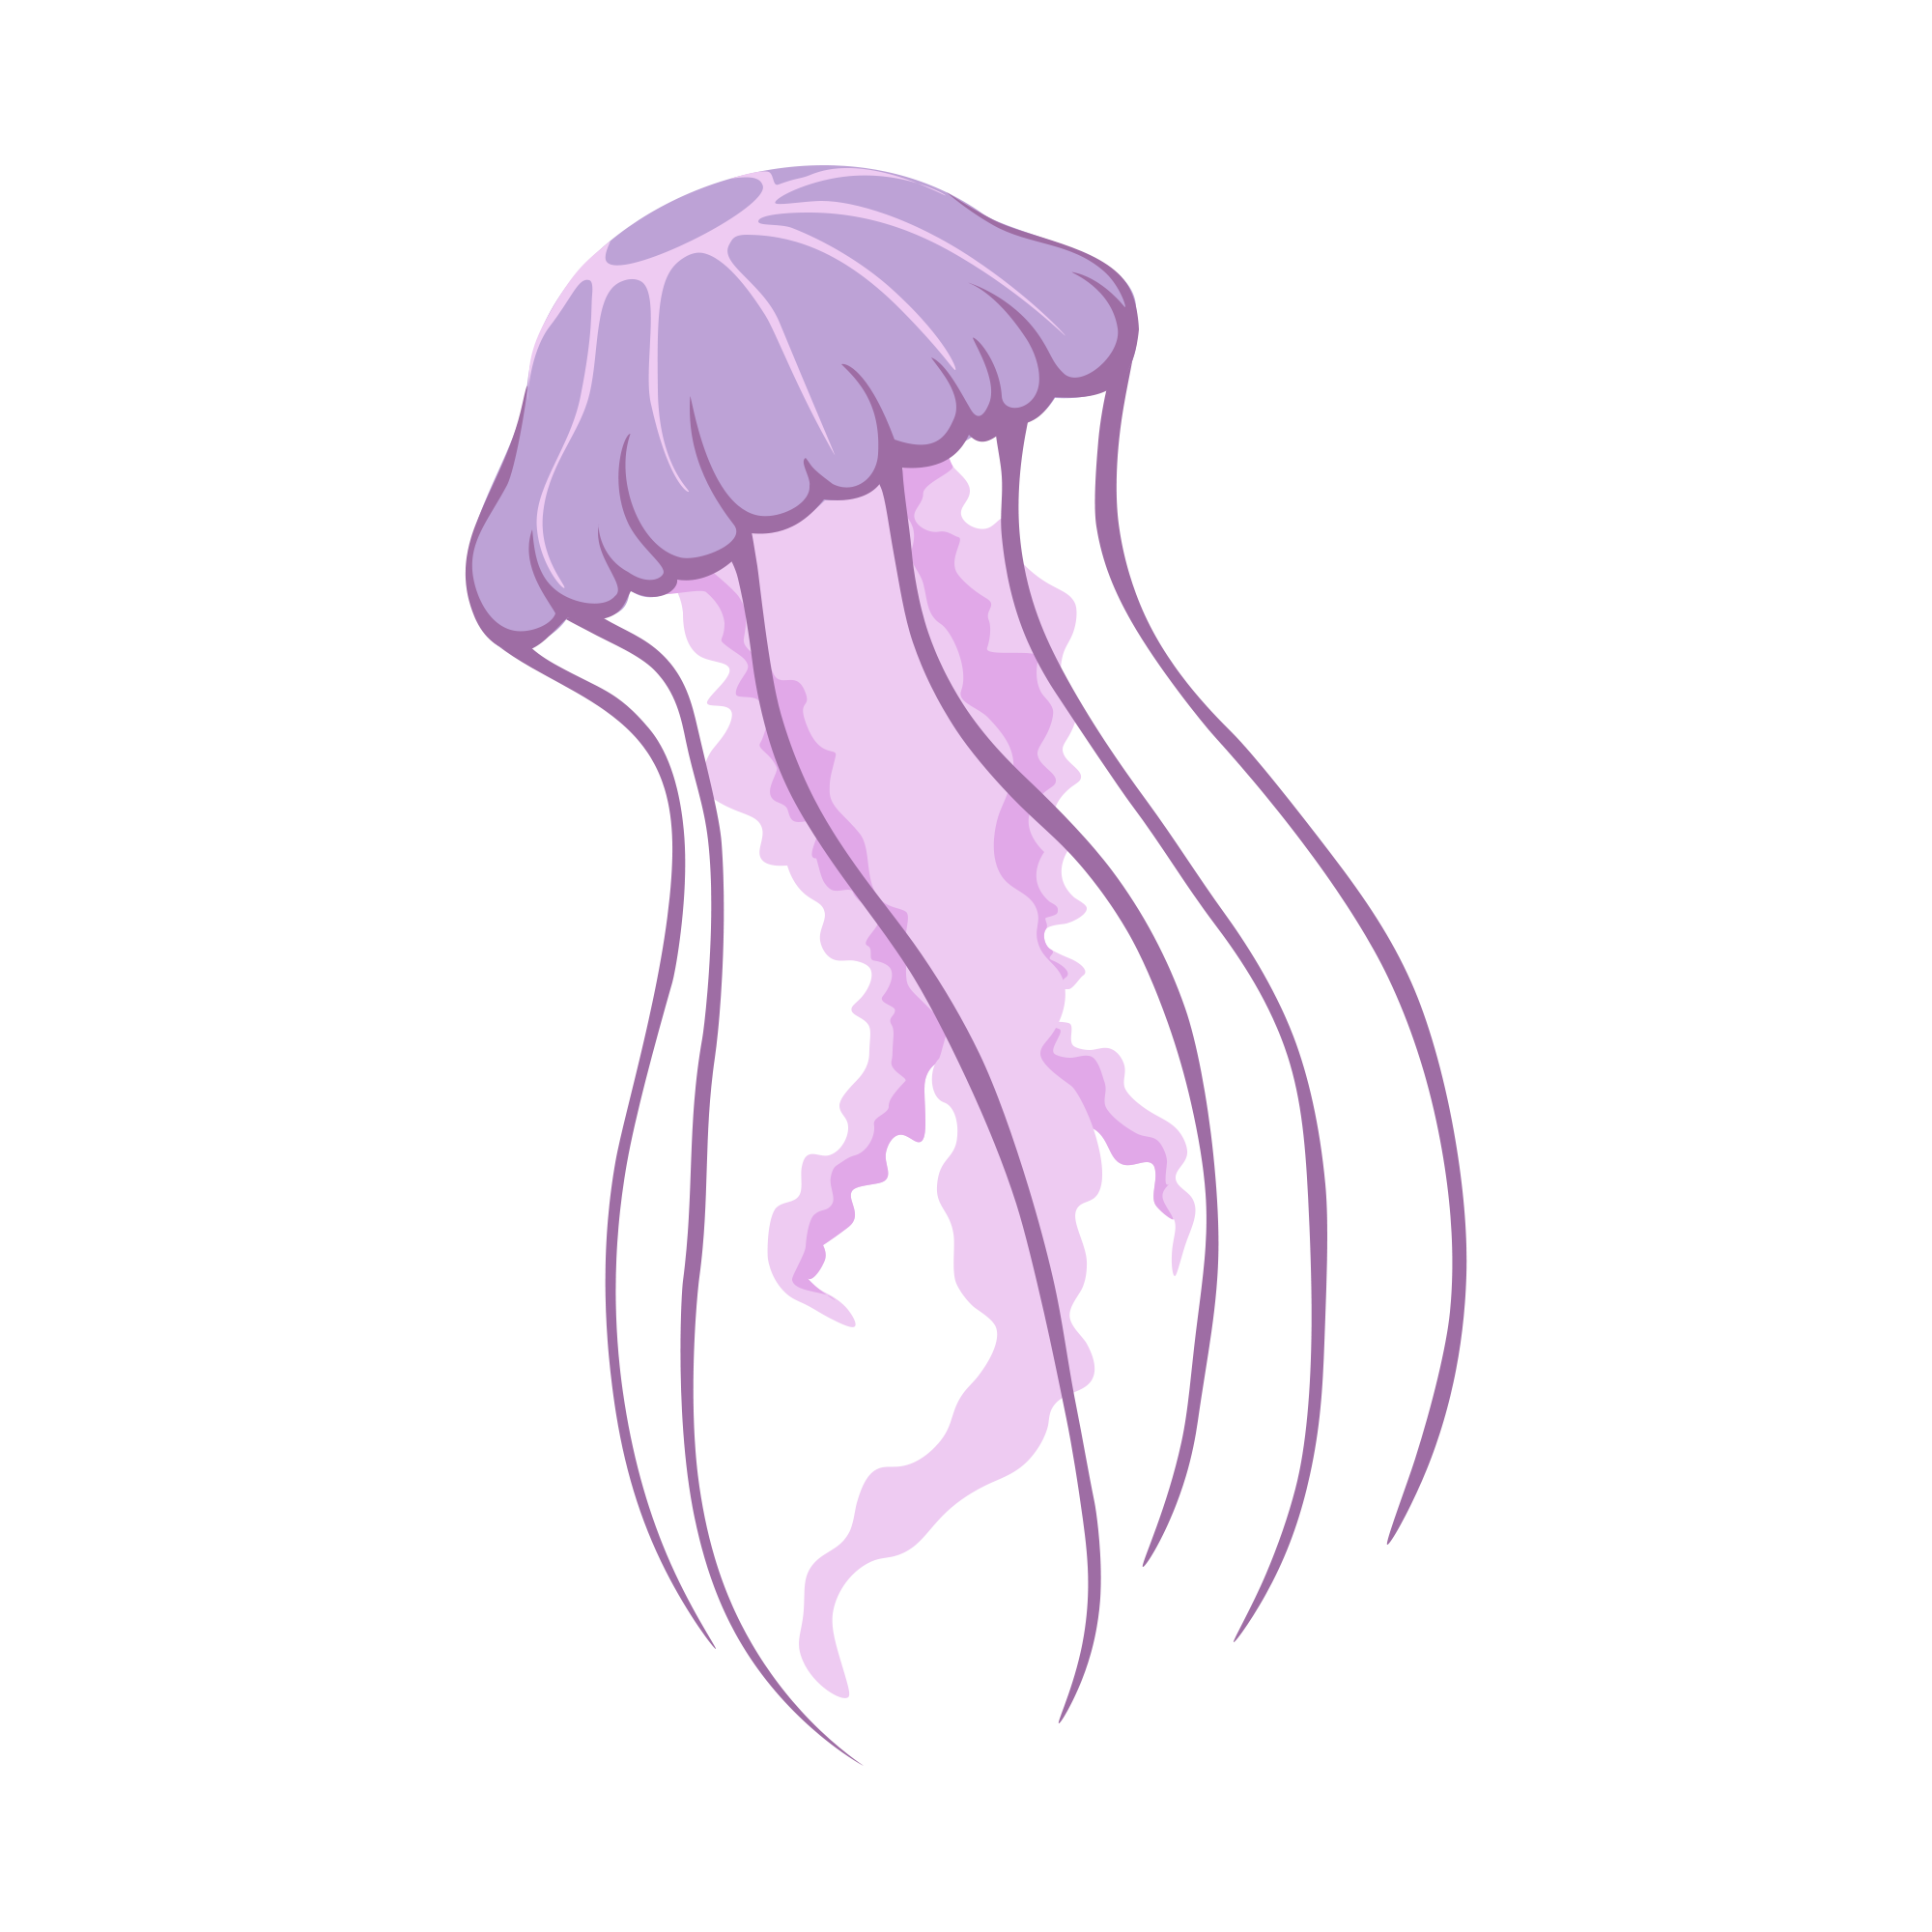  Fist-bump your partner, pulling your hand back at the last second with jellyfish movements.  Jelly Fish Handshake | TURKEY  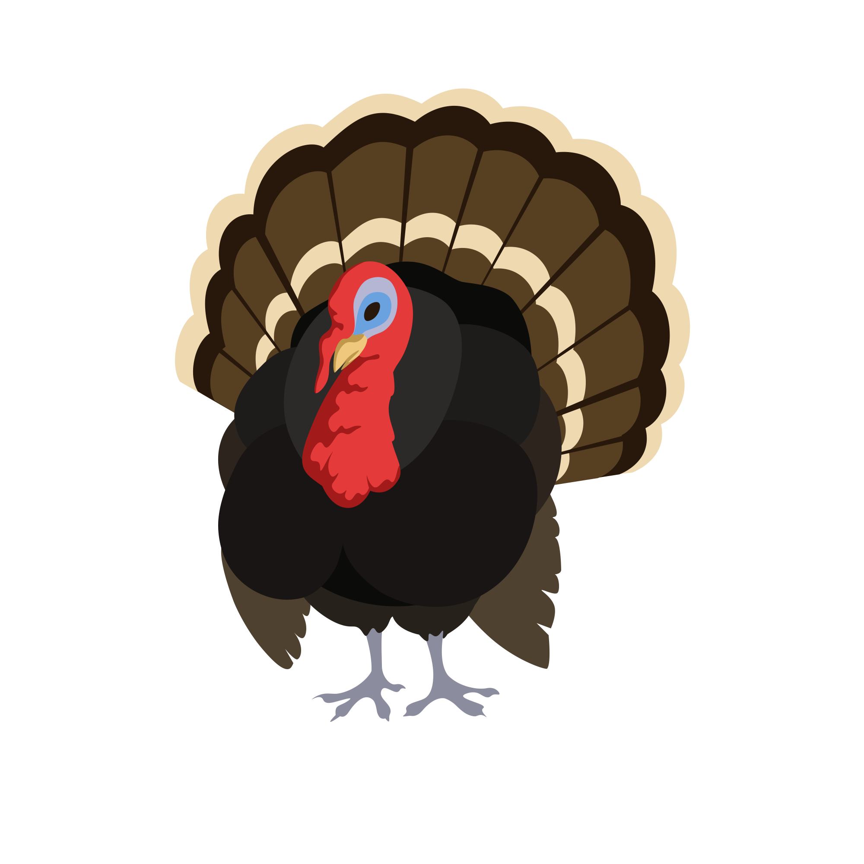  One person fist-bumps, clenching their fist. The other keeps their hand open as if they are coming in for a high five. Touch the fist to the palm of the open hand and gobble.  Happy Endings Your Hand's a Turkey Bro
DAIRY FARMER  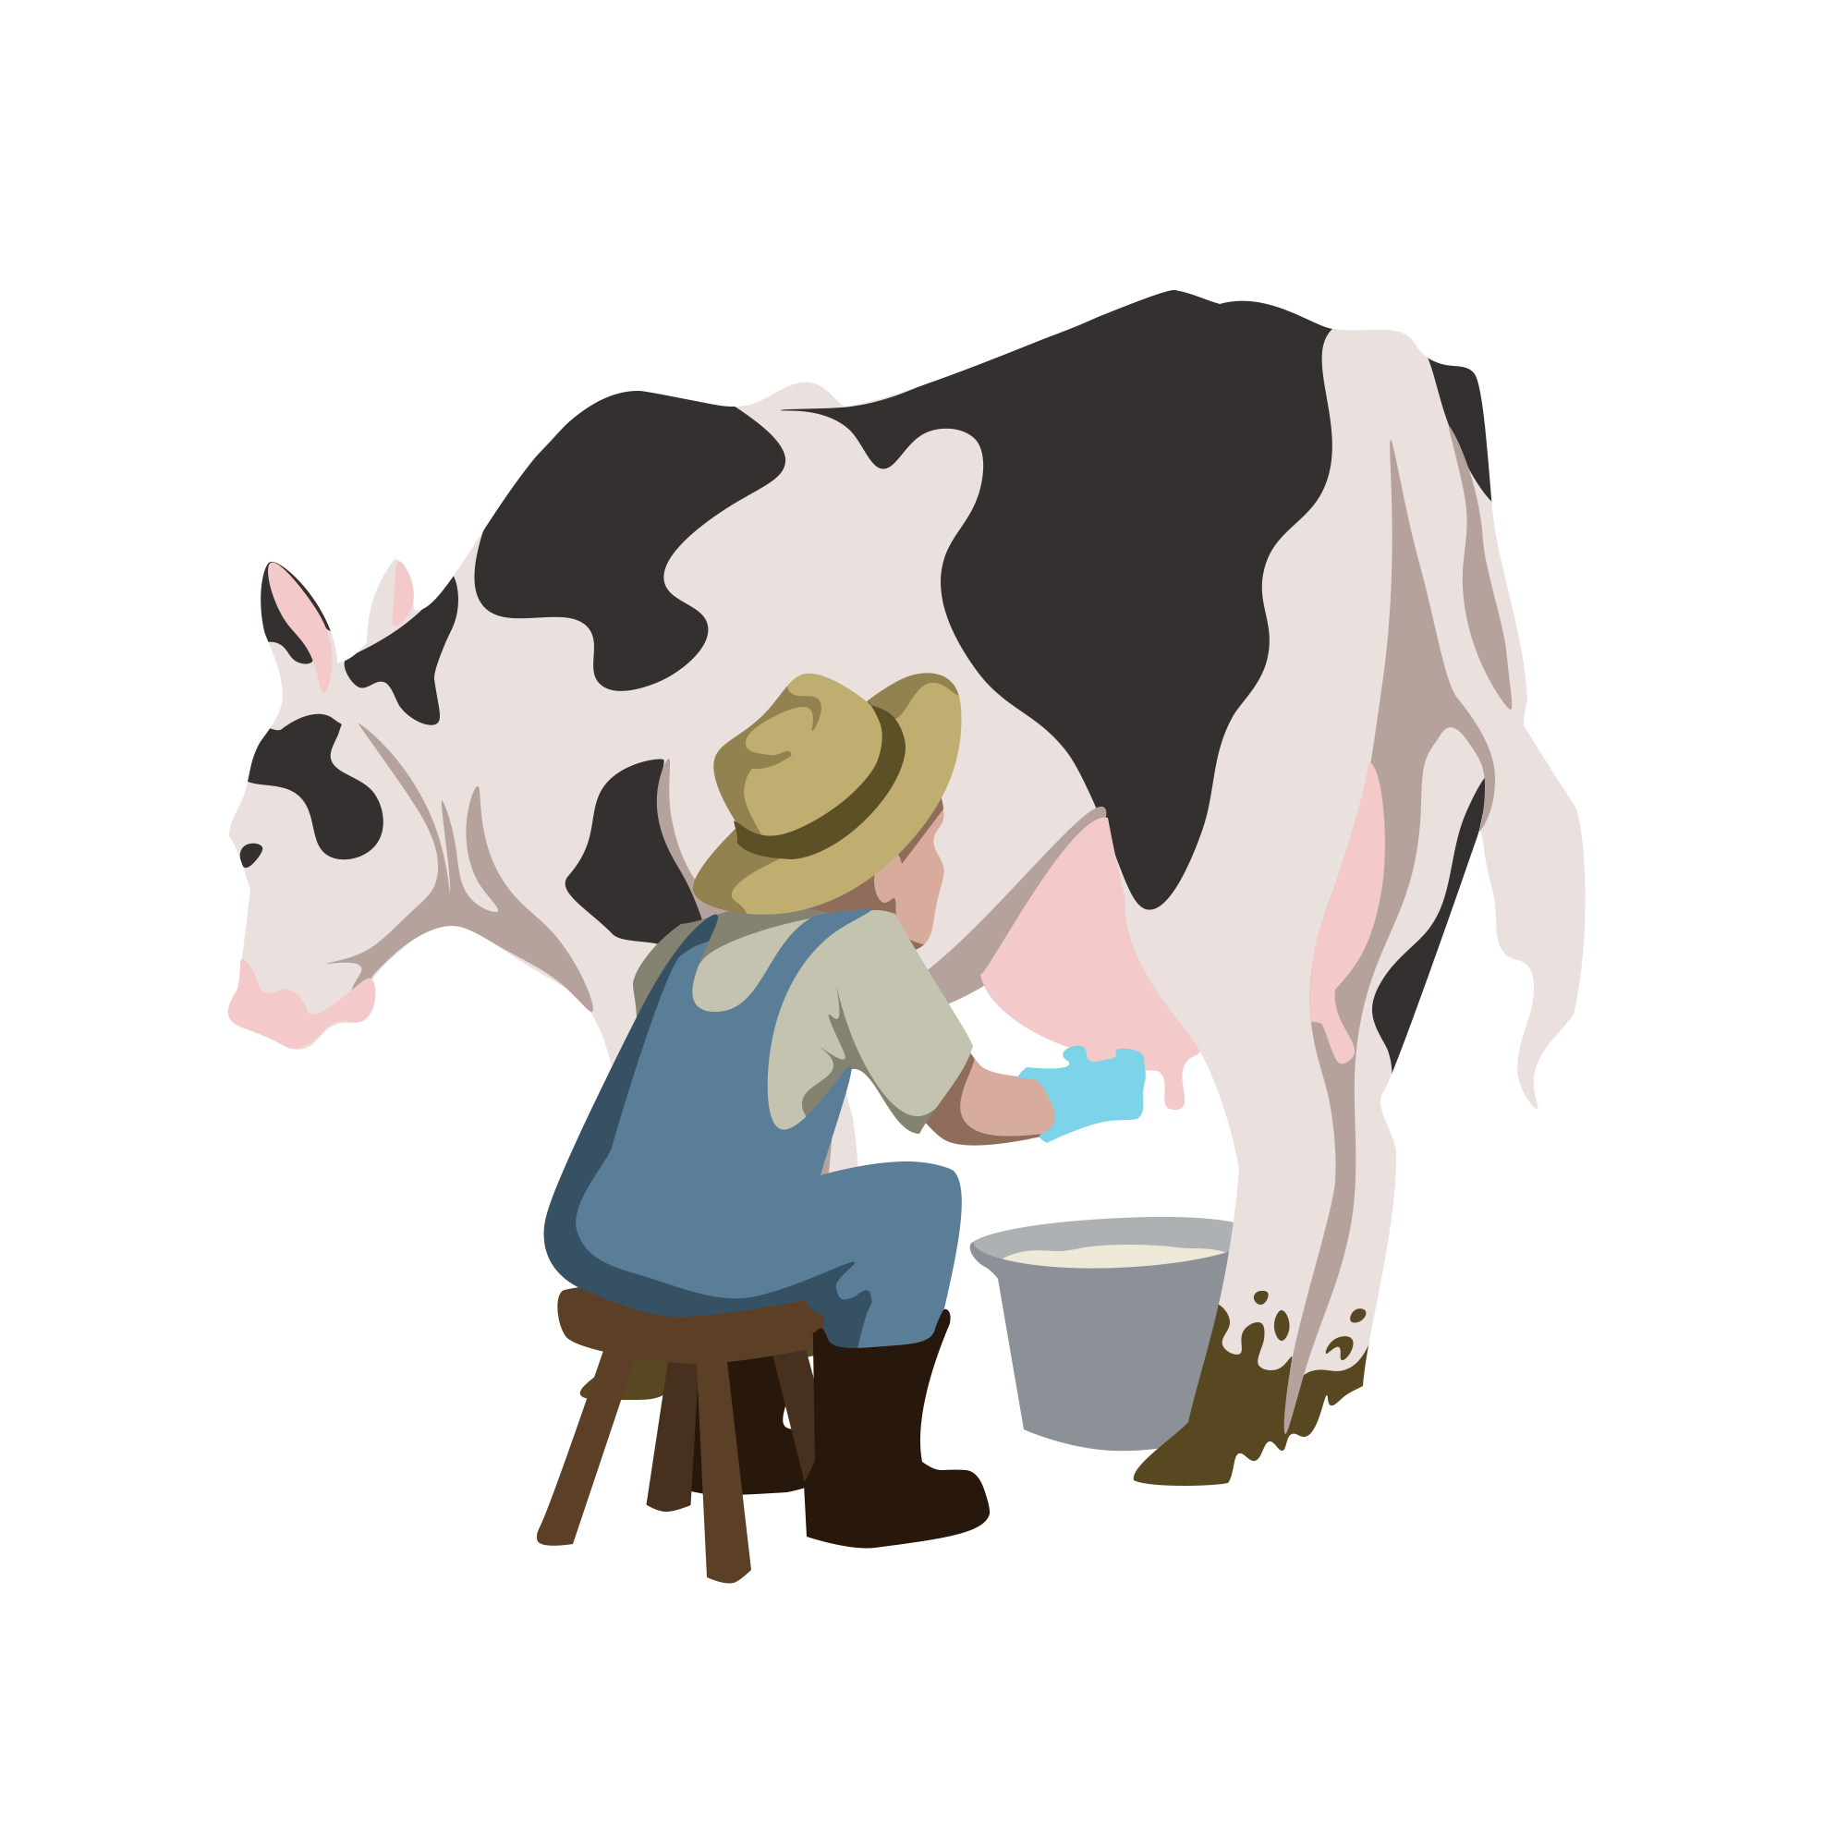  Using a hand-crossing motion, one person will interlock their fingers, leaving their thumbs hanging down with palms facing the other person. The second person will reach out and pull the thumbs gently in a “milking” fashion.  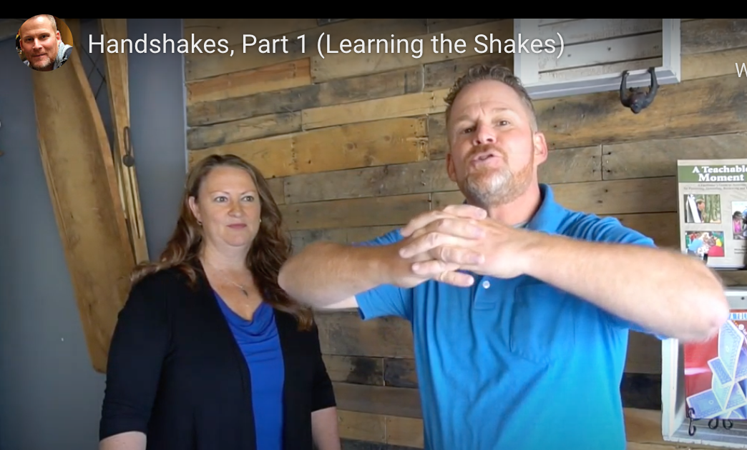  http://www.fundoing.com/blog/handshakes-part-1-learning-part-2-playing-videos  (Start at 3:29) | HAPPY SALMON  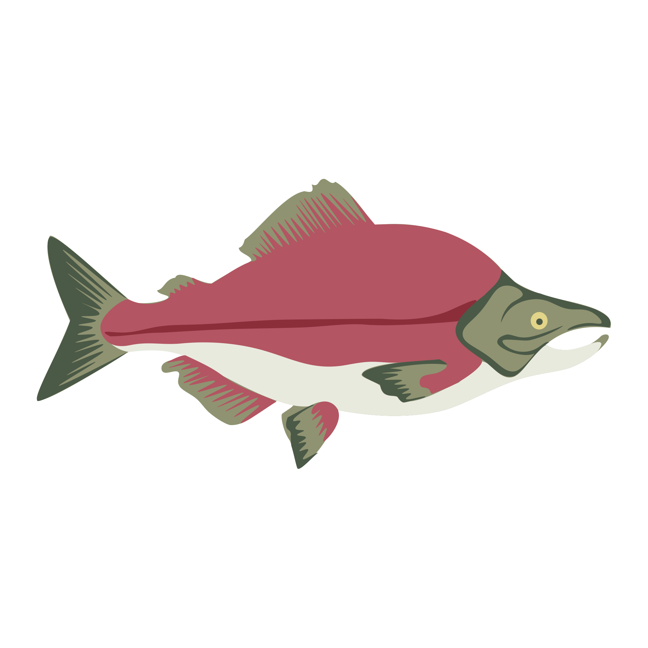  Each person’s hand becomes the tail of a fish. They will move one hand forward, but instead of grasping the hand for a handshake, each person places their hand on the other person’s forearm, and the “tails” flap against each other’s forearms.  The Salmon Handshake

