SCIENCE QR CODES

Place-Based Instruction
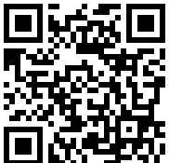  STEM Teaching Tool #57  https://bit.ly/3c3rrV7 | 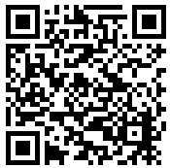  Environmental Impact Studies  https://bit.ly/3HbrT1T |  | 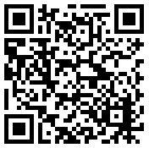  Creature Connection  https://bit.ly/30lYRvV
Project-Based Learning
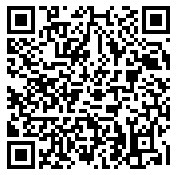  Impact of PBL on Student Achievement  edut.to/3wEFbiL | 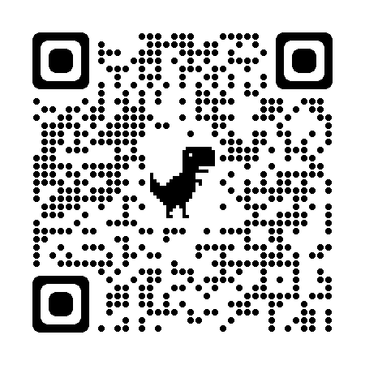  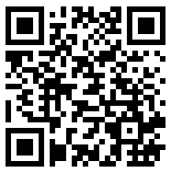  What is PBL?  https://bit.ly/30bIeCH |  | 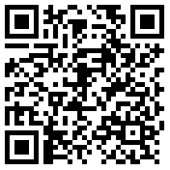  Hancock Playground  https://bit.ly/3c1eafI
Tinkering Pedagogy
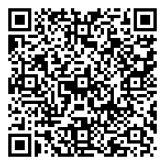  It Looks Like Fun, But Are They Learning?  (PDF, p. 10-12, 14-16)  https://bit.ly/30gxp2O |  | 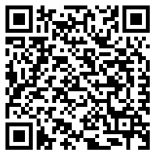  Developing and Implementing Tinkering Activities  (PDF, p. 15, 20, 26-27)  https://bit.ly/3D8PbDc

