BOOTH HANDOUTS (SAMPLES)

TABLE OF CONTENTS
CHANCE BOOTH 1
CHILD CARE 2
HOUSING 4
CAR DEALERSHIP 13
AUTO INSURANCE AND TAG 15
GROCERIES 17

VOLUNTEERS: CHANCE BOOTH
Responsibilities:
- Provide a Chance Card to each student.
- Have them add a “Chance” line on their ledger sheet and record what they earned or lost. There are blank lines to add any additional Chance Cards at the bottom of the ledger.
- Every 10 minutes, spin the 5-color wheel and call out the color from the wheel. (Note: If you do not have access to a wheel, you can draw slips of paper, ping pong balls, or use an online random generator.) Students with that color paper will return to the booth for a new Chance Card and record the results in their ledger. Make sure that all colors are called out at least once before the hour ends. Some students may get more than one Chance Card.
- Initial the box on the ledger sheet to show that students have visited your booth.
- If a student draws a card regarding an expense for a child but they have no children, please have them draw another card.
- If students find themselves with a low salary, a large family, and Chance Cards that deduct from their earnings, make sure to send them to the Supplemental Income booth for advice.
- Chance money can be put into students’ monthly budgets.

VOLUNTEERS: CHILD CARE
Responsibilities:
- Make copies of the Child Care cards on the following page.
- All students will come to your booth. If they do not have children, you can initial the box on the ledger sheet to show that they have visited and let them move on.
- Have students add a “Child Care” line on their ledger sheet.
- All students with children will need to select a child care option. If the student has no children, tell them to put a 0 in the “Child Care” ledger line.
- Give students the cards that match the ages of their children and have them select a child care option to record in their ledger.
- Rates are monthly per child, and students have to deduct for each child.
- If students return to your booth needing help with their budget, please work with them and explain any changes they may need to make. (Note: They cannot change the ages of their children or choose not to have child care.)
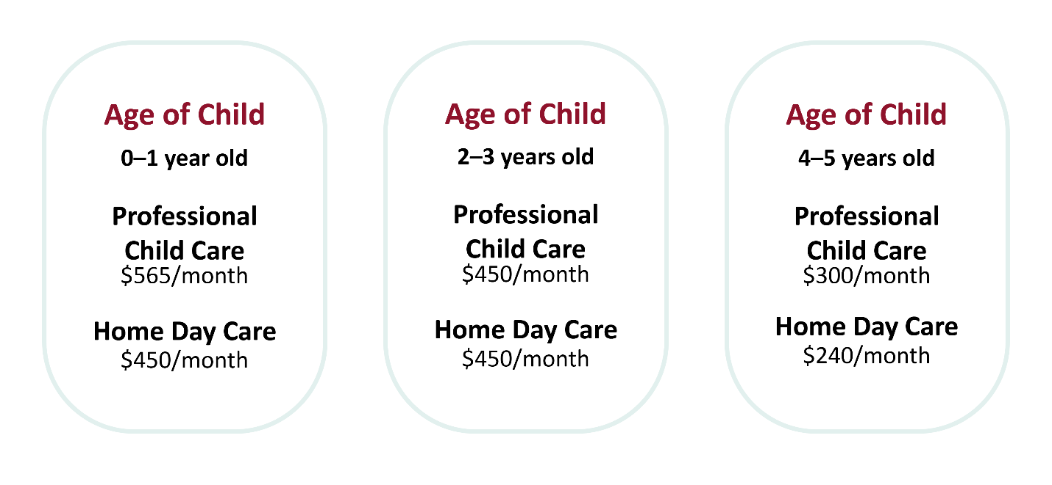
CHILD CARE CARDS
Copy as needed

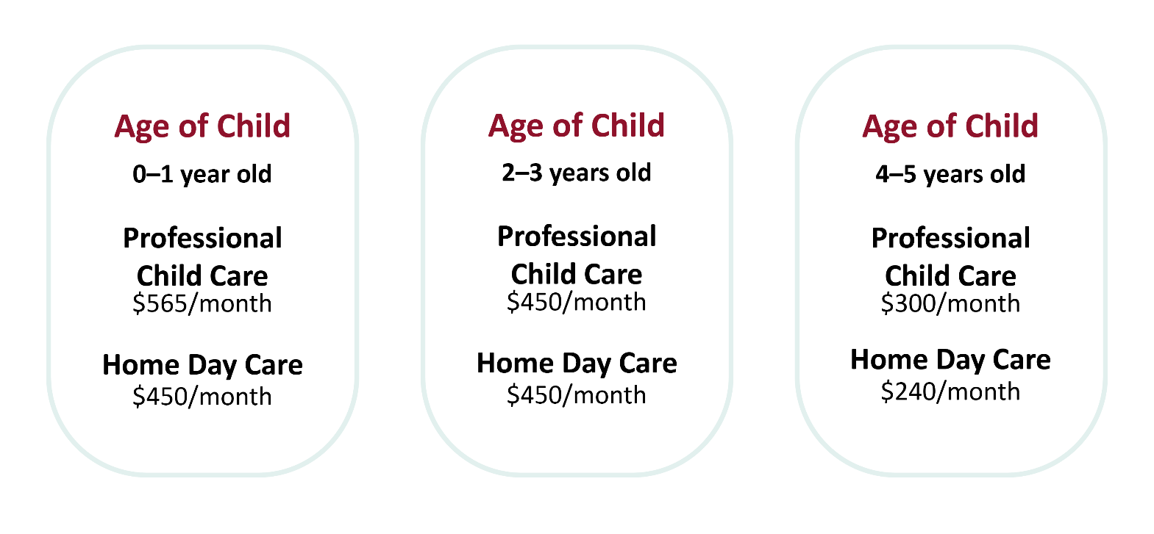

VOLUNTEERS: HOUSING
Responsibilities:
- Make copies of the Housing student handouts. (There are 8 different pages to display at this booth.)
- All students must make a purchase.
- Have students add a “Housing” line on their ledger sheet.
- Have them record the cost on the “Housing” line.
- Remind homeowners and home renters that they will have to visit the Utilities booth to pay for electric, water, and garbage services for their home.
- Encourage renters to visit the Renters’ Insurance booth.
- Initial the box on the ledger sheet to show that students have visited your booth.
- If students return needing to adjust their budget, please work with them to help them select a house that is within their means. Remind them that their house payment (or rent) should never be more than 33% of their household monthly income.

Buy a House | Size | Price per Month  (does not include utilities)
House A $85,000 | Approx. 907 sq. feet | $600/month
House B $125,000 | Approx. 1,400 sq. feet | $1,025/month
House C $175,000 | Approx. 1,739 sq. feet | $1,200/month
House D $235,000 | Approx. 2,024 sq. feet | $1,500/month
Rent a House | Size | Price per Month  (does not include utilities)
House E | 2 bedroom | $850/month
House F | 3 bedroom | $1,100/month
Rent an Apartment | Size | Price per Month  (includes ALL utilities)
Apartment G | 1 bedroom | $550/month
Apartment H | 2 bedroom | $750/month

HOUSING
Buy a House | Size | Price per Month  (does not include utilities)
House A $85,000 | Approx. 907 sq. feet | $600/month
House B $125,000 | Approx. 1,400 sq. feet | $1,025/month
House C $175,000 | Approx. 1,739 sq. feet | $1,200/month
House D $235,000 | Approx. 2,024 sq. feet | $1,500/month
Rent a House | Size | Price per Month  (does not include utilities)
House E | 2 bedroom | $850/month
House F | 3 bedroom | $1,100/month
Rent an Apartment | Size | Price per Month  (includes ALL utilities)
Apartment G | 1 bedroom | $550/month
Apartment H | 2 bedroom | $750/month
HOUSE A

Built in 1970 / Approximately 907 square feet
3 bedroom / 1 bath / 1-car garage
Cost: $85,000
Monthly payment: $600 (includes house payment, insurance, and taxes)
HOUSE B

Built in 1982 / Approximately 1,400 square feet
3 bedroom / 2 bath / 2-car garage
Cost: $125,000
Monthly payment: $1,025 (includes house payment, insurance, and taxes)
HOUSE C
Built in 2005 / Approximately 1,739 square feet
3 bedroom / 2 bath / 2-car garage
Cost: $175,000
Monthly payment: $1,200 (includes house payment, insurance, and taxes)

HOUSE D
Built in 2005 / Approximately 2,024 square feet
3 bedroom / 2 bath / 3-car garage
Cost: $235,000
Monthly payment: $1,500 (includes house payment, insurance, and taxes)
RENTAL HOUSE E

2 bedroom
Monthly payment: $850 (does not include renters’ insurance)
RENTAL HOUSE F

3 bedroom
Monthly payment: $1,100 (does not include renters’ insurance)
APARTMENT

Cost varies by size

VOLUNTEERS: CAR DEALERSHIP
Responsibilities:
- Make copies of the Car Dealership student handout to display at your booth.
- All students must make a purchase at your booth.
- Have students add a “Car” line on their ledger sheet and record the amount they will be spending per month.
- Remind them that they will have to visit the Auto Insurance and Tag booth.
- Initial the box on the ledger sheet to show that students have visited your booth.
- If students return needing to make changes to their budget, please work with them and explain any changes they can make. Remind them that they should buy a vehicle that best fits their family’s need for the lowest car payment.

2005 VEHICLES | 2015 VEHICLES | 2021 VEHICLES
COMPACT CAR: $4,000  (Examples: Honda Civic, Ford Focus)  Finance 60 months: $71/month  Down payment: $100 | COMPACT CAR: $11,000  (Examples: Honda Civic, Ford Focus)  Finance 60 months: $195/month  Down payment: $300 | COMPACT CAR: $22,200  (Examples: Honda Civic, Ford Focus)  Finance 60 months: $395/month  Down payment: $500
MID-SIZE SEDAN: $4,599  (Examples: Ford Taurus, Chevrolet Impala)  Finance 60 months: $81/month  Down payment: $150 | MID-SIZE SEDAN: $13,000  (Examples: Ford Fusion, Hyundai Elantra, Chevrolet Impala)  Finance 60 months: $231/month  Down payment: $300 | MID-SIZE SEDAN: $28,000  (Examples: Ford Taurus, Chrysler 300, Chevrolet Impala)  Finance 60 months: $500/month  Down payment: $500
SMALL TRUCK/SUV: $6,955  (Examples: Ford Ranger, Chevrolet Colorado, Dodge Dakota)  Finance 60 months: $123/month  Down payment: $200 | SMALL TRUCK/SUV: $15,900  (Examples: Ford Ranger, Ford Escape, Dodge Dakota)  Finance 60 months: $284/month  Down payment: $300 | SMALL TRUCK/SUV: $27,500  (Examples: Ford Ranger, Ford Escape, Dodge Dakota)  Finance 60 months: $491/month  Down payment: $500
SPORTS CAR: $8,500  (Examples: Ford Mustang, Chevrolet Camaro)  Finance 60 months: $151/month  Down payment: $200 | SPORTS CAR: $18,200  (Examples: Ford Mustang, Chevrolet Camaro)  Finance 60 months: $326/month  Down payment: $300 | SPORTS CAR: $30,000  (Examples: Ford Mustang, Chevrolet Camaro, Dodge Charger)  Finance 60 months: $537/month  Down payment: $500
LUXURY CAR: $60,000
(Examples: BMW, Lexus, Audi)
Finance 60 months: $1,077/month
Down payment: $800

CAR DEALERSHIP
2005 VEHICLES | 2015 VEHICLES | 2021 VEHICLES
COMPACT CAR: $4,000  (Examples: Honda Civic, Ford Focus)  Finance 60 months: $71/month  Down payment: $100 | COMPACT CAR: $11,000  (Examples: Honda Civic, Ford Focus)  Finance 60 months: $195/month  Down payment: $300 | COMPACT CAR: $22,200  (Examples: Honda Civic, Ford Focus)  Finance 60 months: $395/month  Down payment: $500
MID-SIZE SEDAN: $4,599  (Examples: Ford Taurus, Chevrolet Impala)  Finance 60 months: $81/month  Down payment: $150 | MID-SIZE SEDAN: $13,000  (Examples: Ford Fusion, Hyundai Elantra, Chevrolet Impala)  Finance 60 months: $231/month  Down payment: $300 | MID-SIZE SEDAN: $28,000  (Examples: Ford Taurus, Chrysler 300, Chevrolet Impala)  Finance 60 months: $500/month  Down payment: $500
SMALL TRUCK/SUV: $6,955  (Examples: Ford Ranger, Chevrolet Colorado, Dodge Dakota)  Finance 60 months: $123/month  Down payment: $200 | SMALL TRUCK/SUV: $15,900  (Examples: Ford Ranger, Ford Escape, Dodge Dakota)  Finance 60 months: $284/month  Down payment: $300 | SMALL TRUCK/SUV: $27,500  (Examples: Ford Ranger, Ford Escape, Dodge Dakota)  Finance 60 months: $491/month  Down payment: $500
SPORTS CAR: $8,500  (Examples: Ford Mustang, Chevrolet Camaro)  Finance 60 months: $151/month  Down payment: $200 | SPORTS CAR: $18,200  (Examples: Ford Mustang, Chevrolet Camaro)  Finance 60 months: $326/month  Down payment: $300 | SPORTS CAR: $30,000  (Examples: Ford Mustang, Chevrolet Camaro, Dodge Charger)  Finance 60 months: $537/month  Down payment: $500
LUXURY CAR: $60,000
(Examples: BMW, Lexus, Audi)
Finance 60 months: $1,077/month
Down payment: $800

VOLUNTEERS: AUTO INSURANCE AND TAG
Responsibilities:
- Display copies of the Auto Insurance and Tag student handout at your booth.
- All students must purchase something at your booth, and their insurance and tag must match the type of vehicle they have purchased.
- Have students add an “Auto Insurance and Tag” line on their ledger sheet.
- Have students record the cost on the “Auto Insurance and Tag” line.
- Initial the box on the ledger sheet to show that students have visited your booth.
- If students return needing to make changes to their budget, please work with them and explain any changes they can make. If they need a lower price, they will need to visit the Car Dealership booth to purchase a more affordable vehicle.

 | Compact Car |  |  | Mid-Size Sedan |  |  | Small Truck/SUV |  |  | Sports Car |  |  | Luxury
 | 2005 | 2015 | 2021 | 2005 | 2015 | 2021 | 2005 | 2015 | 2021 | 2005 | 2015 | 2021 | 2021
Single Male | $100 | $120 | $140 | $100 | $120 | $140 | $90 | $120 | $130 | $120 | $130 | $160 | $250
All Others | $80 | $100 | $110 | $80 | $90 | $110 | $80 | $100 | $110 | $90 | $110 | $140 | $180
Tag | $140 | $385 | $777 | $160 | $455 | $980 | $245 | $556 | $962 | $297 | $637 | $1,050 | $2,100
*Military Member Tag Cost: $20

AUTO INSURANCE AND TAG

 | Compact Car |  |  | Mid-Size Sedan |  |  | Small Truck/SUV |  |  | Sports Car |  |  | Luxury
 | 2005 | 2015 | 2021 | 2005 | 2015 | 2021 | 2005 | 2015 | 2021 | 2005 | 2015 | 2021 | 2021
Single Male | $100 | $120 | $140 | $100 | $120 | $140 | $90 | $120 | $130 | $120 | $130 | $160 | $250
All Others | $80 | $100 | $110 | $80 | $90 | $110 | $80 | $100 | $110 | $90 | $110 | $140 | $180
Tag | $140 | $385 | $777 | $160 | $455 | $980 | $245 | $556 | $962 | $297 | $637 | $1,050 | $2,100
*Military Member Tag Cost: $20

VOLUNTEERS: GROCERIES
Responsibilities:
- Display copies of the Groceries student handout at your booth.
- Students must purchase groceries at your booth, but fast food packages are optional.
- Have students add a “Groceries” line on their ledger sheet.
- Have students record the cost of groceries on the “Groceries” line.
- Initial the box on the ledger sheet to indicate that students have visited your booth.
- If students return to your booth needing to adjust their budget, please work with them and explain any changes they can make based on the size of their households.
Household | Thrifty | Low-Cost | Moderate | Luxury
Single | $175 | $250 | $325 | $375
Single with 1 child | $300 | $400 | $500 | $590
Single with 2 children | $500 | $540 | $680 | $800
Married | $400 | $525 | $640 | $800
Married with 1 child | $515 | $675 | $820 | $1,015
Married with 2 children | $600 | $750 | $925 | $1,150

FAST FOOD
OPTIONAL (Examples: Starbucks, McDonald’s, Braum’s, Taco Bell)
Household | Deduct Additional
Single | $175
Single with 1 child | $250
Single with 2 children | $300
Married | $200
Married with 1 child | $400
Married with 2 children | $500

GROCERIES
Household | Thrifty | Low-Cost | Moderate | Luxury
Single | $175 | $250 | $325 | $375
Single with 1 child | $300 | $400 | $500 | $590
Single with 2 children | $500 | $540 | $680 | $800
Married | $400 | $525 | $640 | $800
Married with 1 child | $515 | $675 | $820 | $1,015
Married with 2 children | $600 | $750 | $925 | $1,150

FAST FOOD
OPTIONAL (Examples: Starbucks, McDonald’s, Braum’s, Taco Bell)
Household | Deduct Additional
Single | $175
Single with 1 child | $250
Single with 2 children | $300
Married | $200
Married with 1 child | $400
Married with 2 children | $500

