CRACK THE CODE: INSTRUCTIONS

OBJECT OF THE GAME: Create a functional protein

NUMBER OF PLAYERS: 2-4 Teams

MATERIALS: Crack the Code Instructions, set of Higher Order Thinking (HOTs) questions, Protein Synthesis Team Card, Smarty Pants Answer Keys, genetic code charts (Figures 1 and 2), Mr. Potato Head (arms, eyes, ears, feet, mouth)

TYPE OF GAME: Biology

STANDARD: B.LS1.1: Students who demonstrate understanding can: Construct an explanation based on evidence for how the structure of DNA determines the structure of proteins, which carry out the essential functions of life through systems of specialized cells.

OVERVIEW

Crack the Code is the perfect pastime. Teams are split into two to four teams to determine who is the best at transcribing DNA to RNA and ultimately determine their protein. Do you have what it takes to crack the code?

SETUP
To begin setup, each team will need a set of HOTs questions accessible to one team member, protein synthesis team card, genetic code chart, and Mr. Potato Head unassembled.

GAMEPLAY
- Assign one player on the team to keep track of the HOTs questions and answer keys. We will call this person “Smarty Pants”.
- The remaining players, one at a time, must answer a question correctly posed by Smarty Pants.
- If answered correctly, that team member will then transcribe two DNA codons to RNA codons to the amino acids using the provided genetic code chart.
- Next, determine the protein produced and have it checked by Smarty Pants.
- Once the first protein is completed, a trait of Mr. Potato Head is collected from Smarty Pants and the next player is tagged in to repeat steps 2-4.
- The rotation continues until all 5 sequences have been completed.
- Once each team has successfully completed each protein and collected all parts of their Mr. Potato Head, they must assemble their Mr. Potato Head.
- The first team to identify the correct order of amino acid sequence to build their “proteins” and build their genetic makeup of their organism wins!
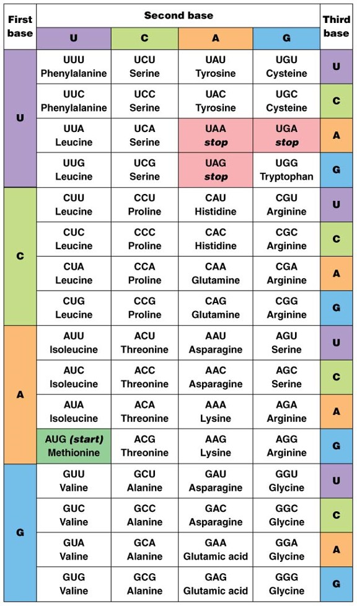
FIGURE 1
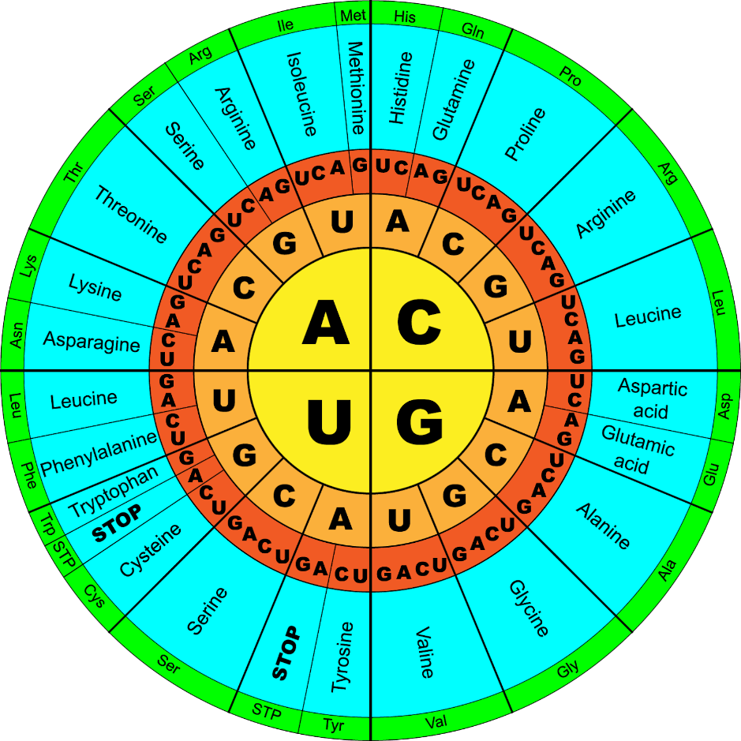
FIGURE 2

1. Which of the following is a nucleotide found in DNA?
a. | Ribose + Phosphate group + Thymine
b. | Ribose + Phosphate group + Uracil
c. | Deoxyribose + Phosphate Group + Uracil
d. | Deoxyribose + Phosphate Group + Cytosine

2. How many codons are needed to specify three amino acids?
a. | 3 | c. | 9
b. | 6 | d. | 12

3. A DNA segment is changed from -AATTAGAAATAG- to -ATTAGAAATAG-. This is a
a. | Translation | c. | inversion
b. | frameshift mutation | d. | point mutation

4. The following sequence of DNA is part of a gene. How many amino acids are coded for by this segment? 5’ ATCAGCGCTGGC 3’
a. | 4 | c. | 12
b. | 8 | d. | 20

5. Genetic information usually flows in one specific direction (more commonly known as “The Central Dogma”). Which of the following best represents this flow?
a. | DNA → Protein → RNA | c. | DNA → RNA → Protein
b. | Protein → DNA → RNA | d. | RNA → Protein → DNA

6. Which of these represents the DNA segment from which this section of mRNA was transcribed?
a. | ACT AAG | c. | CCU TTG
b. | GAA UCU | d. | UCC TGA

7. Which of the following is a change that could be passed on to an organism’s offspring?
a. | Damage to the DNA of sex cells
b. | Damage to skin cells from exposure to sunlight
c. | Damage to DNA in the cytoplasm of cheek cells
d. | Damage to hair pigment cells with permanent dyes

8. Use the “mRNA chart” provided. The assembly of a messenger RNA strand that normally begins with UAC has been changed so that the newly assembled messenger RNA strand begins with UAG. Which of the following will most likely occur?
a. | The protein will be missing the first amino acid.
b. | The amino acids that make up the protein will all be different.
c. | The mRNA will become attached to a ribosome.
d. | The production of the protein will be stopped.
9. Which method would a biologist use to view the site of protein production in a plant cell?
a. | use a magnifying glass to view the chloroplasts | c. | use a microscope to view the chloroplasts
b. | use a magnifying glass to view the ribosomes | d. | use a microscope to view the ribosomes

10. Which of the following nucleotide chains could be part of a molecule of RNA?
a. | A-T-G-C-C-A | c. | A-A-T-A-A-A
b. | G-C-C-T-T-G | d. | A-U-G-C-C-A

11. DNA sequences are often used to determine relationships between organisms. DNA sequences that code for a particular gene can vary, although organisms that are closely related will have very similar sequences. This table shows the amino acid sequences of 4 organisms. Based on these sequences, which two organisms are the most closely related?
a. | Human: C C A - T A G - C A C - C T A | c. | Chimpanzee: C C A - T A A - C A C - C T A
b. | Pig: C C A - T G T - A A A - C G A | d. | Cricket: C C T - A A A - G G G- A C G

12.Hereditary information is determined by molecules of
a. | Carbohydrate | c. | Lipids
b. | Proteins | d. | Nucleic acids

13. The process by which messenger RNA is made from a DNA molecule is called
a. | Replication | c. | Translation
b. | Transcription | d. | Translocation

14. The diagram below shows a segment of a gene before and after a process.
Which is a result of the process shown in the diagram?
a. | An identical DNA sequence that will code for an identical protein
b. | A shorter RNA sequence that will code for a shorter protein
c. | A substituted base in the DNA molecule that could change the structure of a protein
d. | An added base in the RNA molecule that could change the structure of a protein

15. What is a source of genetic variation?
a. | Adaptation | c. | Mutation
b. | Replication | d. | Transcription
(n.d.). The Genetic Code (Interactive Tutorial). Learn-Biology. https://learn-biology.com/ap-biology/module-14-from-gene-to-protein/the-genetic-code/
(n.d.). Course Hero. https://www.coursehero.com/tutors-problems/Biology/27071187-Using-the-genetic-code-chart-pictured-below-list-the-amino-acid-seque/

Adapted from Oklahoma State Department of Education. (2013). 2013-2014 Released Items: End-of-Instruction Biology I. Oklahoma City, OK: CTB/McGraw-Hill LLC.

Adapted from Oklahoma State Department of Education. (2014). 2014-2015 Released Items: End-of-Instruction Biology I. Oklahoma City, OK: CTB/McGraw-Hill LLC.

