3-2-1 Follow Up
3 | Who are 3 people who might be a resource or collaboration team for you? These might be people you run new ideas by and get feedback from.
2 | What are 2 things that you could have used in a lesson last week and how could you have used them?
1 | What is 1 fear or struggle you might have with implementing movement, games, or activities with your students?

Resources:
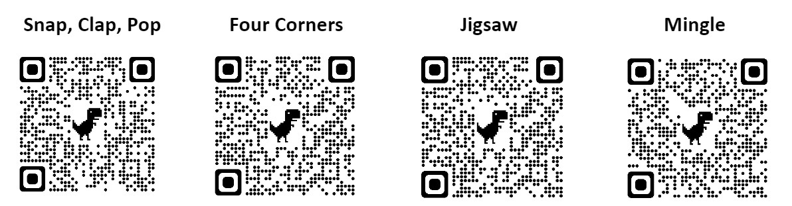
Check out wodb.ca for more Which One Doesn’t Belong? puzzles.

