Four Corners Images: 1
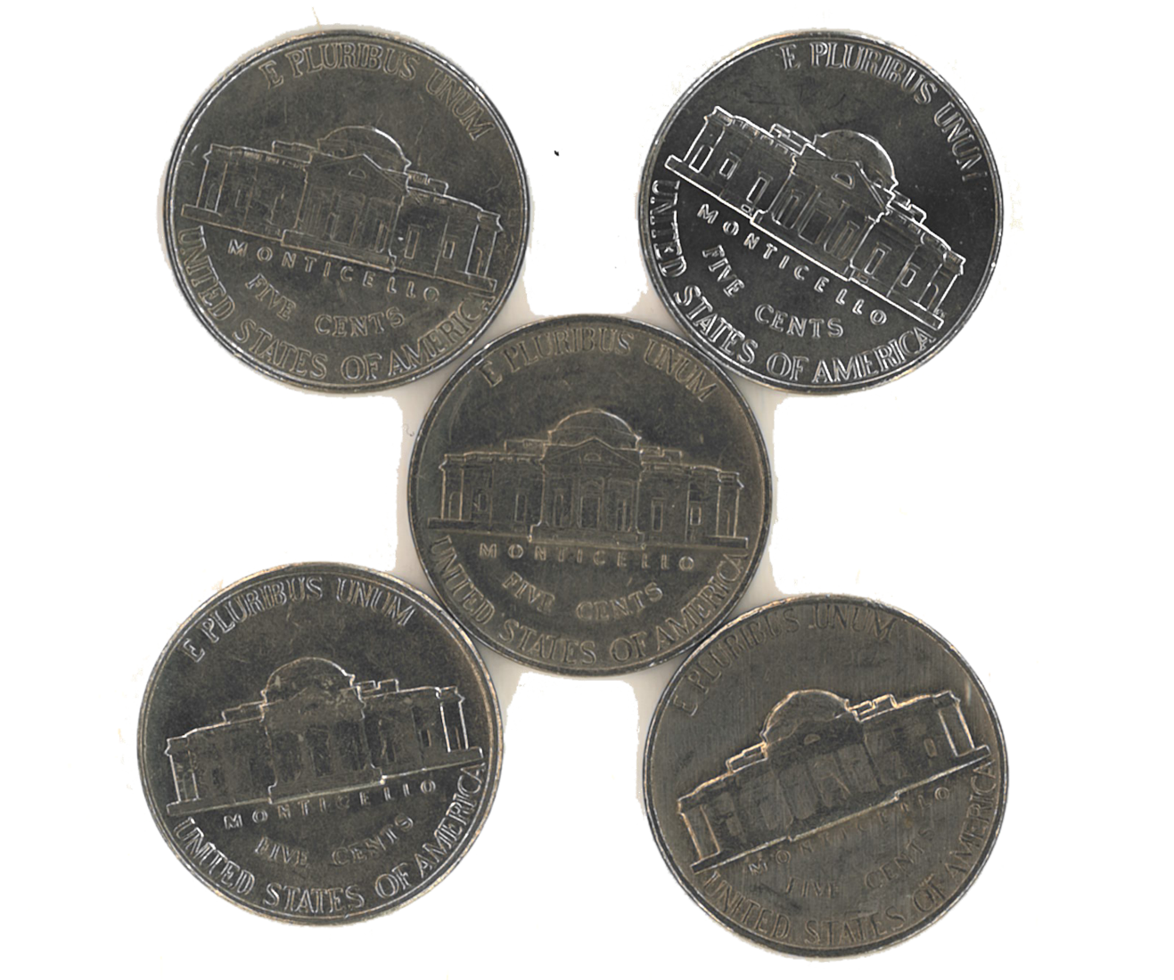

Inspired by Bourassa, M. (2013). Which One Doesn't Belong? https://wodb.ca/

Four Corners Images: 2
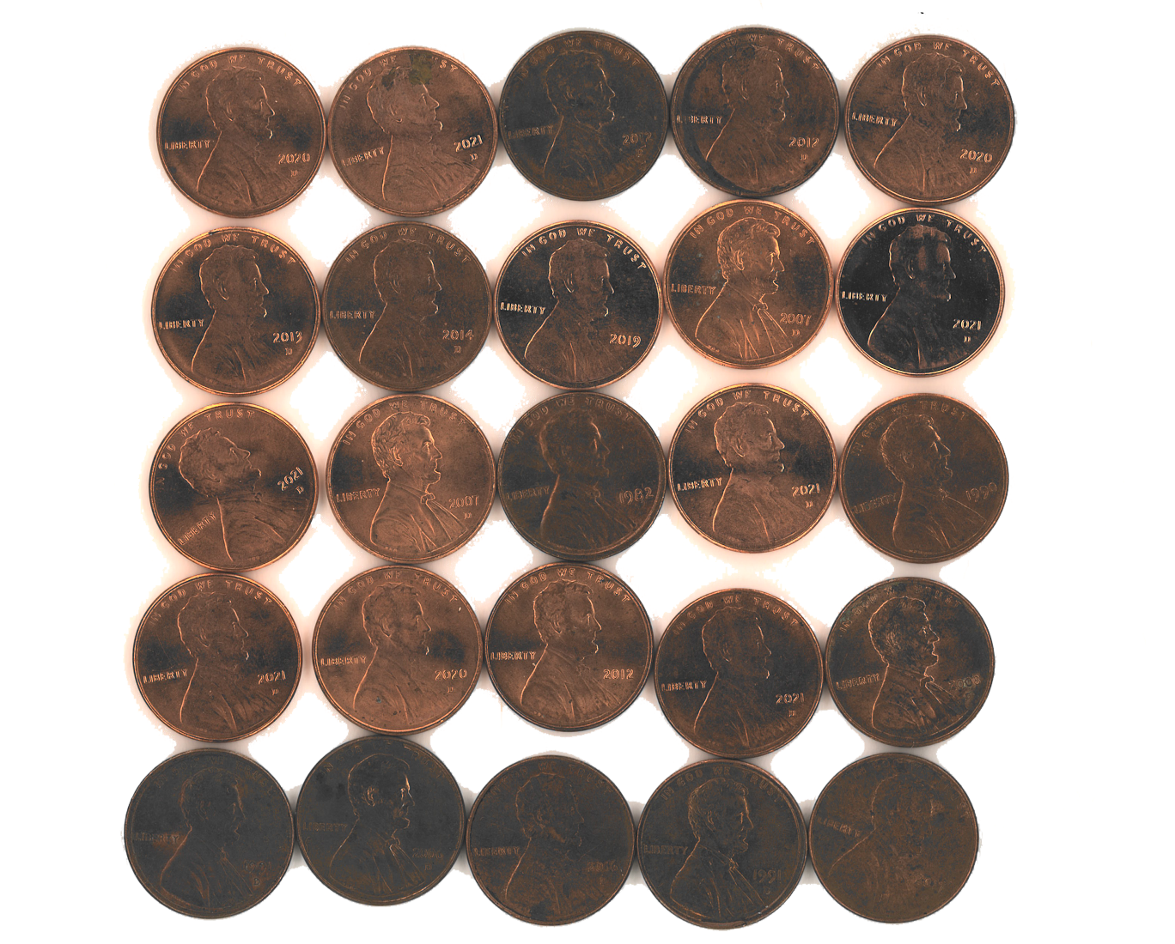

Inspired by Bourassa, M. (2013). Which One Doesn't Belong? https://wodb.ca/

Four Corners Images: 3
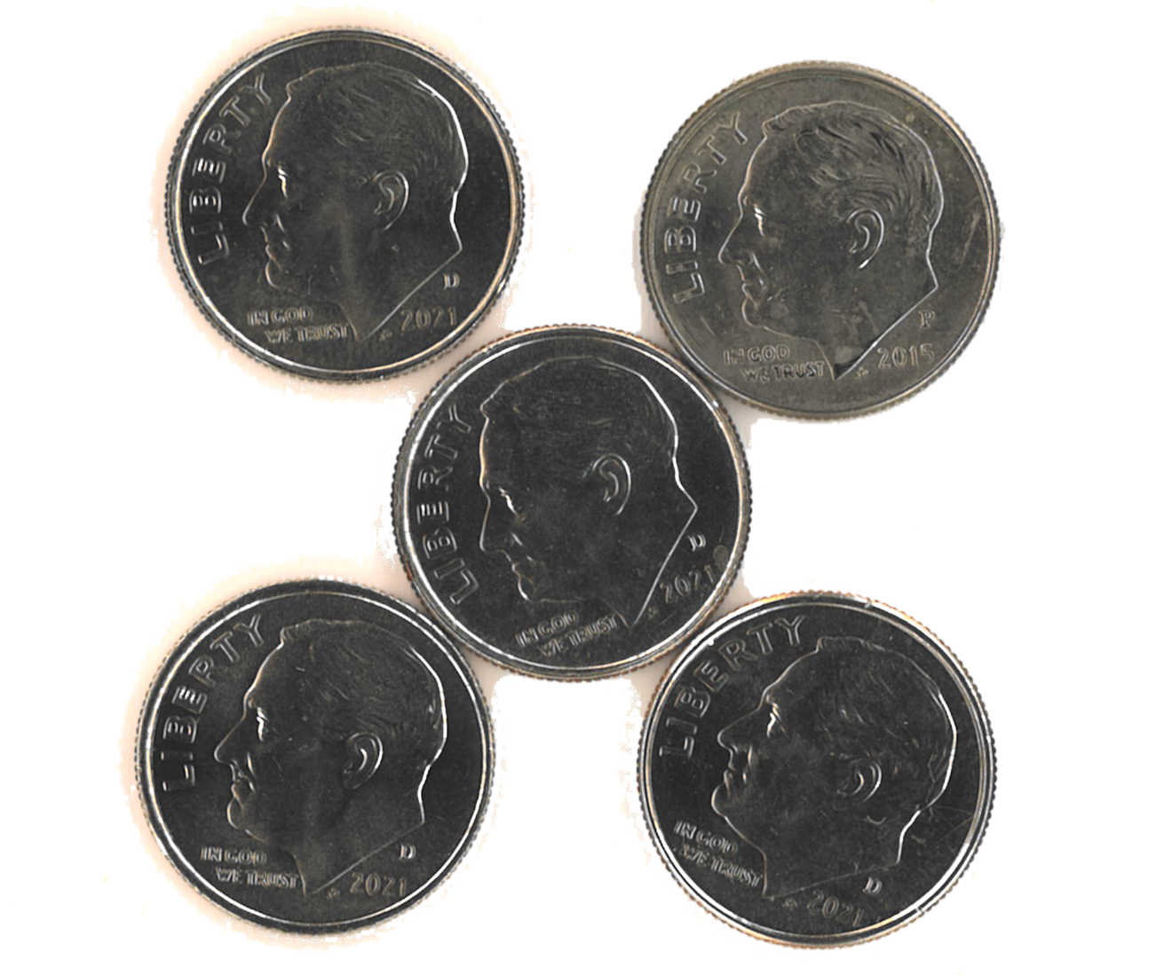

Inspired by Bourassa, M. (2013). Which One Doesn't Belong? https://wodb.ca/

Four Corners Images: 4
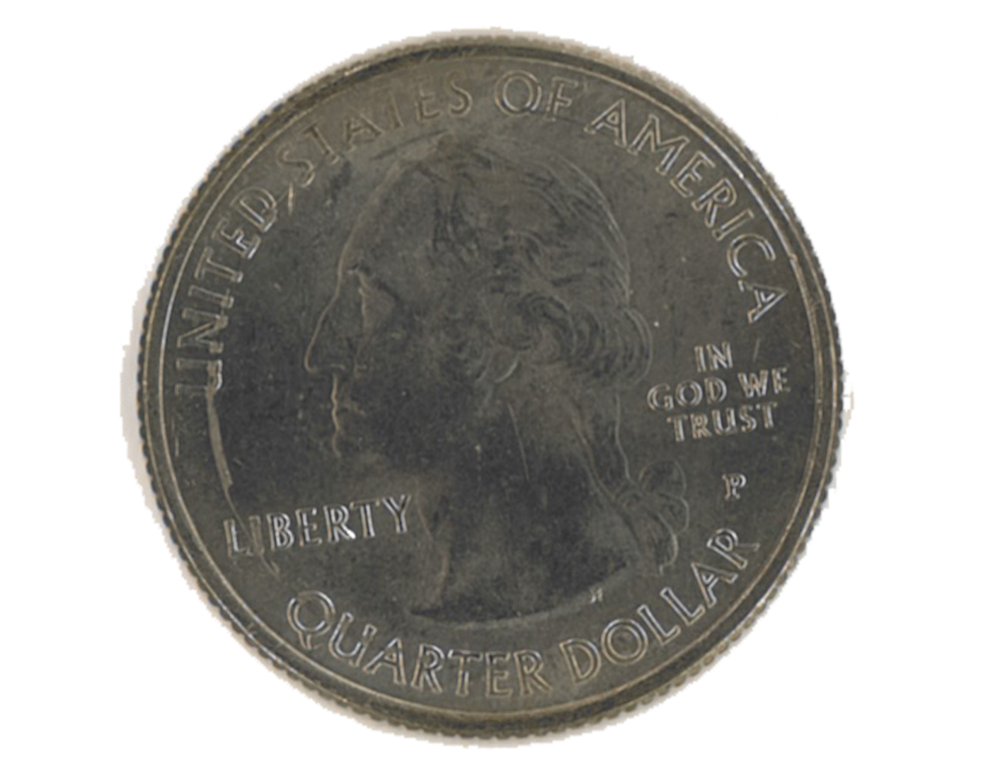

Inspired by Bourassa, M. (2013). Which One Doesn't Belong? https://wodb.ca/

