ISTE Standard | Key Components | Tech that Supports this Standard | How can I implement this in my classroom?
1.1
Empowered
Learner
1.2
Digital
Citizenship
1.3
Knowledge
Constructor
1.4
Innovative
Designer
1.5
Computational
Thinker
1.6
Creative
Communicator
1.7
Global
Collaborator

1.1  Empowered  Learner | Chemix  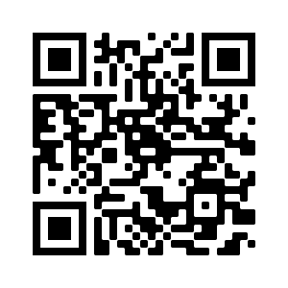 | Flip  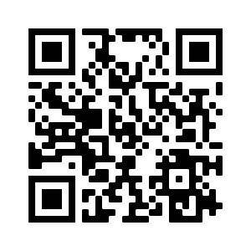
1.2  Digital  Citizenship | Parlay  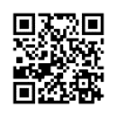 | Seesaw  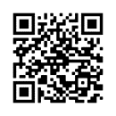
1.3  Knowledge  Constructor | Pear Deck  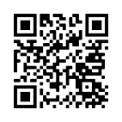 | Google Draw
1.4  Innovative  Designer | Desmos  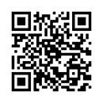 | Kahoot  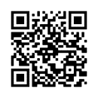
1.5  Computational  Thinker | Blooket  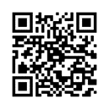 | Wakelet  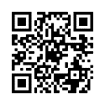
1.6  Creative  Communicator | iMovie  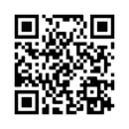 | Mentimeter  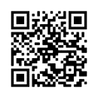
1.7  Global  Collaborator | Padlet  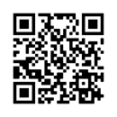 | Powtoon  