Closing the Gap
Description | Access | Notes
Visit the K20 Youtube Playlist to view all of the Virtual Career Expos. | 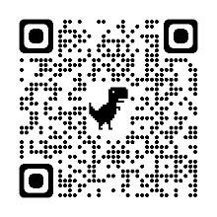  tinyurl.com/K20VCEVideos
To learn more about what the K20 Center does and to explore our lessons and strategies.  Visit the K20 LEARN website. | 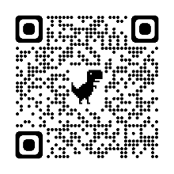  learn.k20center.ou.edu
To view all of our free, student-led career exploration activities.  Visit Student Resources tab on the K20 LEARN website. | 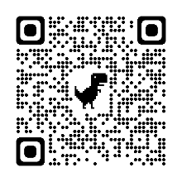  tinyurl.com/K20MentorActivities
View all K20’s activities and videos for each career cluster.  View our infogram. | 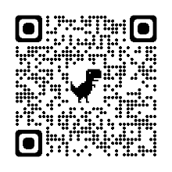  tinyurl.com/k20centercareerclusters
Career Cafés provide a way for small groups of students to meet career professionals, either in person or virtually, and to make meaningful connections. | 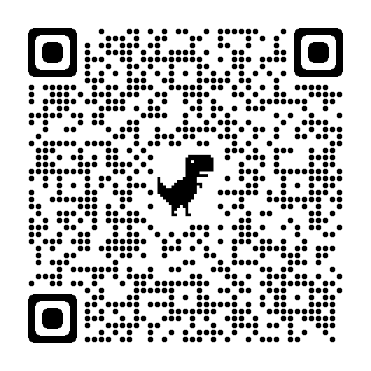  tinyurl.com/K20CareerCafeGuide
The Woman Crush Wednesday series of six lessons looks at the ways female scientists have shaped our views of science. | 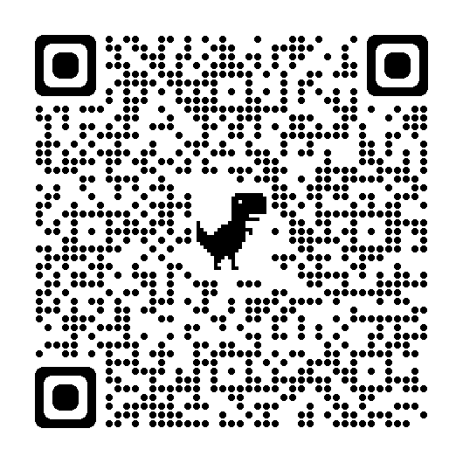  tinyurl.com/K20WCW

