NOTE CATCHER
Information | Key Points | How can I use this in my classroom/school?

Windows and Mirrors

Research and GEAR UP High School Overview
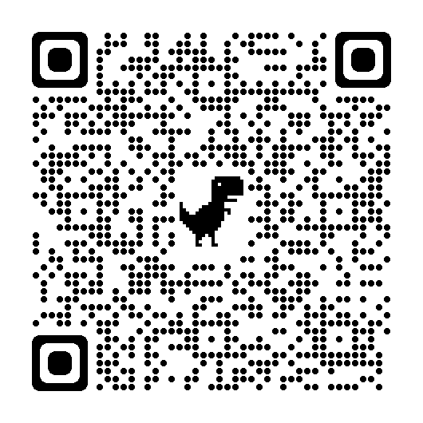

Panel Discussion

Submit questions for the panel here

