CLAIM, EVIDENCE, AND REASONING

“How did the Great Migration impact wartime efforts?”
Develop a claim (i.e., argument) to answer the question above. Then, find evidence from the text and map to support your claim. Finally, write your reasoning (which acts as a conclusion) to explain how the evidence supports your claim.
The Great Migrations
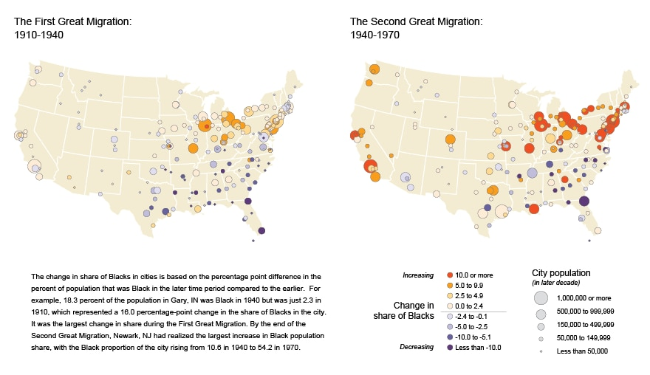
In the 1920s, immigration significantly decreased because of a series of prohibitive laws. Consequently, urban industries faced labor shortages. Meanwhile, defense industries needed more unskilled laborers during WWI and WWII, which led to an increasing number of available jobs in the cities. As cities’ needs for employers grew, Black Americans moved to the Northern cities to seek employment. Although the Great Migration slowed during the Great Depression, migration surged back and gradually increased for several decades after WWII.
References:
United States Census Bureau. (2012, September 13). The Great Migration, 1910 to 1970. United States Census Bureau. Retrieved
October 19, 2022, from https://www.census.gov/dataviz/visualizations/020/
Encyclopædia Britannica, inc. (n.d.). Great Migration. Britannica Kids. Retrieved September 28, 2022, from
https://kids.britannica.com/students/article/Great-Migration/603604#
CLAIM, EVIDENCE, AND REASONING
Question: How did the Great Migration impact wartime efforts?

Claim: (Respond to the question in a complete sentence.)

Evidence: (Provide at least one piece of evidence from the document to support your claim.)

Reasoning: (In one sentence, explain how the evidence supports your claim.)

The maps show how the population shares of Black Americans in different cities changed over two 30-year periods.
For example, during the First Great Migration (left map), Black Americans in Gary, Indiana, made up 2.3 percent of the city’s population in 1910 and 18.3 percent in 1940. Hence, the city’s marker indicates a 16.0 percent increase in the Black American population share. It was the largest change in Black American population share during the First Great Migration.
During the Second Great Migration, Newark, New Jersey, had the largest increase in Black American population share. In 1940, Black Americans had a 10.6 percent share of the city’s population. By the end of 1970, the percentage increased to 54.2.

