Drafted Soldier
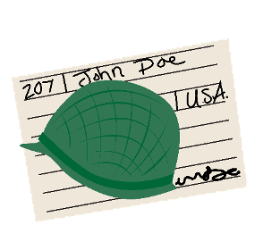 | - I registered for Selective Service, which is the military draft because I am 21.  - My draft number was read by the president, and I was told to report for duty.  - I am going to be sent to the war after 17 weeks of boot camp training.  - I was given a uniform, equipment, and a serial number.  - I became an important part of my unit.  - I made one mistake, so I got kitchen duty.

Rationing
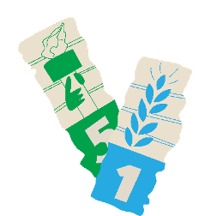 | - I participated in the government’s ration system.  - I have a book of stamps that I have to use when I go grocery shopping.  - Rationed items such as sugar, coffee, and meat are hard to find, and I can only buy those items if I have enough stamps.  - To stretch the small amount of coffee I’m allowed, I often reuse the grounds.

Female Baseball Player
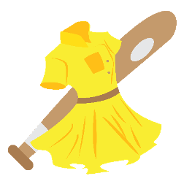 | - I played in the All-American Girls Professional Baseball League.  - With baseball players off to war, the league gave Americans something to cheer for and to be excited about.  - I played for the Rockford Peaches, a team from Illinois.  - I pitched the League's first no-hitter game.  - I played my heart and soul out.  - Attendance just kept going up.

Drafted Soldier
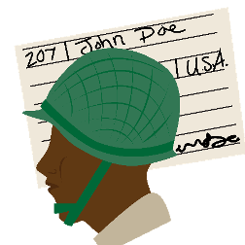 | - I signed up for the draft.  - I was drafted and trained at Camp Claiborne.  - I fought in the 761st Tank Battalion, known as the Black Panthers.  - I have to fight in a segregated unit because I am Black American.  - My unit fought hard to capture the German town of Morville-les-Vic.

Female Nurse Volunteer
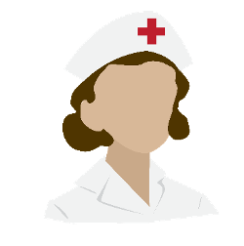 | - Because women are not allowed to fight in the war, I joined the Army Nurse Corps.  - I completed training.  - I was sent overseas to Europe by the Red Cross.  - I cared for injured soldiers in a Clubmobile unit.  - I will receive a Bronze Star for my bravery during the Battle of Bastogne.

Factory Worker
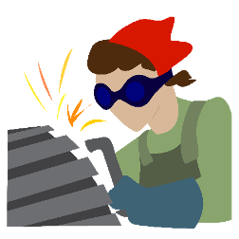 | - I took a job in an airplane factory.  - I used to be a secretary.  - I installed rivets and made sure each one fit just right.  - It was a very tough job, and I didn't want a mistake to cause a death.  - I worked on B-17, B-24, and B-29 aircrafts.

Code Talker
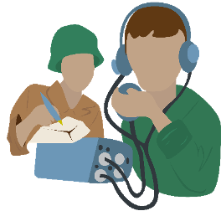 | - I am a Native American of the Navajo tribe.  - I was recruited and trained to be a Code Talker by the U.S. Marines.  - I used my tribal language to send secret communications.  - I worked with a partner. He operated the portable radio, and I received, sent, and translated the messages.  - We played a major role in the Battle of Iwo Jima.

Factory Worker
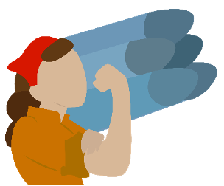 | - I took a job in a bomb factory.  - I worked for General Motors (GM).  - I was needed to help make materials for the war.  - My work was very dangerous.  - It required two hands to carefully put the fuses together.

