painting a picture
With the Painting a Picture strategy, you will observe a set of contents and make inferences based on your prior knowledge about the broader theme they represent. Analyze the images below and record what you observe and infer.
Image | Observations  (What do you see?) | Inferences  (Based on what you see,  what can you conclude?)
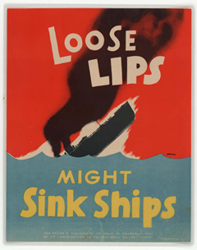
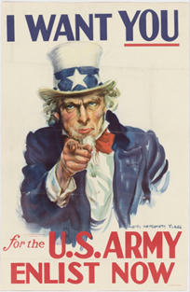
References
Flagg, J. M. (1941). I want you for the U.S. Army : enlist now [Image]. UNT Digital Library. https://digital.library.unt.edu/ark:/67531/metadc445/
Loose lips might sink ships [Image]. (n.d.). Wikimedia Commons. https://commons.wikimedia.org/wiki/File:Loose_lips_might_sink_ships.jpg
Image | Observations  (What do you see?) | Inferences  (Based on what you see,  what can you conclude?)
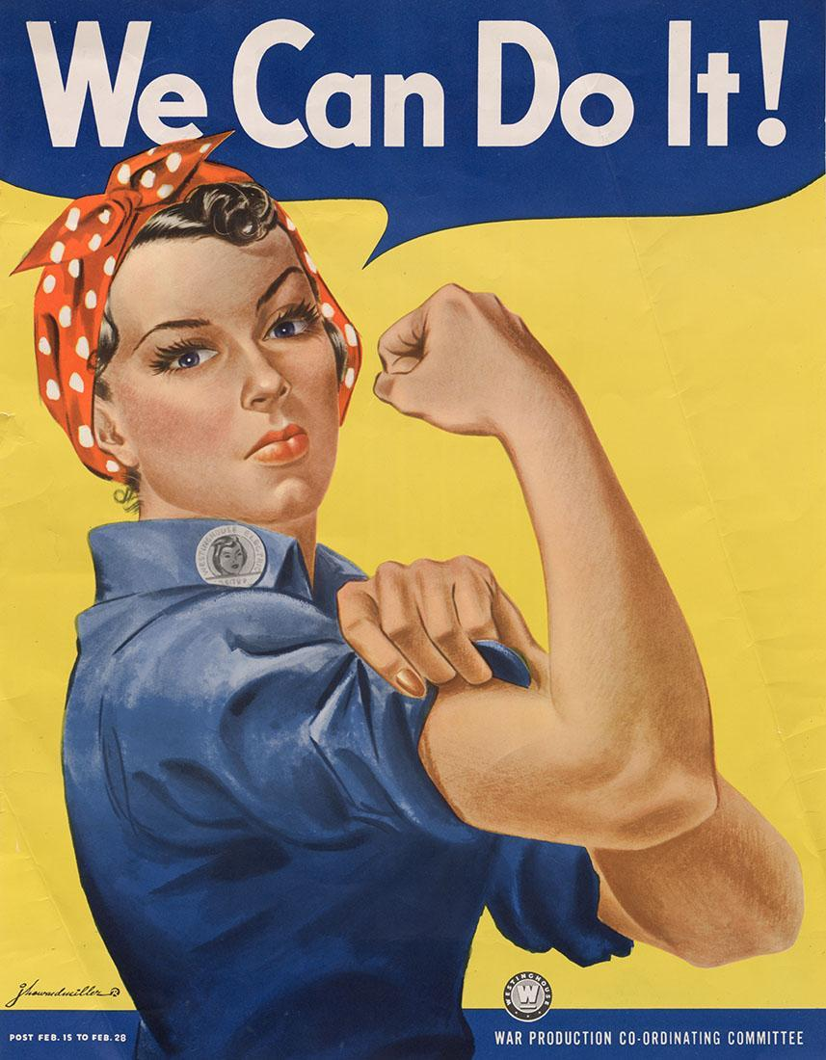
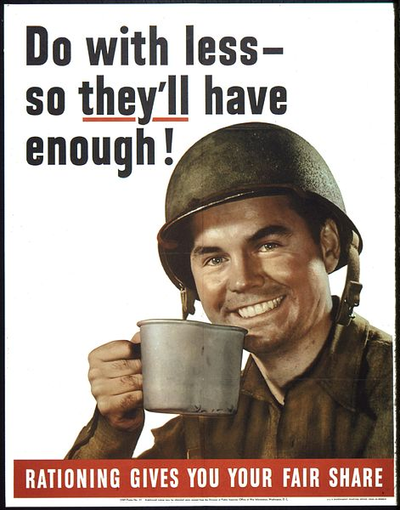
References:
“Do with less so they’ll have enough!” (ca. 1941–1945). Wikimedia Commons.
https://commons.wikimedia.org/wiki/File:%22Do_with_less_so_they%27ll_have_enough%22_-_NARA_-_513838.jpg
Miller. J. H. (1943). We can do it! [Image]. Wikimedia Commons. https://commons.wikimedia.org/wiki/File:We_Can_Do_It!_NARA_535413_-_Restoration_2.jpg

